Introduction:

Social media like Facebook, twitter, or Instagram is typically used as marketing by programs and businesses to help build a brand by informing potential customers the benefits of their company using ethos and logos. Social media has been a beneficial platform for programs that often become unrecognized in the media for doing well like head start programs. Head start is a federal government funded program that enhances school readiness of ages from birth to five years old that assists low income families. Head start helps young children advance in functioning in their cognitive social and emotional development which helps reduce crime rate and teen pregnancy in low income areas. Since the news media often ignores talking about head start programs, it has caused much of the twitter conversation around the #headstart to be from people who have had positive and personal experiences with the program as well as professionals trying to inform the everyday citizen.

Methods:

The original data set of tweets obtained 364 tweets, with the dates between Monday, June 24th, 2016 and Wednesday, June 26th, 2019, forming the excel data sheet by using the Twitter Archiving google spreadsheet (TAGS). But before being able to code the data, the 364 tweets had to be reduced to 100 tweets to lower the sample size. The spreadsheet was able to this by deleting the tweets that contained the letters “RT”. However, since the hashtag headstart contailns the letters “RT” I had to manually delete all of the tweets that contained “RT”. The spreadsheet also deleted tweets that contained foreign language. The spreadsheet also removed tweets that had the hashtag #headstart but not in context towards the federal government funded program. With all of this filtration, the tweets were narrowed down to my final sample space total of 100 tweets.

After having processing and looking over the data enabled coding to begin exercising these categories:

1. 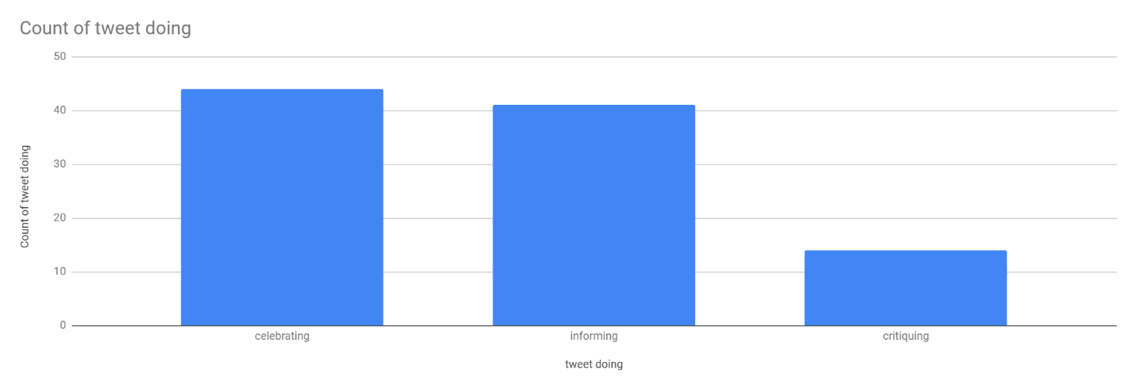Looking at what the tweet is actually doing. This makes the analyzer of the data look at the main point of tweet. The data was able to break down this question and place it into three different sub categories of tweets of whether the tweet was celebrating ,informing or critiquing.
2. Seeing people’s stance on the hashtag head start. This would mean seeing if the tweets with the hashtag headstart were mostly positive, neutral, or negative.
3. 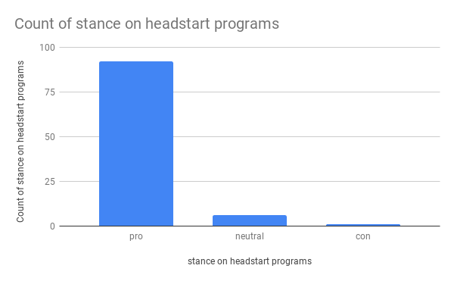The rhetorical strategy that the tweets would use to draw awareness and inform people. Mostly consisting of logos and ethos. 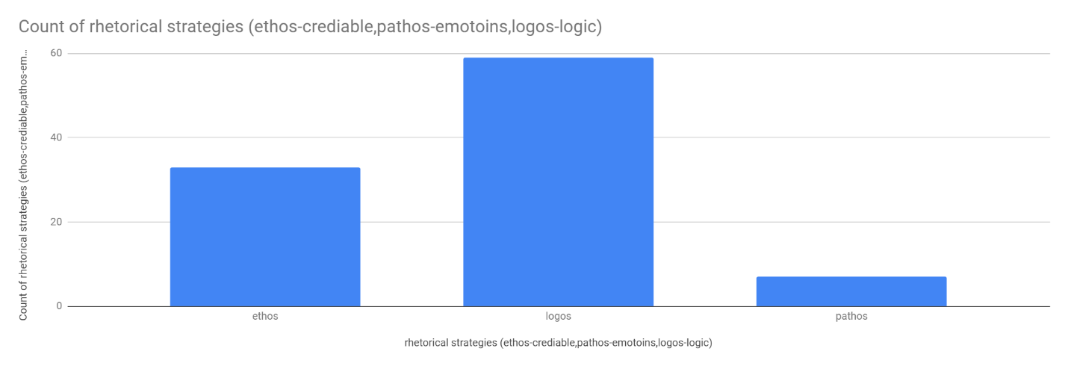

Discussion: