Jurnee Lopez

ENGL 105  
Community Discourse Analysis: Draft

Activism Using Hashtags: How Twitter Promotes Social Activism

Introduction:   
 Since the advent of social media, the symbol “#” formerly known as the number sign or pound sign has come to be more commonly known as a hashtag. Originally used for tagging key words and topics within a post, hashtags have grown in importance with the growth of social media sites such as Facebook, Twitter, and Instagram, among the most common. Due to the nature of Twitter’s platform with text-based posts and limited character usage, hashtags have become an integral part of Twitter’s interface; they can be used to categorize and organize tweets in searches while contributing. to the “Trending Topics” page that varies based on location (How to use hashtags, n.d). In more recent years, hashtags have been used to highlight key phrases in the context of various socio-political issues. The activist movements Me Too, advocating against sexual harassment and assault of women, and Black Lives Matter, advocating against systemic racism towards African Americans, are examples of those that have strategically used hashtags to raise awareness and promote change in their respective areas of focus. It is important to recognize how social media platforms, such as Twitter, and the usage of hashtags enable issues to be prominent in public discourse and cause supporters to actively participate in protest (Xiong, Cho, & Boatwright, 2019).   
 Effectively beginning in Spring of 2018, Donald Trump’s “zero-tolerance” immigration policy led to the separation of families at the United States-Mexico border and the implementation of multiple “detainment camps”. Children were removed from their families and transferred to various facilities with little-to-no way of reuniting them following their parents’ detention (Domonoske & Gonzales, 2018, June 19). The facilities have been in use through 2018 and into the first half of 2019 with no seeming end to their use. Following the publication of an article on ABC News with the title “Doctor compares conditions for unaccompanied children at immigrant holding centers to 'torture facilities'”, a surge of public outcry began as a result of the reported conditions in the detention centers. Not only did politicians and celebrities speak out on the issue, but also many people belonging to the general public; the usage of the hashtag #closethecamps spiked. In this essay, a collection of tweets with the hashtag #closethecamps will be analyzed to find patterns within public usage of the hashtag in order to create a conclusion about how hashtags affect social activism.   
Methods:

In order to analyze the usage of the specific hashtag, a corpus was developed from a larger sample. Using a website titled “TAGS”, a spreadsheet is downloaded onto a google spreadsheet with instructions to obtain and download tweets. I entered the specified hashtag into the terms label while adjusting the maximum number of tweets to be downloaded to 10,000. After connecting the spreadsheet to my twitter account, I allowed the spreadsheet to “Run” and collect the most recent tweets including the hashtag. Upon the first retrieval, approximately 10,000 tweets were collected. I adjusted a setting to update the spreadsheet every hour after the original download; about 24 hours later 28,000 tweets were downloaded onto the spreadsheet. In order to narrow down the tweets into a manageable corpus, I used several filters.   
 First, using the “text” column, I filtered out each tweet that included the phrase “RT” that indicates a retweet; I only wanted to analyze original tweets, not those that were simply retweets. I then used the “user_lang” column to filter out any tweets that were not in English. Because the amount of tweets remained large, I began to filter them by time and date of their creation. I originally started with the date June 25, 2019 and time period between 8am and 8pm; I continued to shorten the time period until I reached 227 tweets within the time frame 7pm to 8pm. I used a total of four constraints to consolidate my sample size and corpus of tweets. I chose to keep tweets that had media/links included in the corpus in order to see how media has been used in the context of this form of activism as well.   
 The final step prior to the analysis of the corpus was coding the tweets. Coding consisted of categorizing each individual tweet using four categories: the “action” of the tweet, the rationale or rhetorical strategies used, whether or not the tweet included media/links, and the topic of the tweet. When looking at the “action” of each tweet, the question “What is the tweet doing” was asked in order to facilitate the process. I identified six actions including some that encompass more than 1 action: agreeing/RT, commenting (reacting, questioning, replying), informing (raising awareness), supporting (advocating), criticizing, and suggesting solutions. Some actions are combined into one main category, as indicated by the parenthesis.   
 Not every tweet included rationale or rhetorical strategies as they were not all creating arguments or evident, but many included various forms of media such as “quoted tweets” (a form of retweeting that allows the user to comment on the original), pictures, graphics, and linked articles. As for the topics of the tweets, I either indicated that the tweet was solely about the camps or if it included focus on other subject matter such as Trump or congress. Using the corpus and coding, I created three separate graphs that illustrate the action of the tweets, media, and topic. Bar graphs were used for indicating the action and topic while a pie graph more appropriately displayed the percentage of tweets containing media versus not.  
Analysis:   
 In Figure 1, the data collected from the first category, the action of the tweet, can be 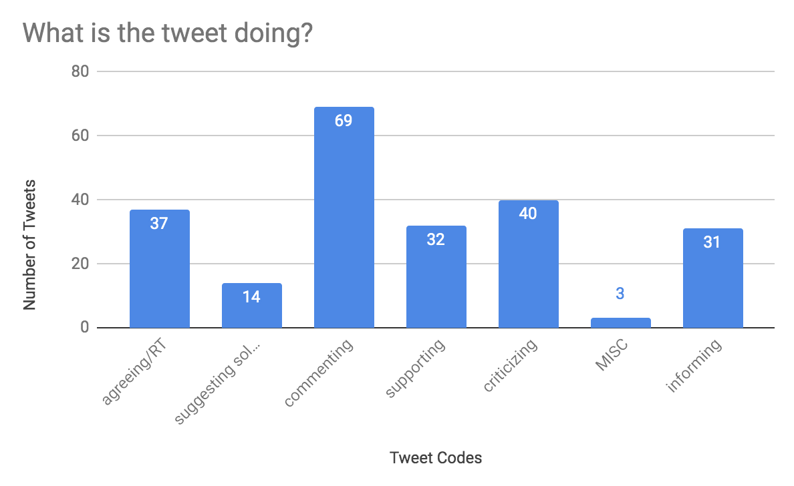seen. The X axis is the code/action while the Y axis measures the number of tweets. I included a category for “MISC”, meaning miscellaneous” to account for tweets unrelated to the subject matter. The action with the most tweets was commenting with criticizing as the second largest. Aside from “MISC” the action of suggestion solutions had the least amount of tweets. In Figure 2, a pie graph is used to show 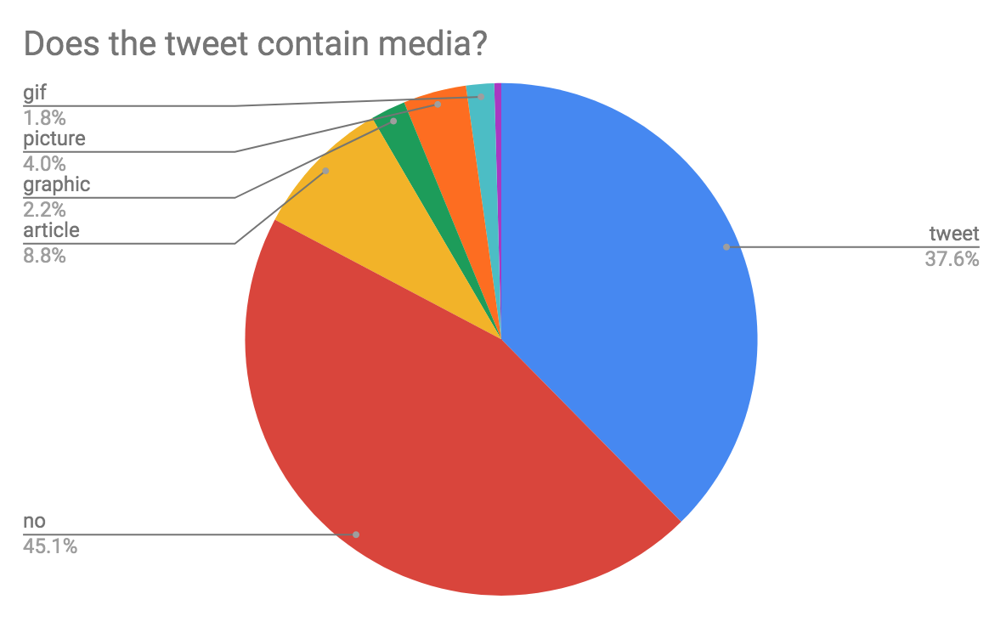whether or not the tweet contained media. If the tweet did not, I indicated “no” while specifically indicating the type of media if the tweet had it included. By adding all of the media categories, the graph indicates that a majority, 54.4%, of the tweets collected included some form of media. In 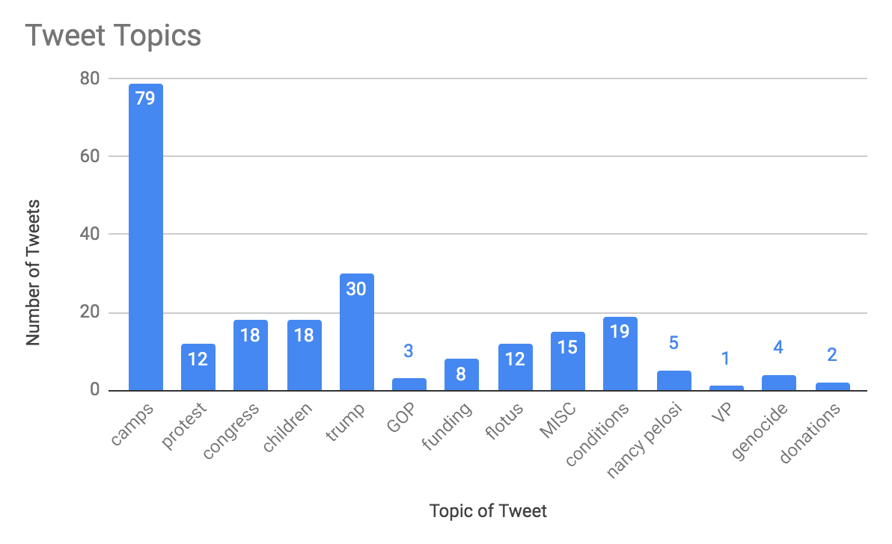figure 3, the topics of the tweets can be viewed. A majority of the tweets were solely about the detainment camps, while the next highest topics were Trump and the conditions of the camps. Many of the topics were related to other political subjects such as Congress and the First Lady, Melania Trump, in addition to other aspects of the camps such as the children and funding of them.   
Implications:  
When analyzing the data collected, it is important to note that the corpus of tweets was filtered to a smaller sample size, with many other tweets using the hashtag not collected. It is also important to acknowledge that the subject of immigration and how to address solutions to the influx of people has been affected by its presentation in the media. The general public does not have sufficient information about the circumstances or policy details that have evolved in recent years (Merolla, Ramakrishnan, & Haynes, 2013). In regards to the use of the hashtag, the data suggests that the majority of users were using it to comment on the situation, reply to other users, and criticize those involved with the continuance of the camps. The least amount of people were suggesting solutions to the issue and informing people about the circumstances. Figure 1 reveals the most about the effectiveness of hashtag activism and how people are using it on Twitter; a minority of users are using the hashtag to do more than make online comments. Figure 3 is also important to acknowledge in that it reveals how people are redirecting the information and emotions towards the events. Many politicians are actively making commentary on social media like Democratic Representative Alexandria Ocasio-Cortez that has prompted various responses by fellow politicians (Alvarez, 2019 June 20). Although a majority are not evoking concrete change, people use the hashtag to relate the issue to other problems, such as the administration.   
Conclusion:   
 Following an analysis of the tweets and data collected, a conclusion can be made that many people use hashtags pertaining to socio-political issues for a variety of reasons, the most common of which being discourse between online users. Many users also utilize forms of media when discussing these topics and often address other factors in the subject matter as opposed to the basic topic.

Figure 1

Figure 2

Figure 3

Works Cited

Alvarez, P. (2019, June 20). Border Patrol chief says description of immigration facilities as 'concentration camps' is 'offensive'. Retrieved from https://www.cnn.com/2019/06/20/politics/border-patrol-response-concentration-camp-remarks/index.html

Domonoske, C., & Gonzales, R. (2018, June 19). What We Know: Family Separation And 'Zero Tolerance' At The Border. Retrieved from https://www.npr.org/2018/06/19/621065383/what-we-know-family-separation-and-zero-tolerance-at-the-border

How to use hashtags. (n.d.). Retrieved from https://help.twitter.com/en/using-twitter/how-to-use-hashtags

Merolla, J., Ramakrishnan, S. K., & Haynes, C. (2013). “Illegal,” “Undocumented,” or “Unauthorized”: Equivalency Frames, Issue Frames, and Public Opinion on Immigration. *Perspectives on Politics,11*(3), 789-807. doi:10.1017/s1537592713002077

Xiong, Y., Cho, M., & Boatwright, B. (2019). Hashtag activism and message frames among social movement organizations: Semantic network analysis and thematic analysis of Twitter during the #MeToo movement. *Public Relations Review,45*(1), 10-23. doi:10.1016/j.pubrev.2018.10.014