A Growing Fight:

U.S.-Iran Conflict and its Effects on the Public

Shawn Rapp

ENG 105

Anderson

A Growing Fight: U.S.-Iran Conflict and its Effects on the Public

**Introduction**

The tension between the United States and Iran has become undeniable in the recent weeks. Although this escalating conflict seems new, it has really been building since the overthrow of the last Iranian monarch, Mohammad Reza Shah. The relationship between the United States and Iran has since been filled with restlessness and uncertainty. Every United States president since Ronald Reagan has had to find the right relationship with a country that according to the U.S. Department of State (2019), is one of the longest state sponsors of terrorism in the world. The Carter and Obama administrations took a softer and more generous stance, whereas the Reagan and now Trump administrations have taken a significantly harder stance with Iran. What has escalated the conflict past the usual threshold is that “the United States is engaged in a campaign of maximum financial pressure on the Iranian regime and intends to enforce aggressively these sanctions that have come back into effect” (U.S. Department of the Treasury, 2019).

One thing that has certainly changed since the Reagan administration has been the presence of social media as sites like Facebook and Twitter have taken over as the primary way to socialize and communicate to mass groups of people. President Trump has taken advantage of this new opportunity and has a large presence on these sites and all social media in general. Consequentially, politics has also been brought into the social media world as people have now begun to voice their political feelings on these sites. In this study, I aim to get a better understanding of what political discussions on these sites look like and the goals of these conversations and individual tweets.

**Methods**

I started my data gathering process with 1,935 tweets using the “#iranwar” hashtag that were tweeted out between June 19th and June 26th. For this process I used the Twitter Archiving Google Spreadsheet (TAGS) which automatically pulls results from twitter into a Google spreadsheet. From the 1,935, I filtered out all the retweets, as I wanted to see what each individual thought and how they expressed themselves, and the tweet total remining dropped to 468. From here I filtered my group of tweets even further down to the 201 that were tweeted within the last two days, June 25th and June 26th. I did this because there was a large enough volume of tweets containing this hashtag that a full week wasn’t needed. With 201 tweets remaining I decided that I would only look at the newest 100 tweets to get an understanding of the most recent conversation.

Now that I had a good sample of tweets I began to code them based on three different categories. The first was what the user’s political stance seemed to be. More specifically, was the tweet in favor of or opposed to the actions being taken against Iran by the Trump administration. I felt like this was an important question to ask in order to get a better understanding as to what people that tweet out political ideas, believed the right course of action is to this growing conflict. The second category looked at the intention of the tweet. This question, I feel is the most important to understanding the conversation regarding Iran on social media. The third and last category looked at whether the tweet was a part of conversation or whether it was just an idle individual tweet.

**Results**

From the data I gathered I was able to see that the majority of people tweeting using the “#iranwar” hashtag were opposed to the actions of the current administration and the current U.S. relation with Iran. Around 43% of the tweets analyzed exhibited comments that 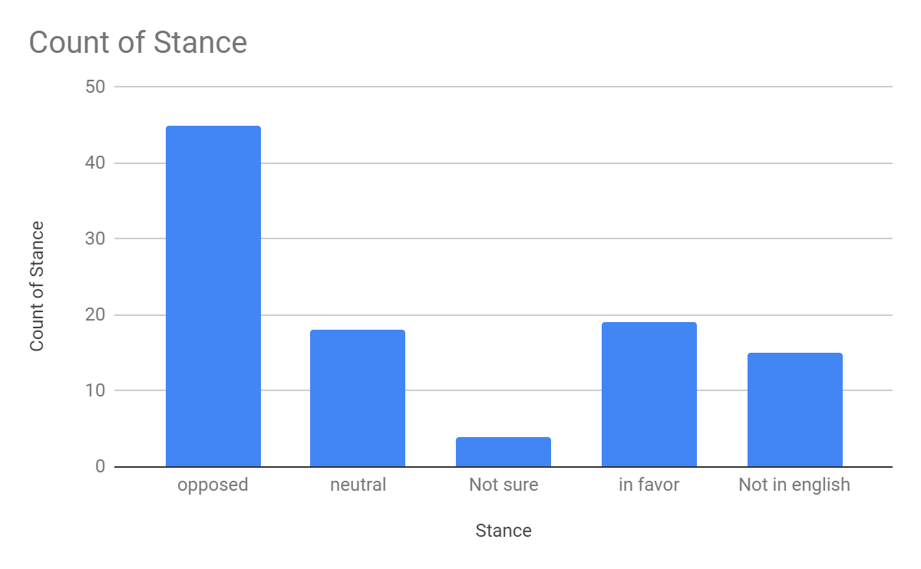were opposed to the current tactics being used whereas only 19% were in favor of the current tactics. 18% of the tweets were labeled as neutral as they did not take any specific stance. The next largest group was the tweets that were not written in English that made up 15% of the total. I felt it was necessary to include these tweets in the data set as they were all written in Farsi which is the primary language spoken in Iran. This data set shows that the majority of people who express their views of the U.S.-Iran 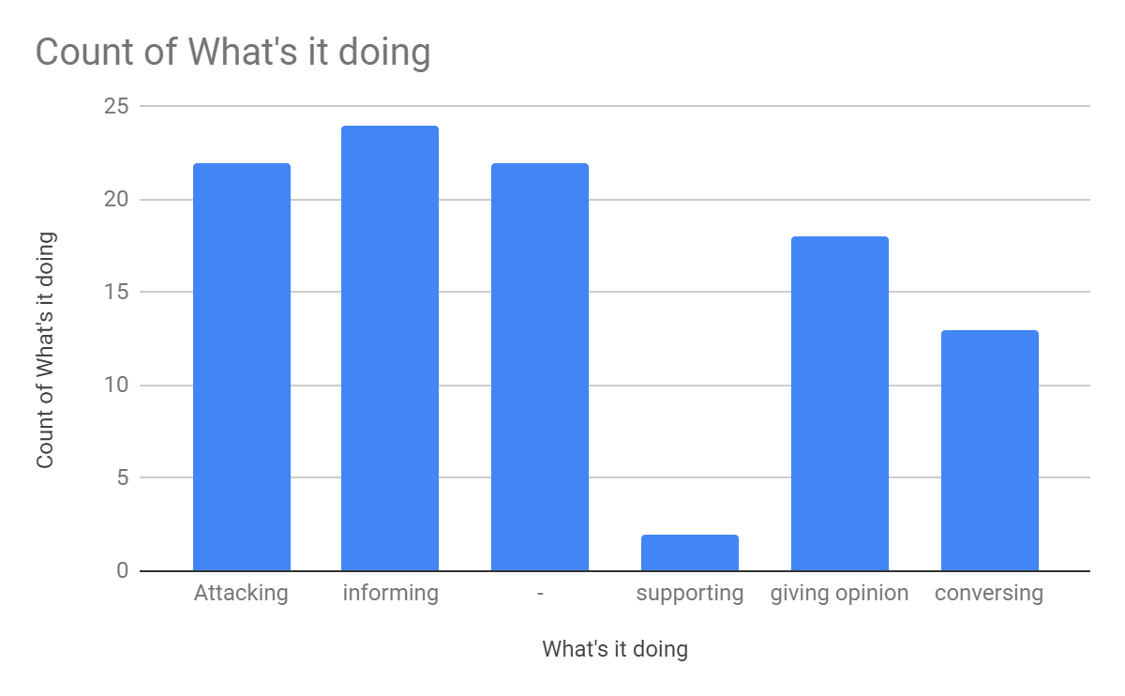conflict on social media are not supportive of the current administration’s tactics.

Figure 1. Count of Stance

After determining what each tweet was attempting to do I noticed a pretty decent variation among the 100 that I analyzed. The largest group was the 24% that aimed to inform all readers of what was going on or a new update on the situation pertaining to the U.S.-Iran conflict. Some of these were journalists or new sources. The next largest group and most shocking were the 22% that blatantly attacked or insulted someone and, in most cases, it was the President of the United States. As an example, user @ kathryn_b_cook tweeted “@senatemajldr Maybe if you slip something in their drinks when they’re not looking. @realDonaldTrump probably has experience with that and can show you. #IranWar #mockavellian” (kathryn_b_cook, June 26, 2019). The 22% that are attacking far outnumber the mere 2% of tweets that were supportive and or positive. The remaining, consisted of tweets that were either not written in English or their intention was unknown (–) or they were just giving a general opinion that did not fall under any of the other categories (giving opinion), (conversing).

Figure 2. Count of What the Tweet its Doing

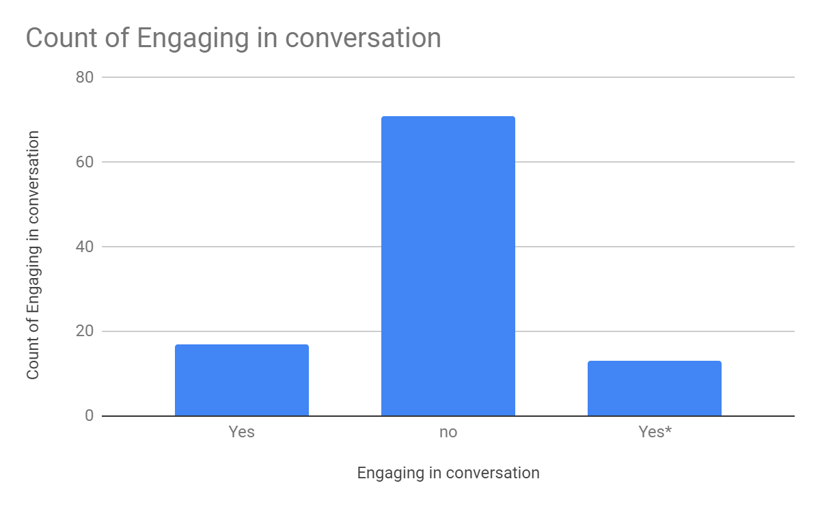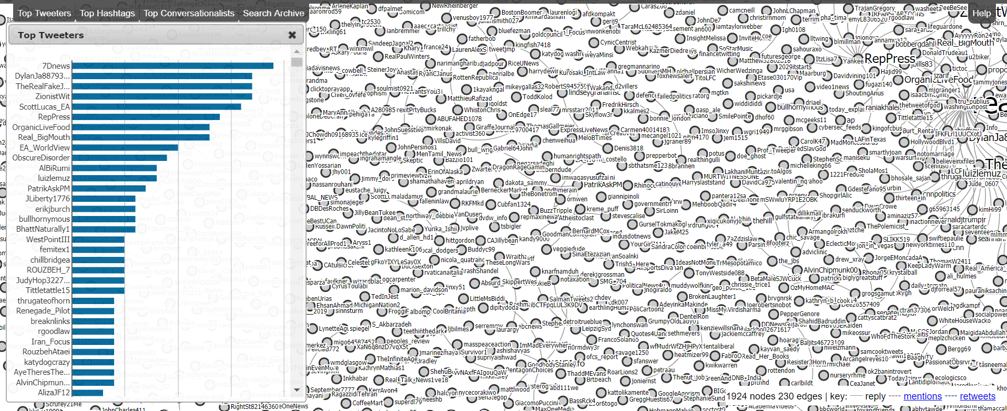 The Third category shows the count of people who used their tweet to engage in a conversation. It is quite apparent from the results, that majority of people who were tweeting using the “#iranwar” hashtag were not intending to have a conversation and were merely just saying what was on their mind. As an example, twitter user @Tittletattle15 tweeted “America if you have guts fight with Russia or China or UK @realDonaldTrump @POTUS should have Steel balls to fight with those countries. Don't fight or threat small countries like Iran. #Iran #America #IranUSTension #IranWar #IranSanctions #IranRegimeChange” (Tittletattle15, June 26, 2019). Only 18% of people in the data set were having or attempting to have a conversation about their political views that they were expressing. The remaining 15% were those who tweeted “@” someone however in most cases, those people would not actually engage in the conversation. Instead tweets seemed to use the “@” sign to call out the President or members of his administration. Figure 4 shows connections between the tweets and the total number of tweets by user. Apart from the large number of tweets that incorporate @realDonaldTrump there are not very many connections being made between users.

Figure 3. Count Engaging in Conversation

Figure 4. Connection Between Tweets

**Conclusion**

Twitter and other social media platforms have changed the way we converse and express our views and beliefs. More and more people are joining in and taking part in the new cultural phenomenon. However, based upon my examination of the “#iranwar” hashtag, it does not seem that this rise in popularity has led to an increase in depth conversations. The data as whole shows a clear lack of conversations and connections being made. The newer generation of tweeters appear to no longer want to engage with others but instead, just spew what they have to say onto the internet.

**Works Cited**

US Iran Conflict

Chulav, M. (2019). Oil tanker attacks will inflame conflict between the US, its allies and Iran. Retrieved 6/28/19, from

<https://search.proquest.com/docview/2239437397?pq-origsite=summon>

Cirincione, J., & Kaszynski, M. (2019). The path to war with iran is paved with sanctions.*Washington Report on Middle East Affairs, 38*(3), S15.

Margolis, E. S. (2018, 10). The looming war against iran.*The Washington Report on Middle East Affairs, 37*, 39-40. Retrieved from <http://libproxy.lib.unc.edu/login?url=https://search.proquest.com/docview/2125614072?accountid=14244>

*Phil's stock world: US is already fighting a conflict with iran – an economic war that is hurting the wrong people* (2019). . Chatham: Newstex. Retrieved from <http://libproxy.lib.unc.edu/login?url=https://search.proquest.com/docview/2229836746?accountid=14244>

State Sponsors of Terrorism - United States Department of State. (n.d.). Retrieved July 2, 2019, from <https://www.state.gov/state-sponsors-of-terrorism/>

U.S. Department of the Treasury. (n.d.). Retrieved July 2, 2019, from <https://www.treasury.gov/resource-center/sanctions/Programs/Pages/iran.aspx>