A Growing Fight:

U.S.-Iran Conflict and its Effects on the Public

Shawn Rapp

ENG 105

Anderson

A Growing Fight: U.S.-Iran Conflict and its Effects on the Public

Introduction

The tension between the United States and Iran has become extremely apparent and undeniable in the recent weeks. Although this escalating conflict seems new, it has really been building since the overthrowing of the last Iranian monarch, Mohammad Reza Shah. Following the regime change, Iran’s economy drastically crashed and the country had fallen from a prospective first world country to one of the most struggling third world countries. The relationship between the United States and Iran since then has also been filled with restlessness and uncertainty. Every United States president since Ronald Reagan has had to find the right amount of association with a country that has become the worlds greatest sponsor of terrorism. Many administrations have had different ideas of best approach. The Carter and Obama administrations took a softer and more generous stance whereas the Reagan and now Trump administrations have taken a significantly harder stance with Iran.

One thing that has certainly changed since the Reagan administration has been the presence of social media as sites like Facebook and Twitter have taken over as the primary way to socialize and communicate to mass groups of people. President Trump has taken advantage of this new opportunity and has a large presence on these sites and all social media in general. Consequentially, politics has also been brought into the social media world as people have now began to have conversations and voice their political feelings onto these sites. In this study, I aim to get a better understanding as to what political discussions on these sites look like and what the goal of these conversations and individual tweets are.

**Methods**

I started my data gathering process with 1,935 tweets using the “#iranwar” that were tweeted out within the last seven days. For this process I used the Twitter Archiving Google Spreadsheet (TAGS) which automatically pulls results from twitter into a Google spreadsheet. From the 1,935 I filtered out all the retweets, as I wanted to see what each individual thought and how they expressed themselves, and the tweet total remining dropped to 468. From here I filtered my group of tweets even further down to the 201 that were tweeted within the last two days, June 25th and June 26th. I did this because there was a large enough volume of tweets containing this hashtag that a full week wasn’t needed. With 201 tweets remaining I decided that I would only look at the newest 100 tweets to really get an understanding as to what people were thinking in a more immediate way.

Now that I had a good feeling about the size and content of the remaining tweets I began to code them based on three different pillars. The first was whether the tweets political stance. More specifically was the tweet in favor of the actions being taken against Iran by the Trump administration or were they opposed. I felt like this was an important question to ask in order to get a better understanding as to what the overall person that tweets out political ideas believed the right course of action is to this growing conflict. The second pillar was asking what the intention of the tweet was. This question, I feel is the most important to understanding the reason people are more often taking their political views to social media. The third and last pillar is determining whether or not the tweet was a part of conversation or whether it was just an idle individual tweet. This pillar is important when it comes to the true reasoning as to why people tweet in general.

**Results**

From the data I gathered I was able to see that the majority of people tweeting using the “#iranwar” were opposed to the actions of the current administration and the current U.S. relation with Iran (see Figure 1.) Around 43% of the tweets analyzed exhibited comments that were opposed to the current tactics being used whereas only 19% were in favor of the current tactics. 18% of the tweets were labeled as neutral as they did not take any specific stance. The 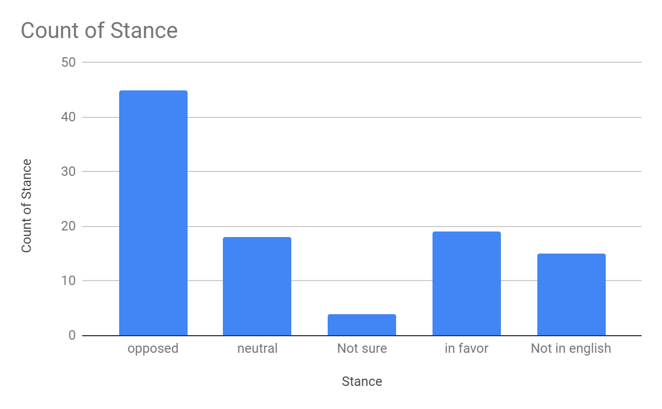next largest group was the tweets that were not written in English that made up 15% of the total. I felt it was necessary to include these tweets in the data set as they were all written in Farsi which is the language spoken in Iran. This data set sows that the majority of people who express their political views on social media are not supportive of the current 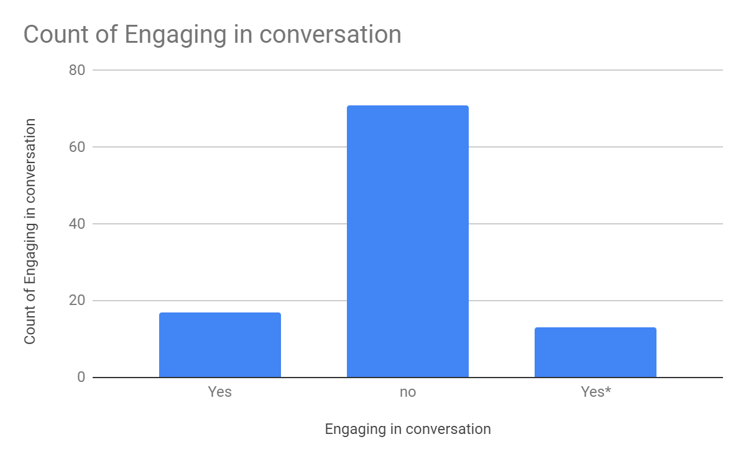administration’s tactics.

The second pillar shows the count of people who used their tweet to engage in a conversation (see Figure 2.) Its’ quite apparent from the results that majority of people who were tweeting using the “#iranwar” were not intending to have a conversation and were merely just saying what was on their mind. This data is important as it shows the changing of times as people no longer want to engage with others and put themselves into positions of discomfort or positions where they could be told they’re wrong. Only 18% of people in my data set were having or attempting to have a conversation about their political views that they were expressing. The remaining 15% were those who tweeted @ someone but in most cases were people that would not actually engage in the conversation such as the President or members of his administration.

**Works Cited**

US Iran Conflict

BILAWAL, A. L., & Shikarpur. (2019, Jun 04). Iran-US conflict.*The Nation*Retrieved from <http://libproxy.lib.unc.edu/login?url=https://search.proquest.com/docview/2241579794?accountid=14244>

Cockburn, P. (2019). *Europe can’t be much more than a spectator in the escalating US-iran conflict*. London (UK): Independent Digital News & Media. Retrieved from <http://libproxy.lib.unc.edu/login?url=https://search.proquest.com/docview/2234946160?accountid=14244>

Chulav, M. (2019). Oil tanker attacks will inflame conflict between the US, its allies and Iran. Retrieved 6/28/19, from <https://search.proquest.com/docview/2239437397?pq-origsite=summon>

*Europe urges restraint as fears of US-iran conflict escalate.* (2019). (). Washington: Federal Information & News Dispatch, Inc. Retrieved from eLibrary; ProQuest Central Retrieved from <http://libproxy.lib.unc.edu/login?url=https://search.proquest.com/docview/2224397731?accountid=14244>

*Phil's stock world: US is already fighting a conflict with iran – an economic war that is hurting the wrong people* (2019). . Chatham: Newstex. Retrieved from <http://libproxy.lib.unc.edu/login?url=https://search.proquest.com/docview/2229836746?accountid=14244>