Marine life suffering from excessive amount of plastic pollution

Dominique Monteon

PID: 730311551

University of North Carolina Chapel Hill

English 105

July 5, 2019

***Introduction:***

We use plastic constantly, whether it’s from the shampoos you use all the way to your garbage bags. You never really realize how much plastic there is in this world until you focus on it. Schultz (2017) states, “It's amazing how long I've gone without knowing plastic is actually a problem in our world” (p. 68). You go to the grocery store and the vast majority of the produce being sold is either covered or wrapped in some form of plastic. According to *Plastic Oceans,* “We produce over 300 million tons of plastic every year, 50% of which is for single-use purposes.” In hopes to eliminate the use of single-use plastic, organizations have been created to start looking for the best fit replacements to substitute plastic. Many of these organizations are frustrated with the fact that big companies like Tesco or McDonalds because they refuse to eliminate plastic production. With large companies remaining part of the problem, many base line problems have come up. To better understand these efforts, we can turn to social media. For this study I have analyzed those efforts by using tweets from users that use the hashtag #waronplastic.

***Methods:***

I started analyzing the tweets by using the TAGS, a google spreadsheet which collects all tweets with a given hashtag. When I initially gathered the tweets, it gave me 9,427 tweets. The tweets that were captured were from Saturday June 15, 2019 to Wednesday June 26, 2019. The initial number of tweets was too large analyze closely. In order to reduce the number of tweets given on the spreadsheet, I added a filter to eliminate all “retweets”. By eliminating all the retweets, it took my number of 9,427 tweets to 1,446 tweets. Even though I already reduced the number of tweets, the number was still too large, so I added another filter, only using the date Wednesday June 26, 2019. By adding this second filter it gave me around 150 tweets the google spreadsheet also included premade categories that were ineffective for my research. I eliminated categories: ID, Geo Coordinates, In Reply to User, In Reply to Screen Name, From User ID, In Reply Status ID, Followers, Friends, Location. By eliminating these categories, it allowed me to add in new categories that would help me find information for the analysis. I added in categories: What is happening within the tweet, Action Verbs, Rhetorical Theory, Involving another person, Stance of the tweeter. By adding in these categories, I was able to get a better vision of what kind of people were using this hashtag and how they felt about the notion.

Once I obtained a reasonable number of tweets, I used my coding strategy to analyze people’s opinions on plastic use. The first coding strategy I used was to see if the tweeter used the “@” and included someone else within the tweet. If the tweet did use the @ symbole it would indicate that they wanted someone else to be involved in their tweet. The second coding stradgey I used to assign action verbs to the tweets. I indiviually read each tweet and put them into one of seven categories: Complaining, Informing, Questioning, Advertising, Thanking, Requesting, N/A. Based on vocabulary the person used in their tweet, I placed the tweet in one of the categories. The last coding system that I used was to see what type of rhetorical appeal the tweet was using. Based off the two previous coding systems and the tweet, I categorized the tweet into one of the three rhetorical approaches: Ethos, Logos ,and Pathos.

***Data Analysis:***

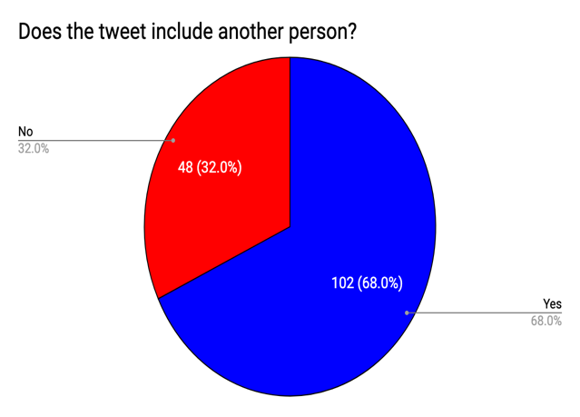 According to the data from the first coding stradegy, 68% of people included someone else within their tweet. The main reason someone would have included someone in their tweets was to either have them engaged in the conversation or to complain about something that they wanted changed or answered. . @LibbyLloyd7 tweeted “@HughFW @BBCOne We don’t need all this plastic packaging #Tescos so I am giving it to you back, please look after our planet #OurPlasticFeedback #WarOnPlastic”. LibbyLloyd7 included user @HughFW whom is very well known in England for the action of elimination of plastic. LibbyLloud7 also includes a large England news source to try to get their attention so they could possibly make company Tesco ban plastic productions

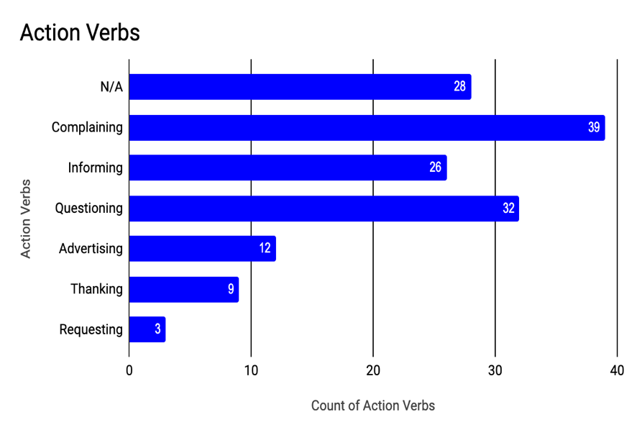 From the second coding system, almost 40 people were complaining somehow within their tweet. Although it is not documented in a graph above within the 150 tweets collected, 100% of the tweets were pro elimination of plastic. It is not suprising that people are pro elimination of plastic. User @sallyoreilly tweets “Oh come on, Tesco! What planet are you living on? #WarOnPlastic #ClimateEmergency”. User Sallyoreilly is showing their frustration, and how unhappy they are with Tesco. The main reason people were complaining was because companies and organizations were not listening to their proposals to eliminate plastic. If the tweet was recored as N/A it ment that there was either no emotion behind the text, or that the tweet was just the hashtag. Majority of the time if someone was asking a question they would include someone else, most people had genuene questions but some asked retorical questions out of anger or frustration. Around 30 plus people were asking questions within their tweet. They could have been asking questions to someone specific or just the twitter community. (Pickin, 2019) “Ok @AmazonUK why, when we are all trying to reduce plastic waste, do you send out deliveries in packaging like this? Most councils don't recycle these so why not use card packaging? @HughFW #OurPlasticFeedback #WarOnPlastic”. Pickin is asking a question to a well-known company and why they find the need to use so much plastic within their packaging.

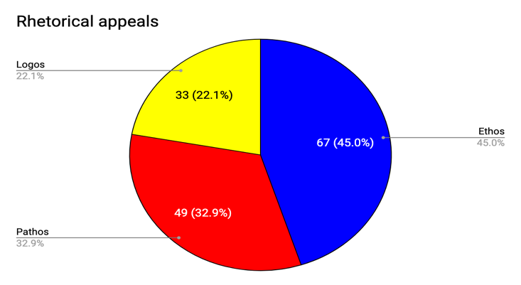 The last and final coding stradgey Showed that 47% of the tweets were using ethos in some form. Most tweets were using ethics within their tweets. @ Mirovekibeerd

tweets “Iran-Kurdistan-Marivan: A taxi driver provides a tap &amp; glass inside the car to prevent thirsty travelers from using mineral water! #TwitterKurds #WarOnPlastic #OurPlasticFeedback”. Mirovekibeerd is showing the ethics behind taxi driver Iran-Kurdistan-Marivan, and how he is substituting the use of plastic bottles with glass.

***Reasearch:***

Plastic is generally supposed to be used so we can limit the use of paper, and it was created so we can repeatedly use it. Ironically the average plastic bag is only used 5 to 12 minutes (Shultz, 2019, p.69). People are using plastic excessively and now with all the plastic pollution going on in the world we’re trying to find substation. Little by little people are trying to make a by limiting their use of plastic, whether it be shopping bags, drinks bottles or toothbrushes to name a few (Spear, 2018, p.173). There are now organizations that go around to help collect plastic waste around the world. Marine life is in danger of going extinct if we continue with this excessive use plastic. According to Brown (2018) “Fitzgerald is happy with the charter’s goal to move to 100 per cent reusable, recyclable and recoverable plastics by 2030 but would have liked to see commitments to plastic reduction.” (p. N/A) Fitzgerald is the director of the Atlantic Canada chapter of the Sierra Club, which is a club specifically made to help reduce the usage of plastic.

***Conclusion:***

Based off all the tweets that I examined most people are upset with the fact that others will not reduce their usage of plastic. People don’t realize how much plastic is affecting the environment. Most tweets that I examined seemed to be frustrated about how companies would not change how they overuse plastic. As time goes on more and more organizations are being created to limit the use of plastic and to clean the environment of plastic waste as best as possible. The world goal is to limit the excessive use of plastic, to save the environment. Marine life is who suffer the most from plastic waste. “It is estimated that up to 13 million metric tons of plastic ends up in the ocean each year—the equivalent of a rubbish or garbage truck load’s worth every minute” (Reddy, 2018). With all of the plastic that enters the ocean, manuals get caught in the plastic which can eventually lead to death, which leads to extinction. My biggest observation from this whole analysis is that people want to eliminate plastic so we can save the environment.

***Citations:***

O’Flaherty, J. (2018). Reducing Plastic Waste. The Veterinary Record, 183(5), 1. <https://doi.org/10.1136/vr.k3318>

Spear, K. (2018). Reducing Plastic Waste. The Veterinary Record, 182(6), 1. <https://doi.org/10.1136/vr.k581>

Brown, S. (2018, June 11). Advocate says G7 charter needs plastic-reduction targets. The Star. <https://doi.org/2053630486>

Waste360. (2019, April 5). ALDI Commits to Reducing Plastic Packaging. <https://doi.org/2053630486>

Schultz, S. (2017). Reducing Plastic Pollution. Alternatives Journal, 43(2), 2. <https://doi.org/1986554293>

Oceans, P. (2019). The Facts Are Overwhelming. <https://doi.org/1986554293>

O’Reilly, S [sallyoreilly]. (2019, June 26). Oh, come on, Tesco! What planet are you living on? #WarOnPlastic #ClimateEmergency [Tweet]. Retrieved from <https://t.co/Kd4wFkyVKc>

Lloyd, L [LibbyLloyd7]. (2019, June 26) @HughFW @BBCOne We don’t need all this plastic packaging #Tescos so I am giving it to you back, please look after our planet #OurPlasticFeedback #WarOnPlastic [Tweet]. Retrieved from <https://t.co/YRm80eoGhb>

Pickin, P [philpickin]. (2019, June 26) Ok @AmazonUK why, when we are all trying to reduce plastic waste, do you send out deliveries in packaging like this? Most councils don't recycle these so why not use card packaging? @HughFW #OurPlasticFeedback #WarOnPlastic <https://t.co/LpHka0FPPy>

Reddy, S. (2018, September 24). Plastic Pollution Affects Sea Life Throughout the Ocean. Retrieved from <https://www.pewtrusts.org/en/research-and-analysis/articles/2018/09/24/plastic-pollution-affects-sea-life-throughout-the-ocean>