Introduction

Since the handover of Hong Kong from Great Britain to China in 1997, the future of the democratic business capital of the eastern hemisphere has been uncertain. The unyielding efforts of the Chinese Communist Party has strained the integrity of Hong Kong’s democratic government. Through censorship of media, influencing Hong Kong legislative members, and now having the ability to extradite people that are deemed to be criminals, China has been able to undermine democracy in Hong Kong, 30 years before the freedoms guaranteed by the handover are up.

On March 29th, 2019, the Fugitive Offenders and Mutual Legal Assistance in Criminal Matters Legislation Bill was published, and allowed mainland China to extradite any criminals that they believed needed to be tried (Al Jazeera). Citizens of Hong Kong believed that this bill was one step too far in undermining the democracy and autonomy of the region and took to the streets to protest the bill. The spread of the protests on social media sites such as Telegram, Twitter and Instagram put Hong Kong in the limelight, and garnered support both domestically and globally. In Hong Kong, protests peaked at two million demonstrators to put pressure on government officials, while Hong Kong police continued shooting rubber bullets and tear gas into the crowd (Al Jazeera). The #HongKongProtests hashtag on Twitter sparked worldwide protests against the encroachment on democratic ideals that both the Hong Kong and China legislation were demonstrating.

Methods

I took a sample of #HongKongProtest tweets from June 18th and June 19th as one of the main protests against the extradition bill happened two days prior. Two million protesters took to the streets in the June 16th protest as Chief Executive Carrie Lam announced that the extradition bill was to be suspended for the time being. Protestors felt as though the bill was just going to be reintroduced later and called for the cancellation of the bill entirely. I chose these dates because I wanted to get some reactions that would reflect on the event as a whole and not individual portions of the event. Unfortunately, this resulted in a lot of news articles that were very general and had little information on the topic. Originally, there were around 10,000 tweets that were collected with many duplicates and retweets. The tweets were collected from June 18th until the 25th which was way too broad of a time period. I narrowed the tweets down to June 18th and 19th, which resulted in about 500 tweets. During the selected time period, I filtered out any tweets that had “RT” which signified that it was a retweet. This narrowed the amount of tweets down and allowed for more accurate data to represent the population that was tweeting. I also manually went through the tweets to delete any duplicates that would skew the data as well. Another filter I used was by language. Because this was an international topic, there were many tweets that were in asian languages. These had to be filtered out because I would not be able to understand them and would ultimately be useless in the report. By the end of this process, I had around 200 tweets to analyze and break down.

Analysis and Discussion

One of the biggest problems regarding this topic is that it deals with social media and China. The Great Firewall of China is the censorship tool that the Chinese Communist Party uses to monitor, block, and track all internet presence within China. Notable sites that are blocked by this firewall are Google, Instagram, Youtube, and Twitter. Because Twitter is blocked within China, there are many perspectives that I could not analyze, such as pro extradition bill and pro communist party. As a result, the vast majority of the tweets are in support of the protestors which can be seen in (Figure 1).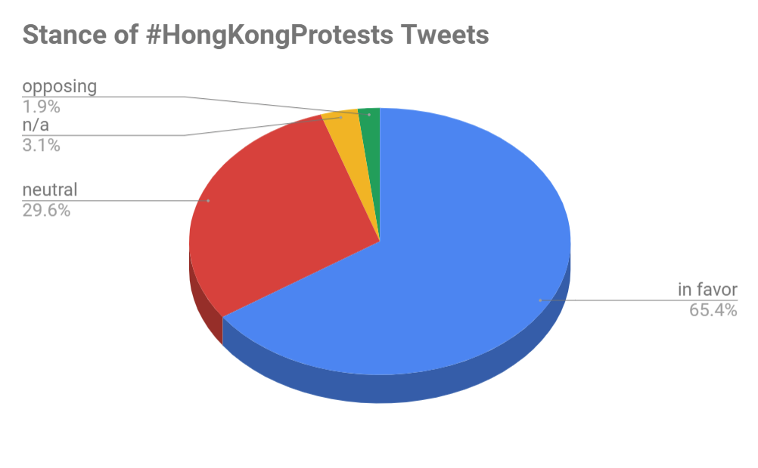Fig. 1

There were also many news outlets which typically take a neutral stance on controversial topics such as this. The few tweets that were opposing were typically international twitter users who sided with the police and authority.

“@SCMPNews #HongKongProtests finally a wise advice! Don't make #police the enemy! Just because you'll regret those guys when the #PLA's #troops will FLOOD ALL THE CITY! (FR) #HongKong ne prenez pas la police comme vos ennemis! Vrai! Quand l'#armée populaire déferlera tu vas bien regretter! https://t.co/8qxx6n1RhB”

As for the content of the tweets, there was a plethora of perspectives that users had when it came to the actual protests. The two actions that the majority of the tweets are taking are supporting the protesters and reporting on the situation in Hong Kong. Because there were many news websites that reported on the protests, their twitter accounts tweeted with the Hong Kong Protests hashtag. The second largest fraction of the tweets are of users supporting the actions of the protestors. Tweets such as sharing advice, praising the bravery of the protestors, or just appreciating photos of the event were being posted across the platform.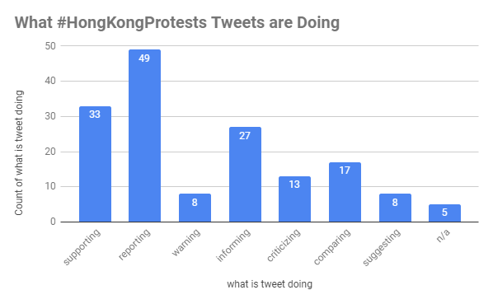

There were four main focuses that the tweets fell under. Tweets regarding Hong Kong legislation, Chinese legislation, international affairs, as well as protestors themselves. The majority of the tweets were focused on the protestors as they were the ones that took action and created the scene that most people reacted to. The other focuses are mostly reacting to the aftermath or results of the protests.

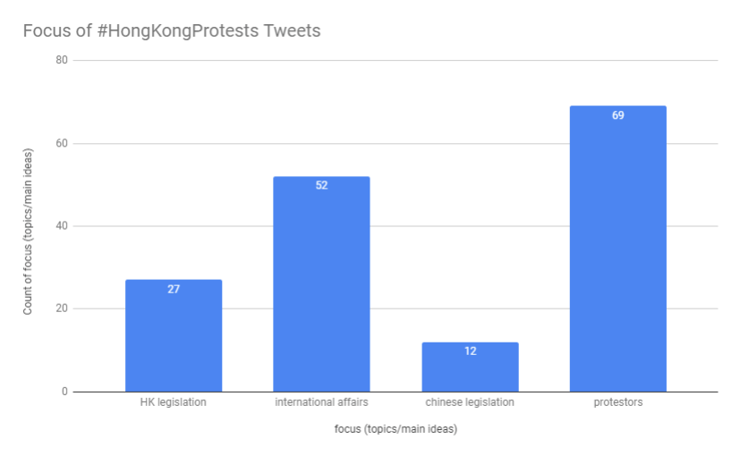

Conclusion

* Mostly positive towards protestors
* Mostly about supporting democracy
* Data could be skewed due to missing opposition (no twitter in china)

**Bibliography**

Ortmann, S. (2015). The umbrella movement and hong kong’s protracted democratization process. Asian Affairs, 46(1), 32–50. https://doi.org/10.1080/03068374.2014.994957

* This journal covers the umbrella movement in Hong Kong in 2014 and the slowing down/halting of the democratization process due to mainland China’s influence. Shows the buildup and process of the protests, starting from the impact that Britain had before and during the handover of Hong Kong. Also talks about the pressure that China imposes on Hong Kong as their attempts at democratization threatens the legitimacy of their communist government. Links to student movements and history of past democratic movements in and around China

Tai, B. (2019). 30 years after tiananmen: hong kong remembers. Journal of Democracy, 30(2), 64–69. https://doi.org/10.1353/jod.2019.0025

* This journal covers the history and overall process of the Tiananmen Square protests and later massacre in 1989. This is essential in the paper because it showcases that democratic protests have been conducted in China in the past and gives perspective on the modern protests. Shows overall process of the CCP stifling and ending the protests, which could set a precedent for the current protests.

Hong Kong protests: All the latest updates. (n.d.). Retrieved June 29, 2019, from https://www.aljazeera.com/news/2019/06/hong-kong-protests-latest-updates-190612074625753.html

* This article outlines every single major protest that has occurred during the 2019 Hong Kong Extradition Bill Protests. Gives insight into what Hong Kong Legislation and protestors are doing as well as reactions from the rest of the world. Connects directly to the tweets and can be used to link events.

The umbrella movement in hong kong. (2016, March 13). Retrieved June 29, 2019, from Diggit Magazine website: https://www.diggitmagazine.com/papers/social-movements-digital-age

* Shows the buildup and process of the Umbrella movement in Hong Kong in 2014 which was very similar to the current protests. China putting pressure on overall freedom and democracy incited the movement. Gives context to the current protests and can be used to compare. Also explains the impact of technology during these protests.

Lai, K. K. R., & Wu, J. (2019, June 28). Protesters in Hong Kong Have Changed Their Playbook. Here’s how. The New York Times. Retrieved from <https://www.nytimes.com/interactive/2019/06/28/world/asia/hong-kong-protests.html>

* Shows how the protestors changed their strategy from the previous Umbrella Movement and how they have become more efficient and smart in their approach to protesting. Also shows the role of technology in the protests and how the CCP is trying to censor this communication. Useful for connecting similar points together. Twitter as an international platform to garner support from around the world.