More Debt More Problems:

The Study of How People Feel About Free College

Jonathan Kim

PID: 730367940

University of North Carolina at Chapel Hill

ENGL 105

July 1, 2019

**Introduction:**

Not everyone is blessed with incredible athletic ability or lucky enough to be born into a rich family. It used to be that only the most fortunate got to go to college. The people who excel in the classroom but do not earn a scholarship, deserve to attend college but what if they cannot afford college. There are tons of people who would love to have the opportunity to go to college but just cannot afford to go. There are also millions of Americans in debt because of student loans. This paper is not to say whether or not everyone should go to college, but more to explain why college should be free for those who do want to go to college. You will find data collected from twitter based off of people’s stances, rhetorical use, and how they used the tweet. This paper will also make connections to other social issues and explain how they are related like how it relates to the upcoming presidential election with Bernie Sanders running for the second time this decade. It will also go into detail about how other places have allowed or tried to give free college and how it worked for them such as Mercer County Community College and how they raised the minimum wage to $15 per hour and how they though that would help lead to free college and what happened to the college after they raised the wage and also talk about Alice Wallace’s story.

**Methods:**

First, we had to find a hashtag on the topic we wanted to research. Once we found #FreeCollege we then had to sort out the tweets that were irrelevant. We sorted out any tweets that were retweeted and tweets that had just “#FreeCollege”. The first method used was analyzing tweets based off of the hashtag #FreeCollege and had three categories such as their stance on the issue, their rhetorical prospective on the issue, and one action verb describing what they are trying to do with their tweet. Then we went to The University of North Carolina at Chapel Hill libraries website and found articles and journals related to free college. There are articles about different schools or places that have done or tried to get free tuition. 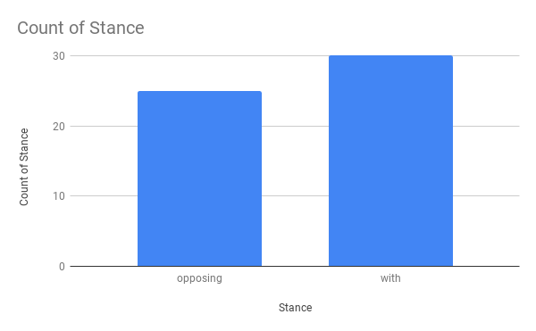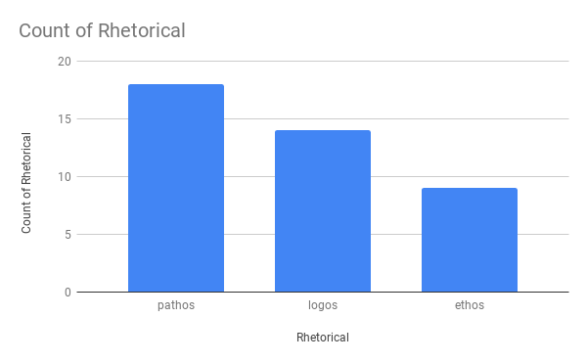

**Data Chart 1:** Stance

**Data Chart 2:** Rhetorical

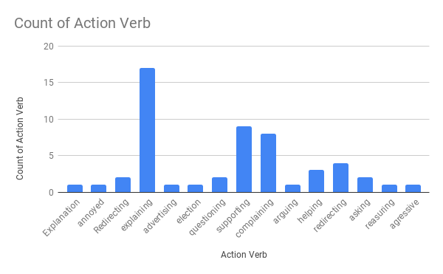

**Data Chart 3:** Action Verb

**Data Analysis:**

When analyzing the tweets based on their stance we came across a pretty well split outcome. About 55% of people were with free college the other 45% were opposed to the idea of free college. The people who usually were with free college were either in college or would be going to college. “Selina, dear, school is only a choice for rich people. For the rest of us, school is a lifetime burden of obscene debt. With #freecollege, school becomes a choice for everyone.” (@Noratoriou5, 2019). This is a tweet is from someone who supports free college and they are explaining to someone named Selina that not everyone can afford college and the people who go and take out loans are in obscene debt. “…We refinanced our home twice to pay 4 our kids college. Perhaps you should get someone other than me pay that $75,000 20 year debt? #FreeCollege.” (@Namashary, 2019). This is an example of someone who is opposed to the idea of free college. They question why they should pay for other people to go to college when they have to pay for their own kids and their house. For the rhetorical part most people used pathos because they felt it would be more relatable to others. The next most popular was logos because they thought that using logic might appeal to more people. The last category was action verb and the most commonly used was explanation by far because they try to give reasoning for other people to believe the same thing as them. These tweets often related to Bernie Sanders or free health care. This upcoming presidential election is a social issue because there are many people who believe trump shouldn’t be in office now and there are others who wouldn’t want anyone else in office. One big debate is about free health care because its accentual for life for people now, without it you cannot afford to go to the doctors or get medicine.

**Research:**

When reading the articles and journals it was mainly about places that tried it. One example is in Ontario, Canada they had removed 1/3 of student debts by increasing minimum wage. When Mercer County Community College tried the same thing, they put a down payment of $50 million and raised minimum wage to $15. They didn’t end up having enough to pay all employees so they had to make cuts and they got a bunch of backlash for it. These are two examples, one where it worked and another where it didn’t work.

**Conclusion:**

Not everyone is blessed with athletic ability or lucky enough to be born into a rich family. This is why college should be free for people who want to go to college but, not for those who don’t want to go. At the same time, they need to find different ways for different places to have free college because not every place is under the same circumstances. We analyzed tweets and researched articles and journals to come up with this conclusion.

**Citations:**

- (2017). Canada : More than One-Third of College and University Students Receiving Free Tuition. Retrieved from https://search.proquest.com/docview/1938102689/citation/C805DCF975014FA8PQ/1?accountid=14244

- Friedman, M. (2017). Even in Bankruptcy, College Debt Stands. Retrieved from <https://search.proquest.com/docview/1902071995/abstract/54C87ECDEF224D98PQ/1?accountid=14244>

- Fossey, R. (1998). Condemning Students to Debt : College Loans and Public Policy. Retrieved from http://web.b.ebscohost.com/ehost/detail/detail?vid=0&sid=c59167f7-a7f9-4e39-a3a9-3b2d86d6519c%40pdc-v-sessmgr05&bdata=JnNpdGU9ZWhvc3QtbGl2ZQ%3d%3d#AN=4968&db=nlebk

- Lybarger, K. (2017). Bargaining for Good Jobs and Debt-Free College. Retrieved from <https://search.proquest.com/docview/1882434924/abstract/F00B678C0F7C4079PQ/1?accountid=14244>

- Journal Binns, C. (2018). Stanford Social Innovation Review; Stanford. Retrieved from <https://search.proquest.com/docview/2007684640/abstract/7573F0DEA30840F5PQ/1?accountid=14244>

**-** Hutter, D. (2018). Murphy details free college proposal. Retrieved from <https://search.proquest.com/docview/2023592661/abstract/C72CC95D7B8D496EPQ/1?accountid=14244>