Wayfair Walkout Twitter Community Debate

Tyler Causey

University of North Carolina at Chapel Hill

**Wayfair Twitter Debate**

**Introduction**

Social media has vastly changed over the years, especially applications such as Twitter. Twitter has evolved from something that was just people sharing their thoughts and ideas with the public to a news platform and communication system that any person in the world can access as long as they have internet access. According to the Washington Post, Twitter has 126 million daily users, which is growing everyday. This shows the variety of people that comment on trending topics each and every day. Many of these topics are organized by keywords, what are commonly called hashtags.

One of those trending topics right now is the Wayfair Walkout. On June 26th of 2019 at 1:30pm Wayfair workers decided to walk out onto Boston’s Copley Square in protest of their employers contract to provide furniture for a detention center in for migrant youth in Carillo Springs, Texas. As reported by the Portland Press Herald over 500 employees had signed the protest letter. Once this information made its way onto Twitter, emotions went flying between users, as mentioned in tweets with hashtags like “#liberalismisamentaldisorder.” To better understand this phenomenon this report examines tweets with the #Wayfair, revealing a range of arguments that shed light on issues of immigration in the US.

**Methods**

By using a Twitter Archiving Google Spreadsheet otherwise known as TAGS, I captured 4,654 unique tweets with the hashtag #Wayfair within the 7 days prior to June 26th, 2019. After I acquired the unique tweets I filtered the retweets out which cut the number to just under 2,000 original tweets. The retweets eliminated most all tweets, other than the original tweets which was really what I wanted. I also decided to filter the tweets to only the English language which only dropped the number to 1,400. Then I took the most recent 200 tweets which ended up being within 24 hours of my search of #Wayfair. Of those 200 tweets I eliminated tweets that were a single word or use only the hashtag #Wayfair which narrowed the corpus down to 110 tweets, which were used for coding.

There were four different categories that I used to code the 110 tweets: political affiliation, their stance, their reasoning, and their rhetorical appeal. A left leaning political affiliation means more of the democratic/liberal side for example, “@Wayfair I will be shopping at @Wayfair ! Thank you!!! 🇺🇸🇺🇸🇺🇸♥️♥️👍🏿👍🏿👍🏿 #Wayfair #wayfairboycott https://t.co/yNkF6nIai7.” (Wed Jun 26 13:25:24). A right leaning political affiliation would more on the Republican side for example, “This is the dumbest thing I have ever heard of. #wayfair should take a page from #ronaldreagan playbook and fire and replace them. https://t.co/k8LJeWO1pA.” (Wed Jun 26 12:22:10). The tweeters’ stance means whether they support or are against the Wayfair walkout. Their reasoning just shows why the tweeters are in favor or against the walkout and lastly the tweeters’ rhetorical appeal is labeled pathos, ethos, and logos.

Pathos means the tweeter is showing more emotion/feelings than anything, for example, “I just learned that employees of #Wayfair will stage a walkout to protest selling beds and furniture to a TX detention center for #MigrantChildren. What kind of sorry pieces of S*** don't want children TO HAVE BEDS?!! I mean, WTF?!!” (JayJennings57, Wed Jun 26 13:14:37). This tweet is really trying to spark some emotion in the reader by using all caps and talking about children not having beds. The tweeter’ knows that the workers aren’t walking out to keep beds away from kids, they just want to make the walkout look like it isn’t sensible whatsoever.

Ethos is ethics as well as credibility, for instance, “@itkahs_Emih @JoeBiden Great point. How much has the house appropriated to help solve the problem and improve conditions?” Why are #wayfair radical left employees walking out instead of sending beds?” (AaronBehunin, Wed Jun 26 12:50:15). This tweet is accusing the employees of not being ethical in the sense that workers are walking out instead of sending beds to these kids. The workers could be working to provide these kids a bed instead of protesting which is taking time away from actually helping provide necessities for the kids.

Lastly logos was used to code tweets that emphasize reasoning such as, “@CSOSR60 Funny, I am a student of history and I do not recall any nation operating 'concentration camps' furnishing their dorms from #Wayfair.” (WorryBig, Wed Jun 26 13:43:18). This tweet attempts to appeal to logic because obviously the internment camps are not nearly as bad as concentration camps due to the fact that concentration camps wouldn’t be furnished and more.

**Results**

The codes used to analyze the #Wayfair tweets revealed many interesting findings. First, as seen in Figure 1 and Figure 2, the charts reveal a good deal of overlap in the analysis. For the most part those with a left political affiliation were in favor of the Wayfair walkout. The difference between these two codes was less than 2 percent. Those that tweeted and did not have a visible political affiliation did not really have a stance on the Wayfair walkout that was clear enough to identify. The tweeters that had a clear right political affiliation opposed the Wayfair walkout and were very emotional with their responses. 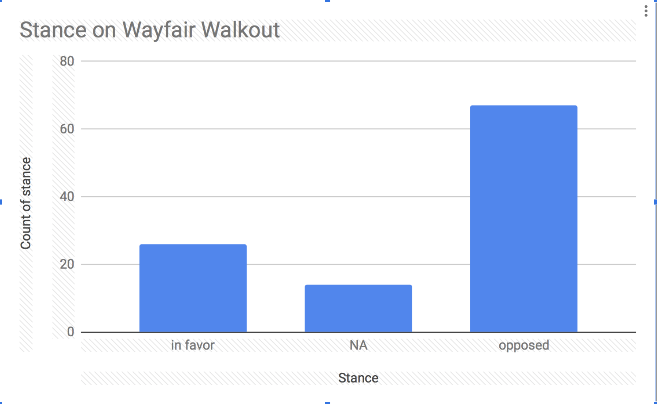

Figure 1 Figure 2

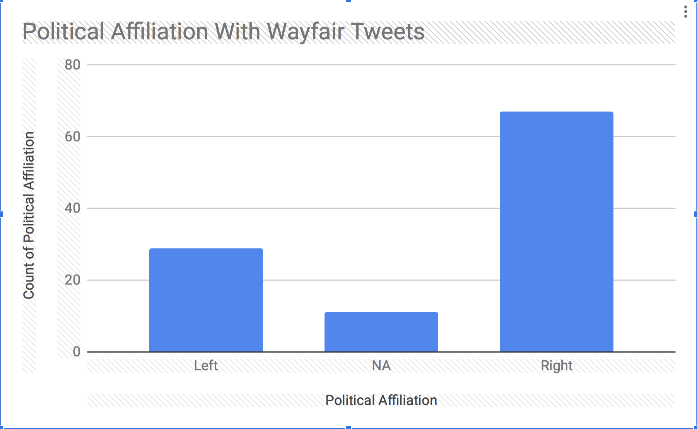

In fact just under 70 percent of all of the tweets were coded under pathos which was the overwhelming majority. Another 24 percent of the tweets were coded under NA which means that the tweets were mostly informational and were not clear enough to be labeled under pathos, ethos, or logos. The last 8 percent were divided under ethos and logos with 5 percent going to ethos and 3 percent going to logos. Figure 3

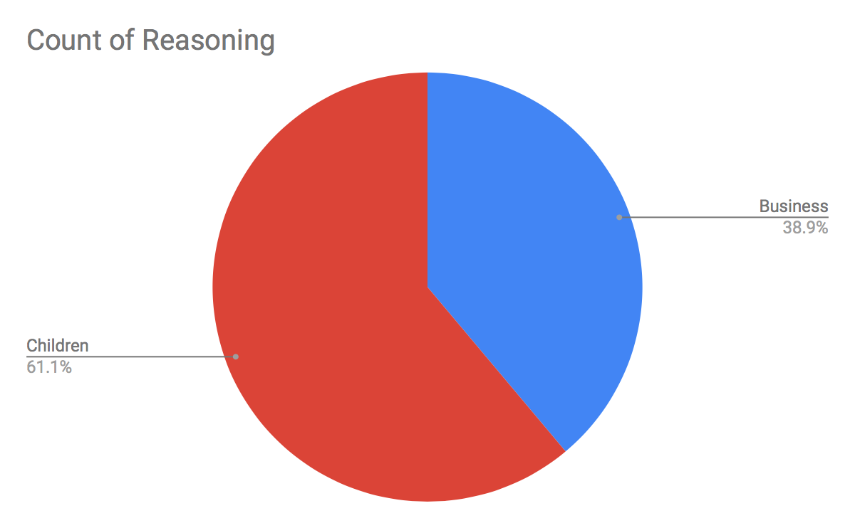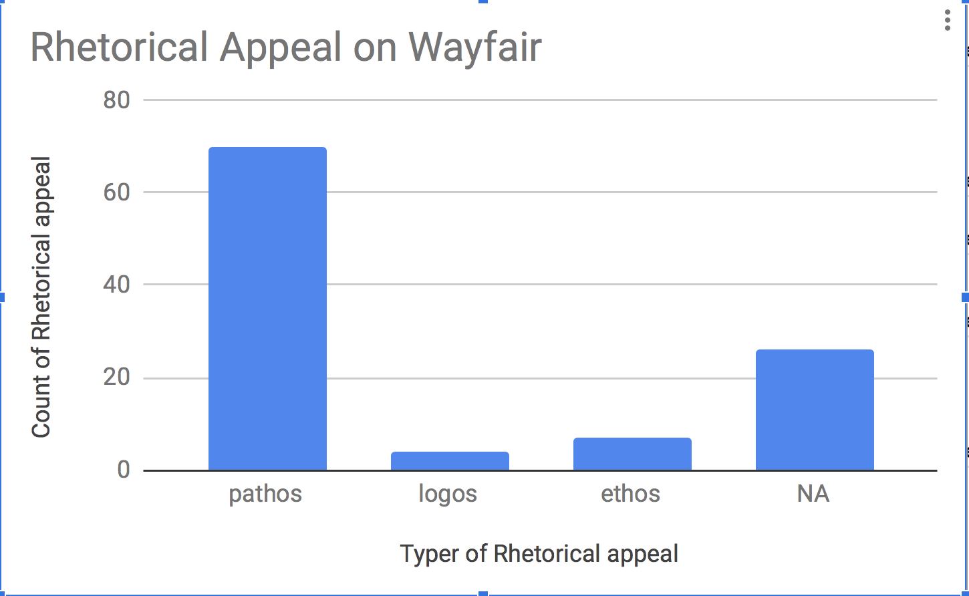

Figure 4

One other interesting point of view was the reasoning behind why people were either opposed or in favor of the walkout. This graph shows that more people were worried about the care the kids were getting and them not having beds, however 38.9% of people who actually said why they were opposed or in favor the walkout were more concerned about the company and the money/business aspect of the walkout. The children could definitely be taking care of better with 6 children dying since September according to USA Today.

**Conclusion**

The community of Twitter users became very heated over the debate about the Wayfair walkout. The overwhelming majority of users that commented on the subject were leaning towards the republican side and were opposed to the walkout, mostly because they thought that walking out and not providing beds for the kids was morally wrong. So many people opposed the walkout Wayfairs’ stocked dropped 5% the day before the walkout as stated in CNN News. Most of the tweets showed a good deal of emotion supporting or opposing the walkout. The high levels of emotions identified in the tweets suggest that Twitter conversations frequently deploy emotions.

Bibliography

Ortiz, J. L. (2019, Jun 26). Wayfair walkout: Employees stage protest over company selling goods to detention camps. USA Today (Online) Retrieved from <http://libproxy.lib.unc.edu/login?url=https://search.proquest.com/docview/2246574100?accountid=14244>

Anderson, J. C. (2019, Jun 26). Wayfair staff to join protest of sales to detention centers brunswick workers' walkout decries wayfair's sale of $200,000 in furniture to an agency overseeing sites that house migrant children on the U.S.-mexico border. *Portland Press Herald* Retrieved from http://libproxy.lib.unc.edu/login?url=https://search.proquest.com/docview/2246624842?accountid=14244

Trafecante, K., & Meyersohn, N. (2019, Jun 25). Wayfair workers plan walkout in protest of company's bed sales to migrant camps. *CNN Wire Service* Retrieved from http://libproxy.lib.unc.edu/login?url=https://search.proquest.com/docview/2246423632?accountid=14244

Alamillo, Rudy, et al. “Framing and Immigration through the Trump Era.” *Sociology Compass*, vol. 13, no. 5, 2019, p. e12676. *Wiley Online Library*, doi:10.1111/soc4.12676.

Shaban, Hamza. “Twitter Reveals Its Daily Active User Numbers for the First Time.” Washington Post, 7 Feb. 2019. www.washingtonpost.com, <https://www.washingtonpost.com/technology/2019/02/07/twitter-reveals-its-daily-active-user-numbers-first-time/>.