Breaking Point of a Former Colony:

The Suppression of Democracy in Hong Kong

Nathan Chen

ENGL 105

Anderson, SSII

Introduction

Since the handover of Hong Kong from Great Britain to China in 1997, the future of the democratic business capital of the eastern hemisphere has been uncertain. The unyielding efforts of the Chinese Communist Party have strained the integrity of Hong Kong’s democratic government. Through censorship of media, influencing Hong Kong legislative members, and now having the ability to extradite people who are deemed to be criminals, China has been able to undermine democracy in Hong Kong, 30 years before the freedoms guaranteed by the handover are up.

On March 29th, 2019, the Fugitive Offenders and Mutual Legal Assistance in Criminal Matters Legislation Bill was published. It allowed mainland China to extradite any criminals that they believed needed to be tried (Al Jazeera, 2019). Citizens of Hong Kong believed that this bill was one step too far in undermining the democracy and autonomy of the region and took to the streets to protest the bill. The spread of the protests on social media sites such as Telegram, Twitter and Instagram put Hong Kong in the limelight, and garnered support both domestically and globally. Twitter, the main social media site I am examining, is an online platform in which users from across the globe post their opinions and reactions to events. In Hong Kong, protests peaked at two million demonstrators to put pressure on government officials, while Hong Kong police continued shooting rubber bullets and tear gas into the crowd (Al Jazeera, 2019). The #HongKongProtests hashtag on Twitter sparked worldwide protests against the encroachment on democratic ideals that both the Hong Kong and China legislation were demonstrating.

Methods

I took a sample of #HongKongProtest tweets from June 18th and June 19th, as one of the main protests against the extradition bill happened two days prior. Two million protesters took to the streets in the June 16th protest as Chief Executive Carrie Lam announced that the extradition bill was to be suspended for the time being (Lai & Wu, 2019). Protestors felt as though the bill was just going to be reintroduced later and called for the cancellation of the bill entirely. I chose these dates because I wanted to get some reactions that would reflect the event as a whole and not individual portions of the event. Unfortunately, this resulted in tweets with links to news articles that were very general and had little information on the topic. Originally, there were around 10,000 tweets that were collected, with many duplicates and retweets. The tweets were collected from June 18th until the 25th which was way too broad of a time period. I narrowed the tweets down to June 18th and 19th, which resulted in about 500 tweets. During the selected time period, I filtered out any tweets that had “RT,” which signified that it was a retweet. This narrowed the amount of tweets down and allowed for more accurate data to represent the population that was tweeting. I also manually went through the tweets to delete any duplicates that would skew the data. Another filter I used was by language. Because this was an international topic, there were many tweets that were in asian languages. These had to be filtered out because I would not be able to understand them and would ultimately be useless in the report. The analysis, then, is somewhat limited in that its prevents an English-speaking perspective on the protests, a phenomenon that is exacerbated by chinese censorship. By the end of this process, I had around 200 tweets to analyze.

Analysis and Discussion

One of the biggest problems regarding this topic is that it deals with social media and China. The Great Firewall of China is the censorship tool that the Chinese Communist Party uses to monitor, block, and track all internet presence within China. Notable sites that are blocked by this firewall are Google, Instagram, Youtube, and Twitter. Because Twitter is blocked within China, there are many perspectives that I could not analyze, such as pro extradition bill and pro communist party. As a result, the vast majority of the tweets are in support of the protestors which can be seen in (Figure 1).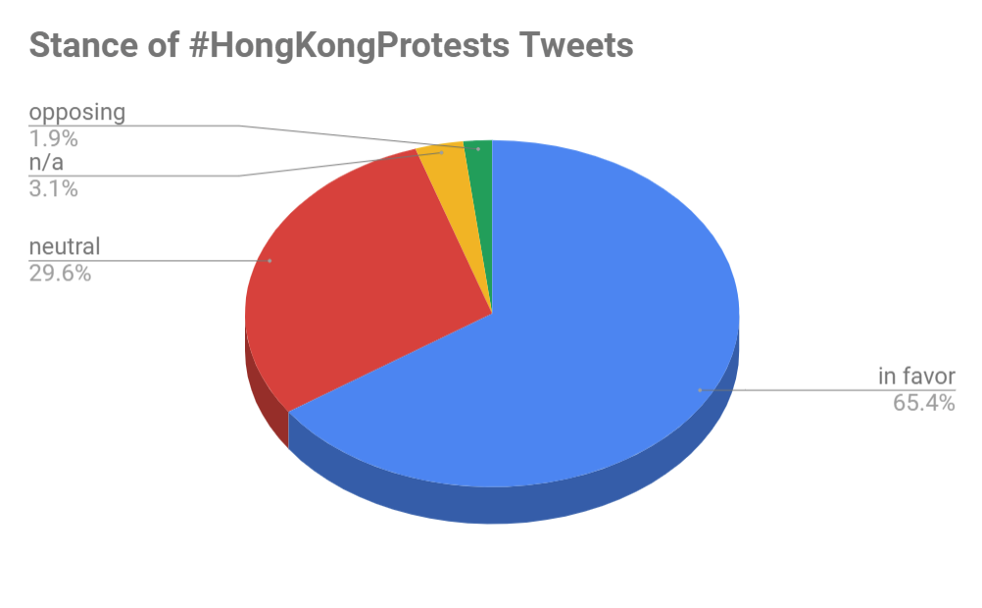Fig. 1

There were also many news outlets which typically take a neutral stance on controversial topics such as this. The few tweets that were opposing the protests were typically international twitter users who sided with the police and authority.

“@SCMPNews #HongKongProtests finally a wise advice! Don't make #police the enemy! Just because you'll regret those guys when the #PLA's #troops will FLOOD ALL THE CITY! (FR) #HongKong ne prenez pas la police comme vos ennemis! Vrai! Quand l'#armée populaire déferlera tu vas bien regretter! https://t.co/8qxx6n1RhB”

As for the content of the tweets, coding for action verbs revealed a number of perspectives. The two actions present in the majority of the tweets are supporting the protesters and reporting on the situation in Hong Kong. Because there were many news websites that reported on the protests, their twitter accounts tweeted with the Hong Kong Protests hashtag. News accounts and articles were coded under “reporting.” The second largest fraction of the tweets are of users supporting the actions of the protestors. Tweets such as sharing advice, praising the bravery of the protestors, or just appreciating photos of the event were being posted across the platform. Tweets such as these were categorized as “supporting” the protestors and their cause. The next category is coded under “warning.” These tweets are from users that are warning protestors to be safe, or to be wary of the police/opposition forces that could harm them. An example of a warning tweet is the one listed above, talking about the dangers of facing police. Next, the “informing” category is very similar to that of the reporting category. However, these tweets come from non-news accounts and are essentially sharing information about the protests to their followers. The “comparing” term was coded to tweets that compared the situation in Hong Kong to other protests or situations across the world. Lastly, the not applicable category is used for any tweets that were incoherent or irrelevant to the Hong Kong protest conversation.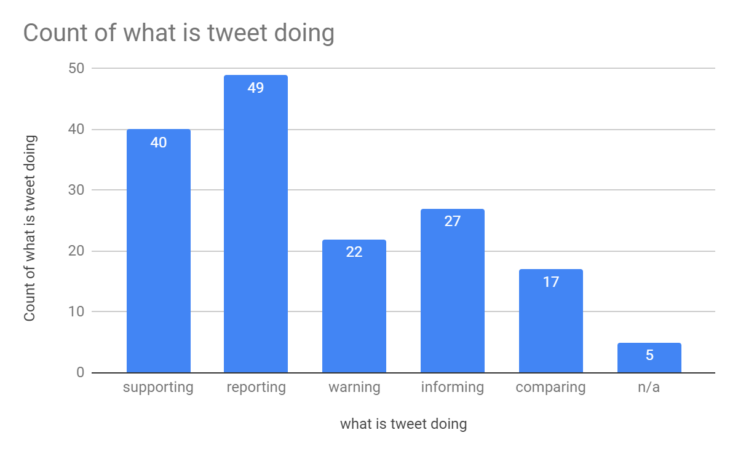

There were four main focuses that the tweets fell under. Tweets regarding Hong Kong legislation, Chinese legislation, international affairs, as well as protestors themselves. The majority of the tweets were focused on the protestors as they were the ones that took action and created the scene that most people reacted to. Posts that were focused on the protestors included both negative and positive perspectives, but were ultimately leaning heavily towards the latter. Conversely, due to the highly western population of Twitter, the focus of Hong Kong and Chinese legislation were overwhelmingly negative. However, these focuses give insight to what people think about the government figures and their reactions. The last focus was on international affairs. These tweets mainly focused on the effects of the protests on other countries. Many of these tweets were calls to action in different countries to protest in solidarity with the Hong Kong protestors.

Thank you, Southern California! 🇺🇸🇭🇰💪Please take good care while/after striking! #NoExtraditionToChina #HongKongProtests Carrie Lam is callous, intransigent, and now ineffective. She is #NotMyMother, not our leader. She should just get lost. <https://t.co/NvoVfFyijU>

This example shows that people in Southern California went to protest the violation of democracy in Hong Kong and how people in Hong Kong reacted.

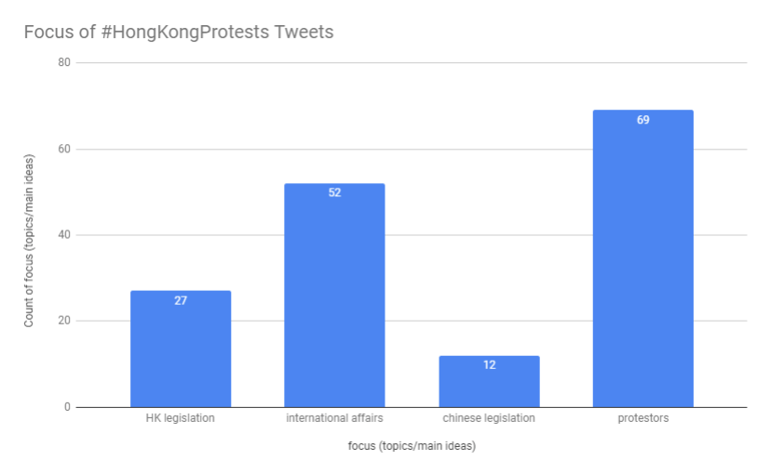

Conclusion

Overall, the majority of the tweets that used the HongKongProtests hashtag were overwhelmingly in support of the protestors. Pictures, encouraging messages, prayers, and well wishes poured in over the duration of the protests, showed that the world will continue to stand behind Hong Kong in their fight for free speech and democracy. However, this data is unsurprising as the majority of the opposition reside in China where Twitter is blocked. Even with this heavily skewed data, we can see that there is a wide range in what people are discussing within a certain topic. Each tweet sparks a different conversation, allowing all opinions to be heard equally. The #HongKongProtests movement showed that democratic ideals are essential to the future of the former British colony. Much like the protests in 2014, the extradition bill protests will set a precedent for the future generations that will fight for democratic freedom in Hong Kong.

**Bibliography**

Ortmann, S. (2015). The umbrella movement and hong kong’s protracted democratization process. Asian Affairs, 46(1), 32–50. https://doi.org/10.1080/03068374.2014.994957

Tai, B. (2019). 30 years after tiananmen: hong kong remembers. Journal of Democracy, 30(2), 64–69. https://doi.org/10.1353/jod.2019.0025

Hong Kong protests: All the latest updates. (n.d.). Retrieved June 29, 2019, from https://www.aljazeera.com/news/2019/06/hong-kong-protests-latest-updates-190612074625753.html

The umbrella movement in hong kong. (2016, March 13). Retrieved June 29, 2019, from Diggit Magazine website: https://www.diggitmagazine.com/papers/social-movements-digital-age

Lai, K. K. R., & Wu, J. (2019, June 28). Protesters in hong kong have changed their playbook. Here’s how. The New York Times. Retrieved from https://www.nytimes.com/interactive/2019/06/28/world/asia/hong-kong-protests.html