Analyzing the Communication Between Individuals on Twitter Over the Topic of

Planned Parenthood

Olivia Diaz

University of North Carolina – Chapel Hill

**Introduction:**

Throughout the years twitter has been a form of communication where everyone is able to express their thoughts and opinions in an open environment. In the past it was mainly used for people to tweet about their daily life such as their interactions and what they are doing, but in the past couple of years it has been one of the main social media networks where people discuss politics and issues going on in the world today. The purpose of this research was to delve into how twitter interacts with social issues that are of major concern and answer questions such as how people are expressing their opinions on it. As seen throughout the research conducted, the use of hashtags allows for a broad subject to be reduced into a more specific topic of study which makes it easier to determine similarities in people’s arguments. For example, the research that was conducted in this study was to examine women’s rights and the diminishing support for women’s health centers, so the hashtag ‘planned parenthood’ was utilized in order to dive into the specific part of women’s rights that is being reduced by the government. By using a coding and data analysis spreadsheet, the tweets were filtered to display tweets that contain #plannedparenthood which then in turn allowed for the research to examine what people have to say about women’s rights.

**Methods:**

In order to simplify the number of tweets to observe, the Twitter Archiving Google Spreadsheet (TAGS) was used in order to sift through thousands of tweets. When first searching for #plannedparenthood, there were about 6,400 tweets which contained this hashtag. After these tweets were compiled into one place, they were then analyzed and coded in a spreadsheet which arranged the tweets and wrote out information about each tweet such as when it was tweeted, where it was tweeted from, what language it was tweeted in, etc. From here, the length of the lists of tweets was reduced to 100 in order to have a smaller sample to go more in depth about what substance the tweets contained. Next, the tweets were filtered to get rid of repetitive tweets which contain the word ‘RT’ at the front of the tweet. Once the retweets were deleted, the risk of duplicates was eliminated which made the results of the research more accurate.

After the list of tweets was reduced, the tweets were analyzed more in depth and organized into different categories. The categories helped to examine similarities between tweets and these following categories are what simplified it:

1. 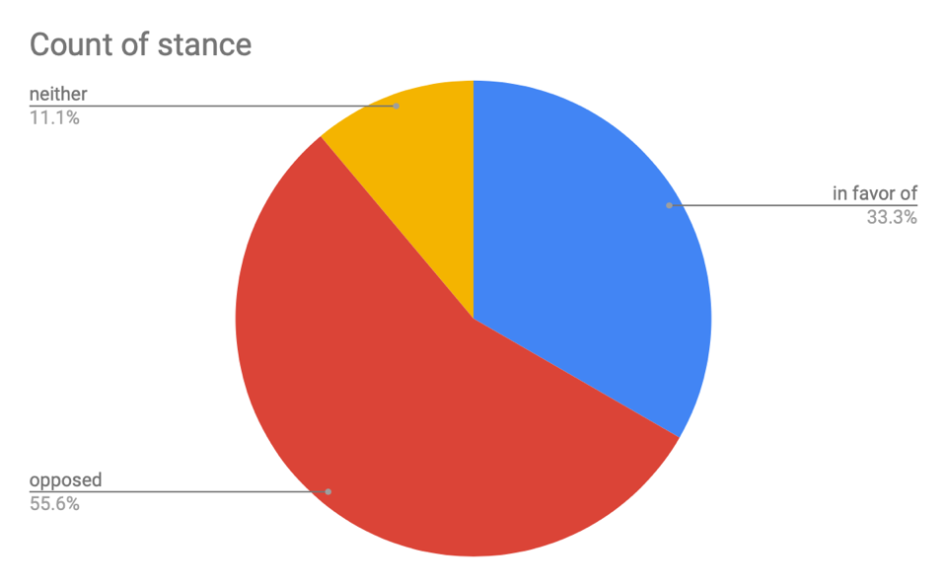The stance was one of the main categories which helped to show similarities between the tweets. These tweets were organized in stance by opposed, in favor of, or neither in terms of planned parenthood. As seen in the pie chart below, the majority of these 100 tweeters were opposed to the idea of planned parenthood at 55.6% while 33.3% were in favor of planned parenthood. The remaining 11.1% were tweets that were neutral and just contained information that talked on both sides.
2. Another category was determining what the tweet was doing. The tweets were sorted into five actions which were informing, criticizing, demanding, promoting, and thanking. The informing tweets were people who were stating facts about the topic, the demanding ones were looking for a change, the promoting ones were raising awareness and money, and the thanking ones were saying thank you to planned parenthood for what they had done 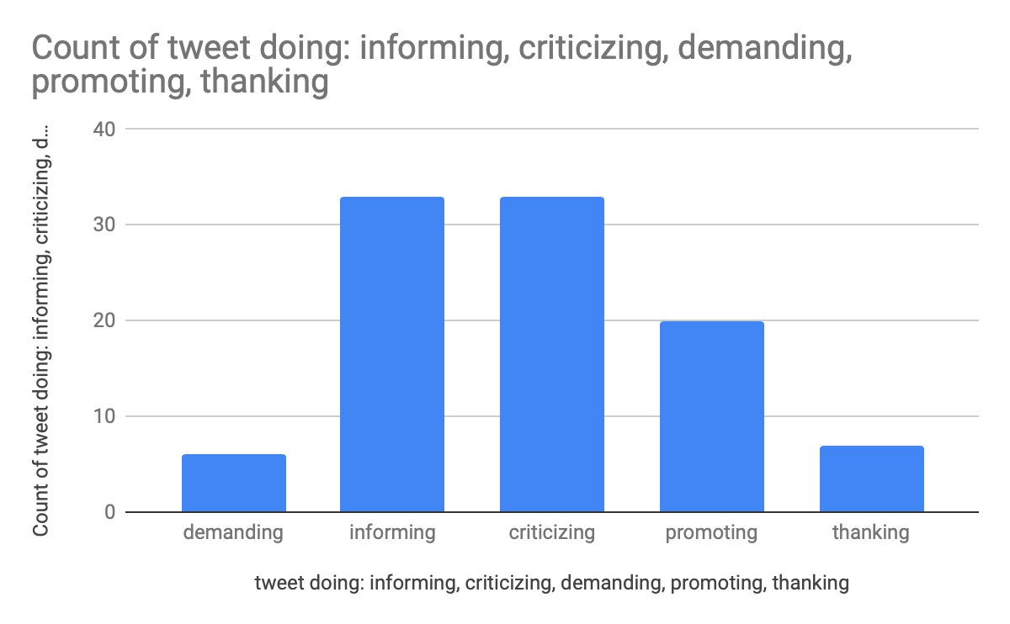for them. The chart below examines that most of the tweets that were analyzed were either criticizing planned parenthood or informing other people about what was going on.
3. 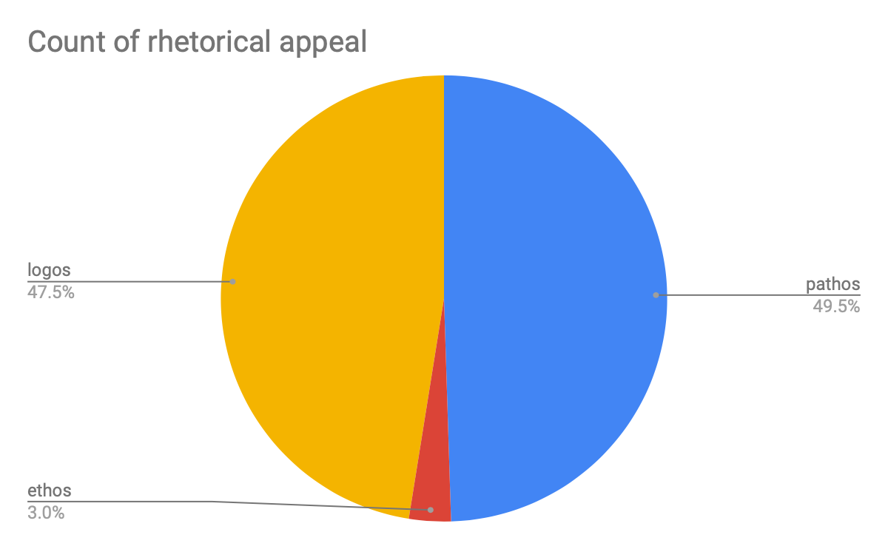Next the rhetorical appeal was applied to each of these tweets to analyze if they were appealing to the audience using ethos, pathos, or logos. As shown in the pie chart below the tweets were basically split in half with logos and pathos while only a small 3% used ethos in order to convey their message.
4. The next category the tweets were searched for was whether they were subjective or objective. The subjective tweets were people who were conveying their own opinions and messages while the objective ones were stating facts and tweeting articles in order to get information out into the world.
5. The last area the tweets were put into was the focus, or the main topic, of the tweet. The majority of these tweets were pro-life and were talking about defunding planned parenthood altogether, while the other tweets were those that are pro-life and wanted to spread awareness as to why planned parenthood needs to stay in operation for women’s sake.

**Discussion:**

According to an article published in the New England Journal of Medicine by Sara Rosenbaum, when discussing planned parenthood and its defunding, it is important to take into consideration the legal question of authorizing such an unlawful thing to occur (2017). To back this article, the research from the tweets only a small portion of the 100 were people who believed that planned parenthood should stay in function as it is important to women’s health and their rights. This being said, those who were taking the side of planned parenthood were most likely looking and the ethical and legal implications the defunding of planned parenthood had on society. Another article that backs planned parenthood and what it provides is published by Hal Lawrence in Annals of Internal Medicine. This article states that the defunding of planned parenthood would mean that up to 650,000 women would have to deal with less healthcare in the short span of one year (2017). It is detrimental for users who are on twitter to analyze both arguments from those who are pro-choice and pro-life as a simple thing such as defunding planned parenthood would lead to hundreds of thousands of women and men without affordable and preventative health care. Also published by the New England Journal of Medicine, George Topulos describes that those who are going on the side of defunding planned parenthood are using misinformation in order to back their arguments (2015). One of the toughest things about listening to what others post online is that most times what they are saying is not accurate which leads to others joining in and making miscalculated judgements. Based on the analysis and tweets a large part of the tweeters who were opposed to planned parenthood were basing off facts that could not be entirely accurate. That being said it is difficult to determine what is real information and what is not when thousands of people are basing off of what a couple of people have to say.

**Conclusion:**

All in all, it is simple to deduce that twitter has taken a vital role in the political area and the way people express themselves about social issues. Planned parenthood is a very controversial topic and it is detrimental that everyone knows the facts about what is occurring before they speak their minds. For this reason, it is important that there are tweets out there by people who are posting articles and websites where others can learn more about the issue. After the conclusion of the research, the majority of the 100 tweets that were analyzed were people who were criticizing planned parenthood and believed that it was a good idea for it to be defunded and out of service. Twitter is an effective and useful source in order to learn more about social issues in the world and to discuss them by stating facts, or plainly stating someone’s opinion.

**Sources Cited:**

Rosenbaum, S. (2017). Medicaid coverage for family planning — can the courts stop the states from excluding planned parenthood?*The New England Journal of Medicine, 377*(23), 2205-2207. doi:10.1056/NEJMp1711490

Lawrence, H. C., & Ness, D. L. (2017). Planned parenthood provides essential services that improve women's health.*Annals of Internal Medicine, 166*(6), 443-444. doi:10.7326/M17-0217

Topulos, G. P., Greene, M. F., & Drazen, J. M. (2015). Planned parenthood at risk.*The New England Journal of Medicine, 373*(10), 963-963. doi:10.1056/NEJMe1510281