A Study of the NCAA and Paying Student Athletes

Ben Kiernan

PID: 730352628

University of North Carolina Chapel Hill

English 105

June 30, 2019

**Introduction:**

There is an ongoing discussion of whether or not athletes in the NCAA should be compensated for their athletic labor. For years, student-athletes have been fined for selling merchandise or charging for autographs. Some have even been taken off scholarship because they had another job. Yet, the NCAA decides that student-athletes are already “paid”.

For example, in 2017 former UCF kicker and now YouTube star Donald De La Haye was kicked off of the football team, all because he was receiving money from his YouTube channel. Donald was not boasting his NCAA likeness on his YouTube channel. He simply showed us what the life of a college athlete was like and he vlogged what interested him. Donald wasn’t even going to use the money he received for himself. He sent it home to his struggling family. In the end the NCAA gave Donald a choice to either delete his YouTube or lose his scholarship. De La Haye thought long and hard on this process but eventually decided to choose his YouTube channel because it is something he loved doing. UCF then stripped him of his full-ride-scholarship and shortly after he had to drop out of college because he could not afford the costs. Donald stated in an interview, “It was surprising. I feel like I'm owned by the NCAA. They can use my name and my likeness to make money off of me, but I can't. I'm not out here selling autographs. I'm not boasting that I'm a UCF player. Any other YouTuber with the same amount of subscribers would make the same amount of money as me. It's a senseless rule, in my opinion, especially in the age of social media. If anything, I feel like I should be rewarded for what I'm doing, not punished," he added. "I don't want to toot my own horn, but I feel like I have a talent. I try to inspire people and to bring smiles to their faces.” (2017).

Athletes all over the world feel owned by the NCAA and are restricted on what they can and can’t do. Donald makes a point that athletes should be able to make money off of their own creativity and idea. Instead the NCAA makes millions off of the athlete’s likeliness. I will be discussing and analyzing tweets on twitter from users using the hashtag #NCAA. (Iliana Limón Romero, & M. Murschel, 2017). The tweets I have gathered for this study shed light on how professional athletes and people all over the world feel about this topic. It shows how the NCAA should be paying athletes and it gives reasons as to why they should not.

**Methods:**

To find data I used a Twitter Archiving Google Spreadsheet (TAGS). This helped me gather tweets about my topic, After I organized them into 3 different categories. I gathered 2965 tweets and filed them into a sample size of 150. In the beginning, I used a filter to remove all tweets that weren’t in English and the ones that were retweets. I then used three categories to describe my tweets. I used stance to determine whether tweets agreed or disagreed with the propositions that the NCAA should pay student athletes. My next category was an action verb. I used words such as explanation, argument, an idea etc. This was so I could understand the tweet as a whole. My third and final category was the rhetorical speech. I used Ethos, Pathos and Logos to describe if the tweet was based around logic, credibility, or emotion. After categorizing all these tweets, I created three graphs to show a representation of all the information I gathered.

This is the information I gathered which explains who was on what side of my topic.

1. In Between, 5.7% – To be a part of this section the tweet had to have positive and negative sides to the debate.
2. With, 60.3% - The tweet would need to have stated that they agreed with my topic, they also needed to have no disagreement in their tweet.
3. Against, Opposed, 34% - The user’s tweet would give a reason as to why the were against my topic.

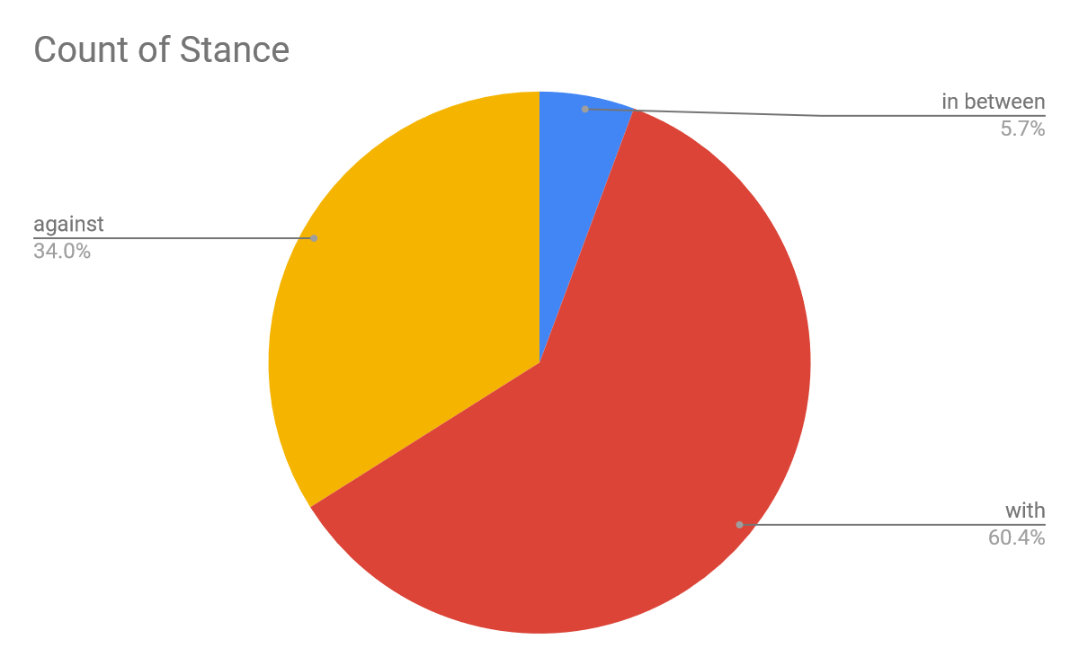

1. Statement (23%) – The tweet had to have an explanation of a bill that people wanted to be passed.
2. Question (28%) – The tweet needed to be in the form of a question towards the NCAA or the general public.
3. Aggressive (36%) – This is a tweet that was probably typed by someone who wasn’t in control of their emotions.
4. Funny (15%) – This is a tweet that was directed towards athletes or the NCAA and is was phrased as a joke.

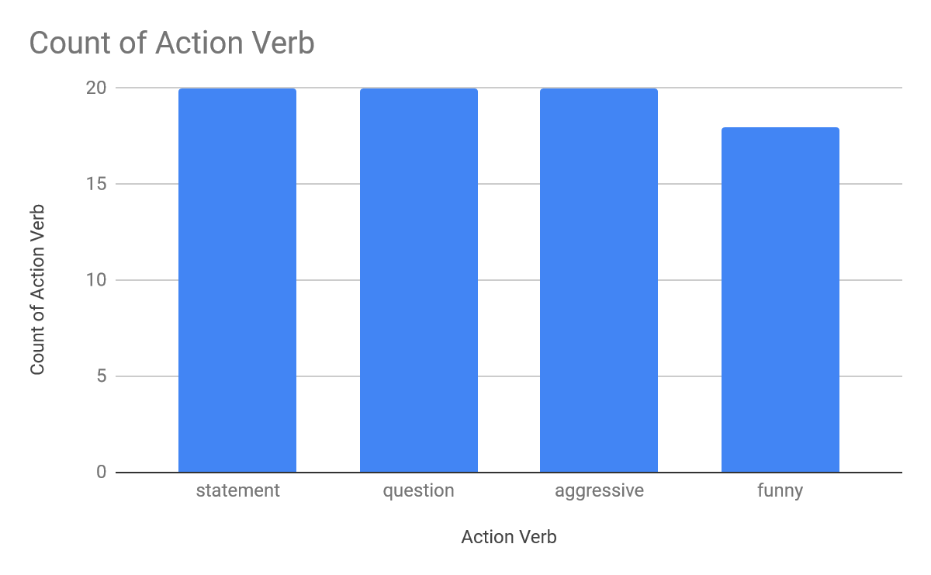

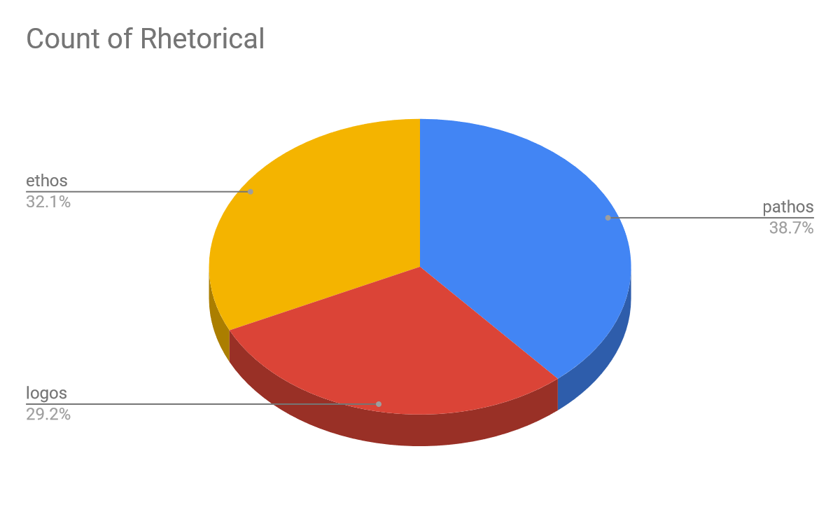

1. Ethos (32.1%) – If the tweet contained beliefs, disbeliefs, ideas and opinions etc.
2. Pathos (38.7%) – If the tweet had any emotion behind it such as anger, happiness or sad.
3. Logos (29.2) – If the tweet was logical and presented facts.

**Data Analysis –**

I have gathered a sample of tweets that will discuss the pros and cons of paying student athletes. These tweets come from athletes, analysts and everyday people. My first example is from former BigTen Athlete Nigel Hayes, “The @bigten made nearly $450 million. My scholarship is about $160,000. If only there was enough money to pay us..@NCAA” (@NIGEL_HAYES). This tweet is “pro paying athletes” because he is sarcastically stating that the NCAA doesn’t have enough money to pay athletes. He provides a fact about how much money his athletic conference made in one year and then how much his scholarship is worth. San Francisco 49’ners quarterback Jimmy Garoppolo tweeted “Just do the right thing and pay the college athletes. We’re the only employees in the nation not being paid” (@JimmyG_). Garoppolo makes a great point that the students are in fact unpaid employees. Athletes that practice and workout for 40+ hours a week should be paid because practice is considered hard labor. “#NCAA threatens to ban California colleges from championships.” (@AM570LASports). This tweet is about the recent bill that could make athletes in CA paid for their likeness. The NCAA immediately after hearing this tweet told the state that if they passed the bill, no college team would be able to qualify for any NCAA championship.

**Discussion –**

The majority of the tweets that I found using the hashtag #NCAA agreed with paying student athletes. The people who agreed made up approximately 60.3% of the population. In between was the minority with 5.7% of the overall population. A big majority of the tweets were about the well being of student athletes and the struggle of balancing all their responsibilities. Some of the more recent tweets were about a bill that is in the process of being passed in California. If this bill gets passed, then high school and college athletes would be able to make a profit from their likeliness. The NCAA immediately came back after hearing about this bill and said that if California decides to pass this bill then all schools and colleges would be prevented from entering any National Championships.

This bill addresses athletes like Zion Williamson. When he was in high school, Zion was a national sensation on social media. Zion made $0 from any merchandise with his name or number on it. Instead he was forced into hoping that in a years’ time he would be signing a multi-million-dollar contract. Thankfully this worked out for him, but what would’ve happened if Zion was a bust and only lasted one year. Basketball athletes every year do what is now called a one and done. This means that they only go to college to play basketball for one year because the NBA has a rule that no high school athlete can be drafted. If these players were to be given a monthly stipend they would be more secure if their athletic dreams don’t work out. They would have enough money to support themselves and their family for a little while until they can either enroll in a college or get a job. (B. Wilson, 2019)

My last example would be when Todd Gurley attended college at Georgia was confronted by an agent who asked him to sign memorabilia, at the time Todd agreed not knowing that this was an agent that planned on selling his autographs for profit. When this happened, Gurley filed a law suit against him and won the case because the court found it unfair that a normal person could make a profit off of a player’s likeliness. Then a bill was passed that if someone did this they would be fined $5,000 and/or up to one year in prison. If a court was able to see that this agent was in the wrong by selling Gurley’s autograph then why can’s a court see that the NCAA is doing the exact same thing to thousands of athletes (M. Payne, 2015).

**Conclusion –**

Based off all the tweets that I examined most people are upset with the fact that athletes are not being paid for their labor. People don’t realize how many hours athletes put in every day in hopes to make it to the next level. Most tweets that I examined seemed to be frustrated about how the NCAA would profit off of the athlete’s likeliness. With all this being said the NCAA does compensate athletes by giving them free meal plans, education, and room and board. My biggest realization from this experiment is that people should not be fined because they are highly admired by the public.

**Bibliography**

Demby, G. (2018). *Why shouldn't we pay student-athletes?*. Washington: NPR. Retrieved from <http://libproxy.lib.unc.edu/login?url=https://search.proquest.com/docview/2017224087?accountid=14244>

Payne, M. (2015). *It might soon be against the law in georgia to pay student athletes for autographs thanks to 'todd gurley bill': Those who solicit student athletes to sign memorabilia could face a $5,000 fine and/or up to one year in prison*. Washington: WP Company LLC d/b/a The Washington Post. Retrieved from <http://libproxy.lib.unc.edu/login?url=https://search.proquest.com/docview/1670099470?accountid=14244>

Iliana Limón Romero, & Murschel, M. (2017). *UCF kicker donald de la haye ruled ineligible for taking YouTube revenue.*

Wilson, B. (2019, Feb 21*). Injury to Duke’s zion williamson renews debate over college players getting paid*. *Lnp* Retrieved from http://libproxy.lib.unc.edu/login?url=https://search.proquest.com/docview/2184498603?accountid=14244