A Study of the NCAA and how they Abuse their Athletes

Ben Kiernan

PID: 730352628

University of North Carolina Chapel Hill

English 105

June 30, 2019

**Introduction:**

This has been an ongoing discussion of whether or not athletes in the NCAA should receive monthly payments for their time and dedication to being a full-time student and full-time athlete. For years student-athletes have been fined for selling merchandise, charging for autographs or even taken off scholarship because they had another job. For example, in 2017 former UCF kicker and now YouTube star Donald De La Haye was kicked off of the football team, all because he was receiving money from his YouTube channel. Donald was not boasting his NCAA likeness on his YouTube channel, he simply showed us what the life of a college athlete was like and he vlogged what interested him. Donald wasn’t even going to use the money he received for himself he sent it home to his struggling family. In the end the NCAA gave Donald a choice to either delete his YouTube or Lose his scholarship. De La Haye thought long and hard on this process but eventually decided to choose his YouTube channel because it is something he loved doing. UCF then stripped him of his Full-Ride-Scholarship and shortly after he had to drop out of college because he could not afford the costs. Donald stated in an interview “It was surprising. I feel like I'm owned by the NCAA. They can use my name and my likeness to make money off of me, but I can't. I'm not out here selling autographs. I'm not boasting that I'm a UCF player. Any other YouTuber with the same amount of subscribers would make the same amount of money as me. It's a senseless rule, in my opinion, especially in the age of social media. If anything, I feel like I should be rewarded for what I'm doing, not punished," he added. "I don't want to toot my own horn, but I feel like I have a talent. I try to inspire people and to bring smiles to their faces.”(2017). Athletes all over the world feel owned by the NCAA and are restricted on what they can and can’t do. Donald makes a point that athletes should be able to make money off of their own creativity and ideas, instead the NCAA makes millions off of the athlete’s likeliness. I will be discussing and analyzing tweets on twitter from users using the hashtag #NCAA.

Methods:

To find data I used a Twitter Archiving Google Spreadsheet (TAGS). This helped me gather tweets about my topic when they were made and organize them into categories. I gathered 2965 tweets and sorted them into a sample size of 150. I gathered tweets that agreed and disagreed with my topic. In the beginning I used a filter to remove all tweets that weren’t in English and the ones that were retweets. I then used three categories to describe my tweets. Stance being the first one where I would read the tweet and then decide whether it was opposed, in agreement or in the middle of supporting my topic. My next category was the action verb. I used words such as explanation, argument, an idea etc. This was so I could understand the tweet as a whole. My third and final category was the rhetorical. I used Ethos, Pathos and Logos, to describe if the tweet was based around logic, credibility and emotion. After categorizing all these tweets I created three graphs to show a representation of all the information I gathered.

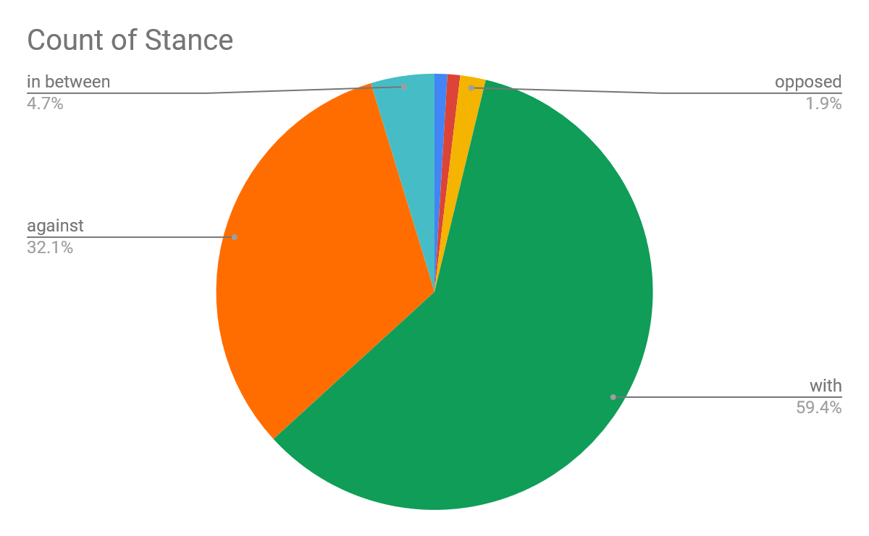

This is the information I gathered which explains who was on what side of my topic.

1. In Between, 5.7% – To be a part of this section the tweet had to have positive and negative sides to the debate.
2. With, 60.3% - The tweet would need to have stated that they agreed with my topic, they also needed to have no disagreement in their tweet.
3. Against, Opposed, 34% - The user’s tweet would give a reason as to why the were against my topic.

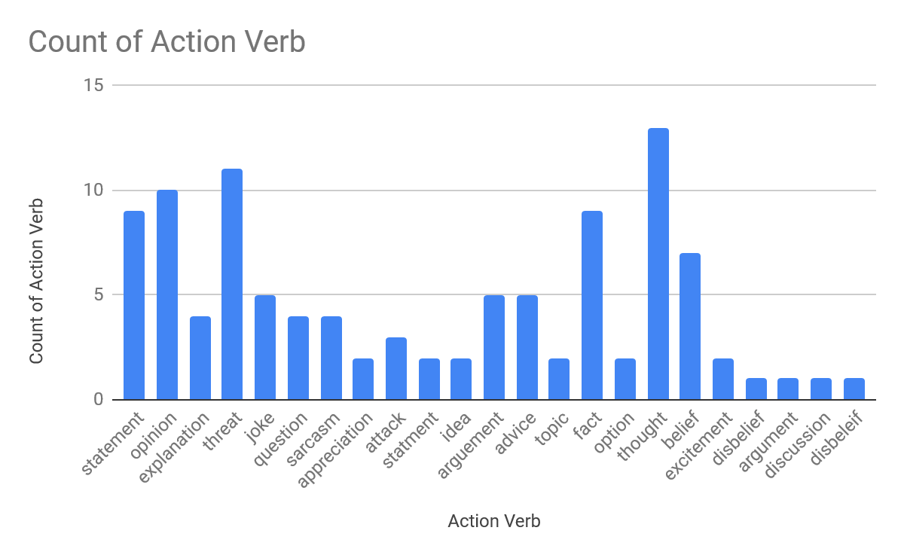

1. Statement (23) – The tweet had to have an explanation of a bill that people wanted to be passed.
2. Question (38) – The tweet needed to be in the form of a question towards the NCAA or the general public.
3. Aggressive (20) – This is a tweet that was probably typed by someone who wasn’t in control of their emotions.
4. Funny (20) – This is a tweet that was directed towards athletes or the NCAA and is was phrased as a joke.

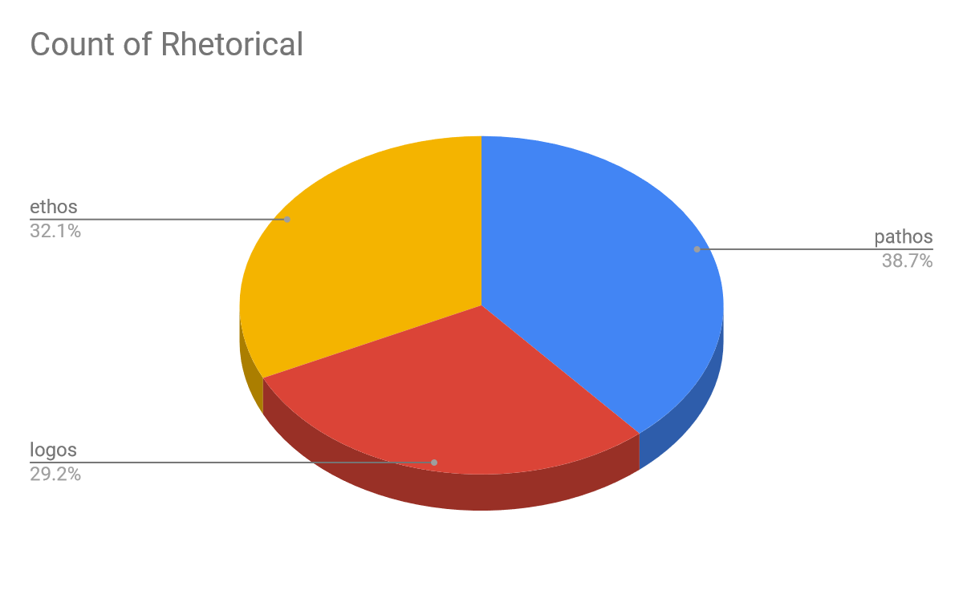

1. Ethos (32.1%) – If the tweet contained beliefs, disbeliefs, ideas and opinions etc.
2. Pathos (38.7%) – If the tweet had any emotion behind it such as anger, happiness or sad.
3. Logos (29.2) – If the tweet was logical and presented facts.

Discussion –

Majority of the tweets that I found using the hashtag #NCAA agreed with paying student athletes. The people who agreed made up approximately 60.3% of the population. In between was the minority with being 5.7% of the overall population. A big majority of the tweets were about the well being of student athletes and the struggle of balancing all their responsibilities. Some of the more recent tweets were about a bill that is in the process of being passed in California. If this bill gets passed then high school and college athletes would be able to make a profit from their likeliness. The NCAA immediately came back after hearing about this bill and said that if California decides to pass this bill then all schools and colleges would be prevented from entering any National Championships.

A great example of this bill is when Zion Williamson was in high school he was a national sensation on every social media. Zion made $0 from any merchandise with his name or number on it, instead he was forced into hoping that in a years’ time he would be signing a multi-million-dollar contract. Thankfully this worked out for him but what happens if Zion is a bust and he only lasts one year. If he is cut from his team after one year, he has not earned enough money to support a family for life and he now has to find a job with only being in college for 1 year. Basketball athletes every year do what is now called a one and done, this means that they only go to college to play basketball for one year because the NBA has a rule that no high school athlete can be drafted. If these players were to be given a monthly stipend they would be more secure if they’re athletic dreams don’t work out. They would have enough money to support themselves and their family for a little while until they can either enroll in a college or get a job.

Another example would be when Todd Gurley attended college at Georgia was confronted by an agent who asked him to sign memorabilia, at the time Todd agreed not knowing that this was an agent that planned on selling his autographs for profit. When this happened, Gurley filed a law suit against him and won the case because the court found it unfair that a normal person could make a profit off of a player’s likeliness. Then a bill was passed that if someone did this they would be fined $5,000 and/or up to one year in prison. If a court was able to see that this agent was in the wrong by selling Gurley’s autograph then why can’s a court see that the NCAA is doing the exact same thing to thousands of athletes.

**Bibliography**

Demby, G. (2018). *Why shouldn't we pay student-athletes?*. Washington: NPR. Retrieved from <http://libproxy.lib.unc.edu/login?url=https://search.proquest.com/docview/2017224087?accountid=14244>

Payne, M. (2015). *It might soon be against the law in georgia to pay student athletes for autographs thanks to 'todd gurley bill': Those who solicit student athletes to sign memorabilia could face a $5,000 fine and/or up to one year in prison*. Washington: WP Company LLC d/b/a The Washington Post. Retrieved from <http://libproxy.lib.unc.edu/login?url=https://search.proquest.com/docview/1670099470?accountid=14244>

Iliana Limón Romero, & Murschel, M. (2017). *UCF kicker donald de la haye ruled ineligible for taking YouTube revenue.*

Wilson, B. (2019, Feb 21*). Injury to Duke’s zion williamson renews debate over college players getting paid*. *Lnp* Retrieved from http://libproxy.lib.unc.edu/login?url=https://search.proquest.com/docview/2184498603?accountid=14244