Draft

Intro-

Since the beginning of time, women have been perceived as inferior to men. They have had to protest and fight just to get simple rights like voting and ownership of homes, which most men had already had decades before. That is why to this day, women are still having to fight for equality, but for equal pay in the workforce. By using #paycheckfairnessact and #equalpay, I will be discussing topics like women in sports, the European Union’s actions for gender equality, and social influence along with the toll it can take on people’s opinions on the internet.

Methods-

In the original set of tweets, very little was reduced in order to be able to use them all for the coding and visualizations. The TAGS archived 204 tweets, and only one tweet was omitted due to lack of importance; it was an outlier of a tweet and was unnecessary in the research. The retweets ended up being a big part of the study, and is discussed in the research portion later on. There were four tweets that were not in English, so instead of not using them for data, the tweets were able to have been translated and placed into categories after. One tweet was in French, one was in Spanish and two were Dutch, each contributing to the data. A few of the categories the data were split into weren’t displayed on the spreadsheet, so accounts were each clicked on to figure out the location and gender of the tweeters. If gender and location were not apparent in the profile, the accounts were not used for data in those two categories.

Data-

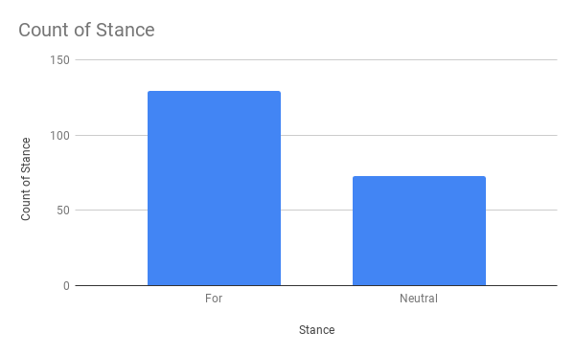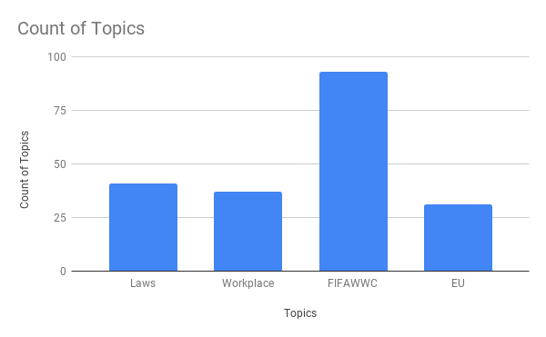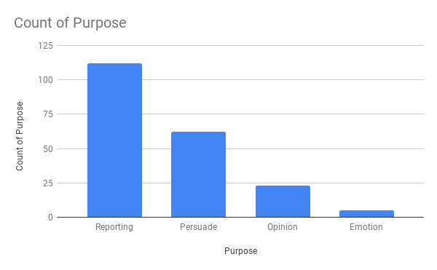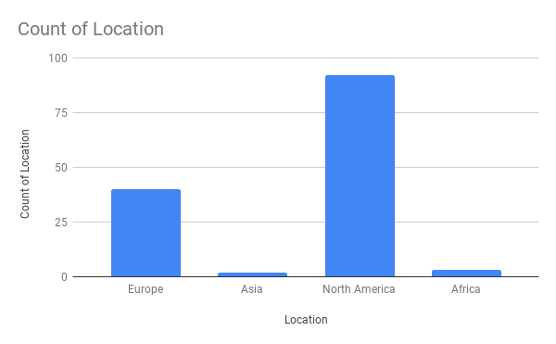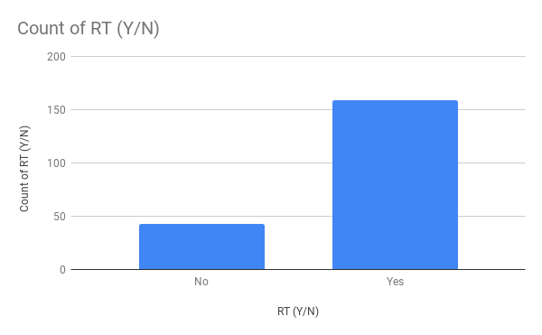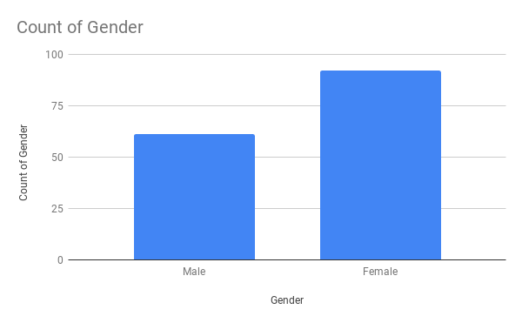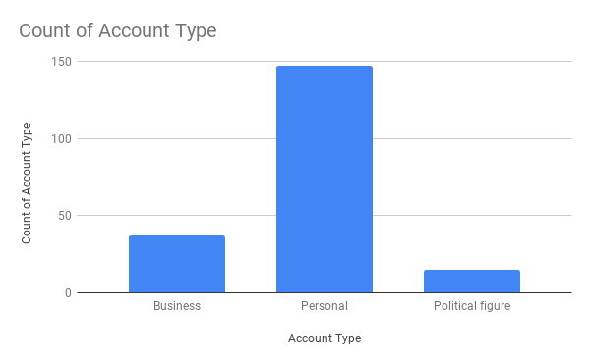

Data Analysis-

While looking through the tweets over and over again, they were able to be broken down into categories:

1. Stance- The tweets were surprisingly either pro equal pay, or didn’t state their specific belief, so the only two columns were for or neutral.
2. Topics- At first, the topics were all over the place, but after being thoroughly read through, four topics were able to be applied to all tweets: laws, workplace, FIFAWWC, or the EU. As for laws, it was a lot of accounts discussing the passing of bills. The workplace tweets ranged from articles informing workers to pay attention to their pay to statistics comparing pay of women vs. men. The FIFA Women’s World Cup ended up being the most tweeted about topic. It was mainly about the team demanding equal pay and users showing their support. The EU tweets were mainly about the successes the European Union has had in women’s rights like equal pay for equal work, improvement in protection against harassment, etc.
3. RT- The retweets category was simpler to collect data from, because it is either a yes or no question and is easily spotted.
4. Purpose, which was split into four dividends: to report, persuade, give opinions, or show emotion. Reporting was the most common purpose, which makes since due to the fact that many users had neutral tweets about the topic. Many articles and facts were tweeted keeping a neutral tone and only serving the purpose of informing people. Persuading was next, which was usually about accounts trying to get users to vote and fight for equal pay and the paycheck fairness act. Opinions usually consisted of tweets about Bernie Sanders and what he believes in. Emotion was the least common, only with a few, but they would tend to comment on somebody else’s tweet or call out an account, but tweet with anger.
5. Location- The location was noted due to the fact that the second most common topic was about the European Union and the four locations that users tweeted from were North America, Europe, Africa, and Asia.
6. Gender- Gender was important in the research because it was important to figure out if men supported women’s rights as much as women do. The gender was recorded by going through user’s profiles and then was recorded in the spread sheet

Research-

The Equal Pay Act is meant to close the gender pay gap by enforcing equal pay for equal work. There are some loopholes around this act, because the gender wage gap still exists. The issue with equal pay for equal work is that there are different job descriptions, so a man can get paid more with a different job title, but do the same work as a woman. Kurt Stanberry makes a point in his journal when he says, “The gap has shown steady improvement… However, it is not an ethically acceptable position to say to any victim of discrimination that ‘things are getting better, just wait another 50 years’ especially after they have already waited another 50 years,” (Stanberry 190). That’s why the Paycheck Fairness Act is so important to people, because it is meant to close the gap by enforcing equal pay for equivalent/similar work, but the different versions of the act have never gotten passed, and people want change now.

The graphs with the number of retweets and the types of accounts that are posted correlate in this next topic. Many of the original tweets were by businesses or political figures that have many followers and the power to influence. So, the purpose of the graphs and the article is to prove that????? Every day on the internet people post their opinions and show the world what they think and what they have to say. People who share similar opinions tend to gain confidence after discussing said similar opinions with each other. This is good for the people sharing opinions because they are able to unite and work together to fight for what they want. On the other hand, by uniting and strengthening their judgement, people with opposing opinions may be too scared to talk about it. This makes sense because when collecting data, nobody spoke out against the topic. This may or may not have been the reason or caused an issue with how people actually feel about the topic, but it’s an idea???

Many of the tweets were about the US Women’s National Team and the FIFA Women’s World Cup. Some asked for readers to join the fight, showed support to team members, and shared their beliefs about the topic. The main issues with the USWNT and their reason for protest is the fact that their salaries are not reflected the same as the USMNT. Despite the US Women’s Soccer Team’s games have generated more revenue than the men’s teams over the past 3 years, the women still don’t have equal pay(Abrams 2019). In the article in Forbes, Abrams explains why women don’t make as much in just about every sport. A major problem is the fact that there is not near as much media coverage in women’s sports as men’s, and the other issue is the fact that men’s leagues generate way more revenue than women’s leagues.

A common tweet that was retweeted by many, a political party lists the successes of the EU and its successes in women’s rights. According to the tweet, they have been successful in equal pay for equal work, equal access to pensions, better protections from harassment. This string of tweets looks a little different than from what USA is experiencing with women’s rights. The EU enforces things like the Equality Directives and Positive Action Programs on Behalf of Women and new policies.

Conclusion-

Overall, users tweeting #equalpay and #paycheckfairnessact are very supportive of the people pushing for the changes. They stay informed and like to inform other people around them. With all the graphs and data collected, the USWNT was the main topic, which wasn’t surprising, but the fact that the European Union was highly tweeted about, was a shock. This topic will never die down or give up until gender equality and equal pay are achieved. By looking through these subjects, groups unite and tweet about what they believe is right and what they want to see be achieved.