Tariff War:
The ongoing problem with trades worldwide

Joseph Destro
PID: 730306939
University of North Carolina at Chapel Hill
ENGL 105
June 27, 2019

Introduction:
Being an active twitter user leads most people on how to navigate social media well. Twitter has a very unique idea of how it handles new topics. Twitter members can send out tweets and follow other users' tweets by using any platform that works for them. A popular news source can post the link to the article or they can make a comment on something, then anyone in the world can respond to that tweet. This creates a big discussion especially when it’s an important topic that comes out and there can be multiple views on the tweet. CNBC is a great source that is always posting articles every day, keeping the world updated with the news that can be positive or negative to the economy. A topic that has been ongoing for about a year is the trade war tariffs that Trump has been implementing on China. United States of America’s President, Donald Trump, strongly believes in being the strongest country in the world. He feels in order to do this; he needs to make tariffs heavy on our countries to have goods stay in the United States. Twitter has been blowing up over this topic for a year. Every time updated news comes out on twitter, the article will be flooded with twitter users being in favor or not in favor. In this paper, I will be analyzing the trade war news with China and the US and how twitter has reacted to the hashtag #TradeWar.

Methods:
The original data set of tweets organized 1,905 unique tweets, captured between Sunday, June 16th, 2019 and Thursday, June 27th, 2019, was collected using the data-harvesting Twitter Archiving Google Spreadsheet (TAGS) tool and then moved over to a google sheets datasheet to be analyzed, filtered, and coded. Before coding the data, it had to be reduced from the original data set of 1,905 tweets into a more suitable sample size of approximately 350. The sample size appeared plenty as it was in the popular size range of 350 to 400 twitter articles that covered the topic and were enough to handle. To first method used was to make sure the user language filter of the spreadsheet removed all languages other than English using the filter keywords “en.” This simple took out all the tweets in Chinese that were not readable. The next step which was done in class was to eliminate all the articles of retweets by applying the text filter ‘begins with - “RT”’ to the column that the tweet was in. This took out around 70 tweets and was helpful to have more direct tweets being used. The other filter that was beneficial was using, “text to contain- “Tariffs”’ to the column being applied. This filter helped bring down another 50 tweets to help eliminate other news that was not involved with that. After applying all of these helpful filters, more sources detailed to the topic were performed, there were a various removal of tweets only comprised of hashtags, tweets which were community irrelevant, and “@username(s)”-only tweets. This sheet was now full of 220 twitter articles to work with.
After working with all this data, two columns were made to help write a better analysis on the article:
- My view/response on the tweet. A personal response was given per tweet.
- Whether the writer of the tweet was in favor or not. 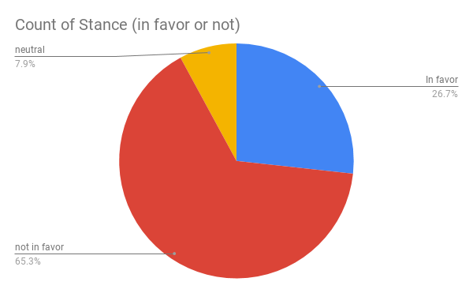
- A close read.
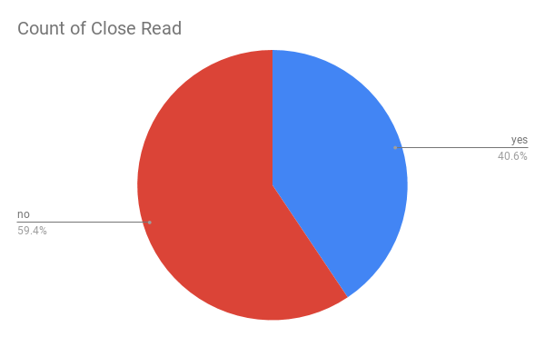

Discussion:
Based on the two charts above, that is how the spreadsheet was separated. The first column was my response to the tweet. This was meant for what was precepted on about the twitter. The second column was if the people writing the tweet were in favor of the tariffs or not. Around 65.3% of the users were not in favor of the tariffs that Trump implemented on China. The third column is whether the article was a close read or not. Around 59.4% was not a close read, which meant the twitter articles were short and easy to read. As found in the spreadsheet of a disagreement of the tariffs, “Trade disagreements between the US and China are at risk of becoming symbolic of a great power rivalry... A dangerous nationalistic fervour is brewing in both countries. It does not take much to go from simmer to boil.’ #G20 #tariffs #tradewar #China” (brianpklein). This tweet showed this user not being in favor because the trade war is now making a rivalry. Another point of view from the spreadsheet is, “@realDonaldTrump And your #TrumpTARIFFS bring in BILLIONS of DOLLARS, being paid by #China 🇨🇳, to the @USTreasury right? And the Great #American Famers 🇺🇸 are getting so very RICH from this. They are WINNING! @Larry_Kudlow @SecretaryRoss @@StevenMnuchin1 #TalkTheTruth” (realdonaldtrump). This is the other side that shows this person thinking of success for the future of the US.
The community of users posting the hashtag #tradewar can be very diverse. It ranges from people who are in high favor about the tariffs that are being applied to China to people who highly disagree with tariffs being implemented on other countries. This hashtag was trending from countries all over the war who had their eyes on the news going on. All of these twitter users can be from 18 years old till 70 years old based on their profile pictures. The rhetorical strategies that twitter users employ in their conversations about the topic is to make sure they address their point on how they feel about the tariffs. Online conversations explain that people are very frustrated about what Trump is doing to the USA. Twitter makes people open up their thoughts and expose it to the public. The details related to the research on the topic clarifies that this has been an ongoing topic. Studying twitter conversations can help engage with social issues because it shows all the people’s reactions and views to what is happening. When the twitter users like something on twitter, they rave on how much they love it and will send out multiple tweets about it. But, when twitter users despise something, they will write whatever they want to get their thoughts out and to reach out to others. Another perk of studying twitter is that it can be easier to get news. To get these news articles quickly, people follow news accounts like CNBC or NBC where the information is a liking to them.
Conclusion:
In conclusion, the tariffs that Trump has implemented on other countries, especially China, and it has caused up a lot of reactions on twitter. Twitter has been a very reliable and great source to find new articles. All of the twitter users have gotten fired up over this whole deal and it definitely stirred up a lot of conversation. Since the beginning of the trade talk, there have been many views on what the people think of Trumps actions. The people who have had hatred towards Trump and his thoughts have thoroughly expressed it online. Throughout using the spreadsheet to find out more information, it was very helpful to source out the tweets that were most important.

Sources Cited
Demertzis, M., & Fredriksson, G. (2018). The EU response to US trade tariffs.Intereconomics, 53(5), 260-268. doi:10.1007/s10272-018-0763-2
Elliott, L. (2019, ). US prepares to raise china trade tariffs. The Guardian
KNOTT, M., & GRAY, D. (2019, ). Australia safe from trump's trade tariffs. The Sydney Morning Herald (Sydney, Australia)
NEEDHAM, K. (2018, ). China ramps up pressure on US trade: TARIFFS. Sydney Morning Herald
Peters, D., & McKay, D. (2018). Trump's tariffs. Plastic Surgery, 26(4), 295-296. doi:10.1177/2292550318806000

Reflection
While writing my essay, I found it very interesting to see all the different views being shown by all of the twitter users. Using the spreadsheet to organize these tweets was a cool idea and something I have never done before. I am pretty good at technology, so I found it easy to figure it out. Overall, I thought this research paper was a solid time with the twitter research and made it a good topic to write on.

