Plastic Elimination

Dominique Monteon

PID:730311551

University of North Carolina Chapel Hill

English 105

June 29, 2019

Introduction:

For over 110 years plastic has been in existence, we use it almost constantly in our everyday lives. Starting your day off you see plastic whether it’s from the shampoos you use all the way to your garbage bags. You never really realize how much plastic there is in this world until you focus on it. Schultz (2017) states that “It's amazing how long I've gone without knowing plastic is actually a problem in our world.” (p. 68). You go to the grocery store and majority of the produce being sold is either covered or wrapped in some form of plastic. According to *Plastic Oceans* “We produce over 300 million tons of plastic every year, 50% of which is for single-use purposes”. In hopes to eliminate the use of single-use plastic, organizations and people are looking for the best fit replacements to substitute for plastic. Many of these organizations are frustrated with the fact that big companies like Tesco, McDonalds, Grocery stores, etc. refuse to eliminate plastic production. Not only is the elimination of plastic a large project within the United States of America, but it is also a large project around the World. Many countries are in realization that the use of plastic could cause marine life extinction and could cause health problems to the human species. Within this paper I will be analyzing the process of elimination of plastic by using tweets from users that use the hashtag #waronplastic.

Methods:

I started analyzing the tweets by using a link to a website called TAGS. The website for TAGS provided steps to follow in order to get all the information needed for my project. By following the given steps and inserting your hashtag it takes you to a google spreadsheet where all the tweets with your hashtag are presented. When I initially gathered the tweets, it gave me 9,427 tweets. The tweets that were given were from Saturday June 15, 2019 to Wednesday June 26, 2019. The initial number of tweets was too large to gather effective information from. In order to reduce the number of tweets given on the spreadsheet I added a filter to eliminate all “retweets” given. By eliminating all the retweets, it took my number of 9,427 tweets to 1,446 tweets. Even though I reduced the number of tweets given 1,446 tweets is still too large of a number to examine, so I reduced the number to 150 by eliminating the last 1,296 tweets. The google spreadsheet also had premade categories, I eliminated categories: ID, Geo Coordinates, In Reply to User, In Reply to Screen Name, From User ID, In Reply Status ID, Followers, Friends, Location. Eliminating these categories wasn’t critical, because I did not need them to gather information. Also, by eliminating these categories it allowed me to add in new categories that would help me find information for the analysis. I added in categories: What is happening within the tweet, Action Verbs, Rhetorical Theory, Involving another person, Stance of the tweeter. By adding in these categories, it allowed me to get a better vision of what kind of people were using this hashtag and how they felt about the notion.

Data:

Now that I have obtained a reasonable number of tweets, I used my coding strategy to view people’s opinions on plastic use. The first coding strategy I used was to see if the tweets had included another person, therefor I was examining the tweets to see if the tweeter used the “@” and included someone else within the tweet. If the tweet did use the @ symbole it would indicate that they wanted someone else to be involved in their tweet. The second coding stradgey I used was to see what kind of adverbs were being used or were being shown within the tweet. I indiviually read each tweet and put them into one of seven categories: Complaining, Informing, Questioning, Advertising, Thanking, Requesting, N/A. Based on vocabulary the person uses in their tweet I place the tweet in one of the categories. The last coding system that I used was to see what kind type of Rhetorical theory the tweet was. Based off the two previous coding systemsm and the tweet, I categorized the tweet into one of the three rhetorical theory’s.

Data:





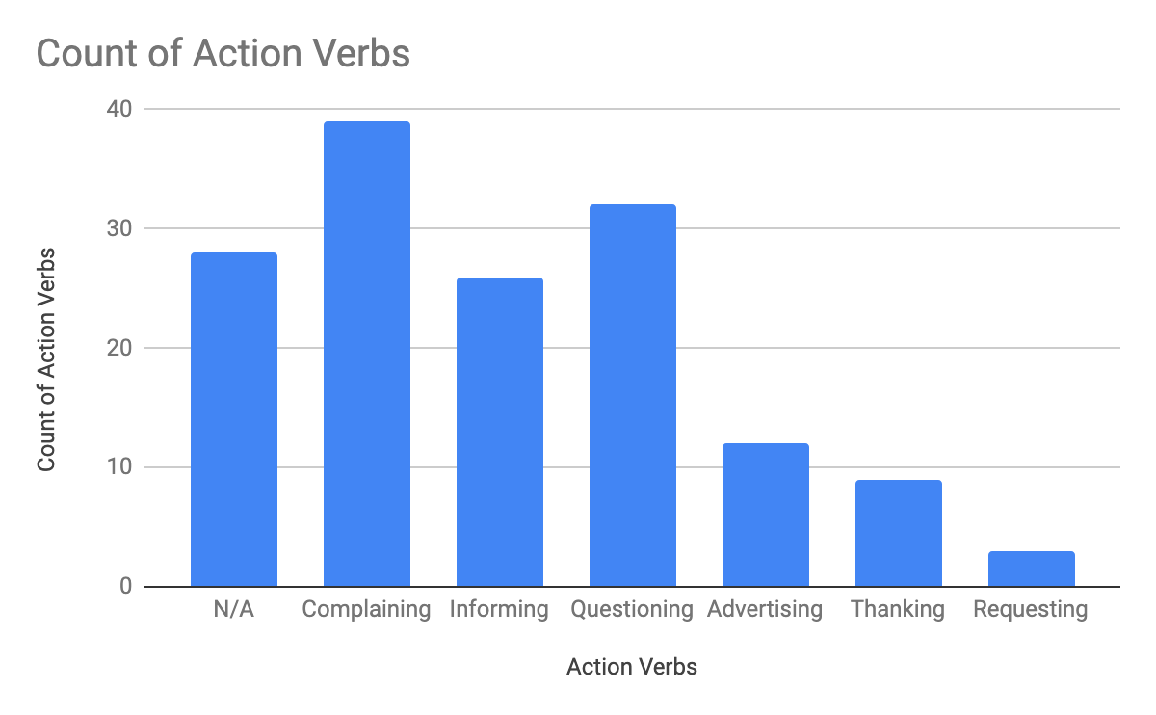

Data Analysis:

According to the data form the first coding stradegy that is shown, 68% of people included someone else in their tweet. Most people included someone else to either have them ingaged in the conversation or to complain to them about something that they want changed or answered. From the second coding system, almost about 40 people were complaining somehow within their tweet. Around 30 plus people were asking question within their tweet, they could have been asking questions to someone specific or just the twitter community. The last and final coding stradgey Showed that 47% of the tweets were using ethos in some form. Most tweets were using ethics within their tweets. A lot of the tweet also show people advertising or proposing ways to eliminate plastic use. It is not suprising to me that

Research:

Plastic was made so we can use it repeatedly. Ironically the average plastic bag is only used 5 to 12 minutes. (Shultz, 2019, p.69) Plastic in general is supposed to be used so that we can limit the use of paper. But now with all the plastic pollution going on in the world we’re trying to find substation for plastic. Little by little people are trying to make a change in the usage of plastic, whether it be shopping bags, drinks bottles or toothbrushes to name a few. (Spear, 2018, p.173) There are now organizations that go around to help collect plastic waste around the world. The largest part that is greatly affected by plastic pollution is the marine life. Marine life is in great danger of going extinct if we continue with the use of plastic. According to Brown (2018) “Fitzgerald is happy with the charter’s goal to move to 100 per cent reusable, recyclable and recoverable plastics by 2030 but would have liked to see commitments to plastic reduction.” (p. N/A) Fitzgerald is the director of the Atlantic Canada chapter of the Sierra Club, which is a club specifically made to help reduce the usage of plastic.

Conclusion:

Based off all the tweets that I examined most people just want organizations and stores to reduce the use of plastic. Most people were frustrated with all the single-use plastic that goes around the world. People gave out facts to try to influence others to reduce their own use of plastic. Our goal as a country is to save the marine life. The marine life throughout this world is beautiful and it would be a shame if it didn’t exist anymore because of something that we could have prevented.

Citations:

O’Flaherty, J. (2018). Reducing Plastic Waste. The Veterinary Record, 183(5), 1. <https://doi.org/10.1136/vr.k3318>

Spear, K. (2018). Reducing Plastic Waste. The Veterinary Record, 182(6), 1. <https://doi.org/10.1136/vr.k581>

Brown, S. (2018, June 11). Advocate says G7 charter needs plastic-reduction targets. The Star. <https://doi.org/2053630486>

Waste360. (2019, April 5). ALDI Commits to Reducing Plastic Packaging. <https://doi.org/2053630486>

Schultz, S. (2017). Reducing Plastic Pollution. Alternatives Journal, 43(2), 2. <https://doi.org/1986554293>

Oceans, P. (2019). The Facts Are Overwhelming. <https://doi.org/1986554293>