The Shutdown of NRATV

Karenna Wurl

English 105

Anderson, SSII

**Introduction:**

Twitter was invented by Jack Dorsey and Evan Williams in 2006 and it was intended to be an app for small groups of people to communicate with one another. Fast forward 13 years later, and it is one of the largest, most well-known apps in the world. It’s original purpose no longer stands, since now twitter is the place for millions of people to tweet whatever they desire, whether it is how their day is going, a funny incident, or a rant about what is going on in our world. The focus of this paper will be more on the angry side of twitter, since the topic of the NRA is very controversial these days. The NRA stands for the National Rifle Association, which is the largest gun advocacy organization with 4-5 million members who stand by the second amendment and their rights to own guns. Starting in 1911 and continuing until now, they fight against gun control policies both in-state and nationally. Again, the NRA is such a hot topic especially in such a politically polarized society we live in now and in this evaluation, I will look at different patterns and tendencies both pro-gun and pro-gun control people tend to use in order to defend their side.

**Method:**

To start, I made a spreadsheet with the program TAGS (Twitter Archiving Google Spreadsheet) which once you enter a hashtag, processes all the tweets from the past week and puts them in a spreadsheet. Information such as the time, their language, if they replied to someone, what country they’re tweeting from, etc. is included next to the tweet which I could use to help analyze the tweet. When I started with the #NRA, I originally had about 6,000 tweets starting from Friday June 21st, until Wednesday, June 26th. I then removed all of the tweets that included “RT” since that just represents a retweet, which is when someone shares that same tweet on their profile. Once I removed all of the retweets, I was left with about 600 all original tweets. To continuing to narrow it down, I noticed starting on June 26th, people were talking about NRATV getting shut down and was interested in that topic, so I cut it down to 100-200 tweets that were all posted on June 26th. Then I skimmed through all the tweets and deleted the ones that were irrelevant, didn’t make sense, or only included hashtags and had no actual other content in the tweet. I then started to code the tweets and filled out the information about their stance on the NRA, what the tweet was doing, the rhetorical appeal, the types of evidence, and the focus of the tweet.

**Discussion:**

Right away, I noticed most of these tweets were about the NRATV shutting down and many of them mentioning Dana Loesch who was the host. Going in, I expected most of the tweets under #NRA to for the most part, be in support of the NRA. However that was not what happened. Out of just over 100 tweets, 65% of them were opposed to the NRA, 20% were in favor, and 14% was neutral which mostly consisted of new articles. The high opposition could be due to the fact that NRATV was shut down and not liked by many, even including some of its own members because they believed the show was straying away from its core mission: to protect the second amendment. This show was hosted by Dana Loesch who came to the public eye when she represented the NRA at the CNN town hall after the parkland school shooting. After this town hall was when many people started to dislike her and this hatred carried over to NRATV. The majority of tweets were arguing or criticizing the other side. For example, a few people were arguing against those who were happy NRATV got shut down and we’re saying things like “we still have the right to gun ownership and there’s not a damn thing that you or anyone else will ever be able to do about it…” and “The people celebrating the end of Dana Loesch's career with the #NRA are some of the most despicable humans to exist. Thankfully, they will never ban guns in America.” The few that were in favor of the NRA immediately went to reminding everyone that they still have their guns. It even got more aggressive when someone threatened a politician if they tried to go to their house to get their guns. Now, the majority of people were criticizing NRATV and especially were laying into Dana Loesch. People even started to get a little aggressive with their remarks saying “Now that the @NRA has cut its ties with @DLoesch she is free to follow her inner Nazi and join up with an openly fascist and white supremacist group—or should I say, one that is even more open than the #NRA.” This just shows how many people Dana Loesch upset and the fact that she has lost her job is causing people to want to put her down even more. A trend I started to notice was many people writing or hashtagging “thoughts and prayers” in their tweet. I originally thought they were literally sending their thoughts and prayers, but then realized these were people opposed to the NRA and were mocking them. Whenever there is a mass shooting and people call for gun reforms, the NRA sends their “thoughts and prayers”. So, when people learned the NRATV shut down, they ironically wrote they are sending their thoughts and prayers to mock what the organization always says when a shooting occurs. 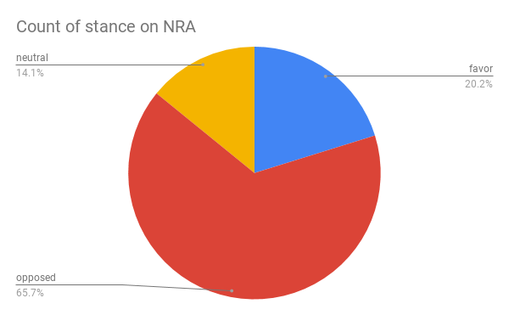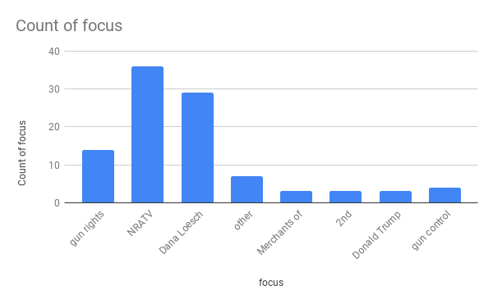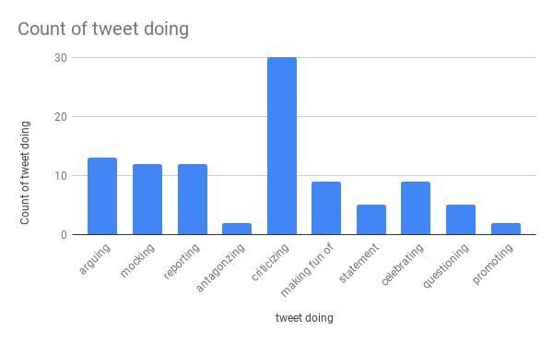

**Conclusion:**

Since the NRA is a very popular and controversial topic, it explains why so many people were tweeting about the organization, and NRATV shutting down and have such strong opinions on both sides. It will continue being a huge topic, especially since the election is coming up next year and candidates are starting to explain what their plans are for the future of guns in our country.

Works Cited

Goodbye, dana loesch and nratv. (n.d.). Retrieved June 29, 2019, from Vogue website: <https://www.vogue.com/article/thoughts-and-prayers-for-dana-loesch-nratv>

National Rifle Association (NRA). (2016). In Grey House Publishing (Ed.), *The gun debate: an encyclopedia of gun rights & gun control in the United States* (3rd ed.). Amenia, NY: Grey House Publishing. Retrieved from <http://libproxy.lib.unc.edu/login?url=https://search.credoreference.com/content/entry/greygun/national_rifle_association_nra/0?institutionId=1724>

Nra shut down nratv and its chief lobbyist resigned in the same day. Here’s what to know about the group’s troubles. (n.d.). Retrieved June 29, 2019, from Time website: <https://time.com/5614707/nratv-shutdown-cox-resigns/>

NRA’s top lobbyist resigns as association pulls plug on Dallas-based NRA TV, cuts ties with spokeswoman. (2019, June 26). Retrieved June 29, 2019, from Dallas News website: https://www.dallasnews.com/news/dallas/2019/06/26/dallas-based-nra-tv-shuttered-gun-lobbying-organization-cuts-ties-controversial-spokeswoman

RANDY, D. C. (2003, Dec 17). Latest path around soft-money ban: Buy a TV station: National rifle association's latest plan for getting its message across could change the face of US journalism. *The Christian Science Monitor (1908-Current File)* Retrieved from <http://libproxy.lib.unc.edu/login?url=https://search.proquest.com/docview/1802792663?accountid=14244>