**Analyzing #TrumpCamps On Twitter and Immigration in The United States**

Emily Elkas

PID: 730310473

The University of North Carolina at Chapel Hill

English 105

July 1, 2019

**Analyzing the Hashtag Trump Camps and Immigration in The United States**

Immigration has been a hot topic in the United States and the world for the past decade as countries struggle through their own internal conflict and deal with the repercussions of their neighbors’ conflicts through the dispersion of migrants. Within Trump’s term as president, he has been vocal about his push for more restrictive policies on illegal immigrants stating “Illegal actions must have consequences” (2018). He has done everything in his power to put his words into action by creating “Trump camps” that hold immigrants crossing the border from Mexico in conditions that many say are inept. This has sparked discussion countrywide on social media platforms like twitter for people to input their opinions and express a need for change. An attorney for the Trump administration defended these camps stating in court that toothbrushes, soap, and sleeping arrangements are not necessary for safe and sanitary conditions (Blow & Charles, 2019). Situations like this give twitter users the perfect opportunity to @Trump and @GOP their perspective, which is what I will be analyzing. This is the first time in almost a decade where a child has died under the custody of US Customs and Border Protection (Blow & Charles, 2019). The conditions of the camps on top of the ethical debate of separating children from their families at the border has caused many angry Americans to take to Twitter to express their outrage.

**Method**

In order to further analyze the topic of immigration in the US, I used the TAGS v6.1.9.1 to find tweets that included the #Trumpcamps. The program finds tweets that include the hashtag within the time period of a week. The TAGS program found 5,979 tweets so in order to narrow that down I needed to cut out tweets to an amount I could analyze and categorize myself within a short period of time. To narrow down my compilation, I first filtered out the retweets because they were not important to include for my research. The focus was tweet substance rather than how many people reacted to it. This brought the number of tweets down a considerable amount to around 1,593 tweets. I then got rid of any tweets that tagged the first lady (@FLOTUS), which didn’t narrow down my search too much but shifted the focus of the tweets to be centered around Trump and the GOP a little more. The pile of tweets was then down to 1,424. The next constraint in order to randomly narrow down the tweets was to filter out any that had a link starting with “HTTPS” because a lot of those tweets were responses to other tweets with a link to a GIF or photo that did not provide me any useful information for my research, but did help me get down to 686 tweets. This was still too many tweets to analyze so I just deleted all the tweets up until the 150th. Then picked through and got rid of tweets that only had the “#TrumpCamps” and nothing else included in the tweet, tweets that were not related to the topic, tweets that were in another language, and tweets that did not make sense and got down to 110 tweets. I than categorized each tweet into 7 different categories: for/against/neutral regarding keeping refugees in these camps, political affiliation republican/democrat/neutral, the rhetoric of the tweet, whether it was a reply or not to another tweet, whether the tweet was just expressing ones opinion or if it was emphasizing a need for change, whether the reasoning of the tweet was economic/political/religious, and if the tweet used more than one hashtag.

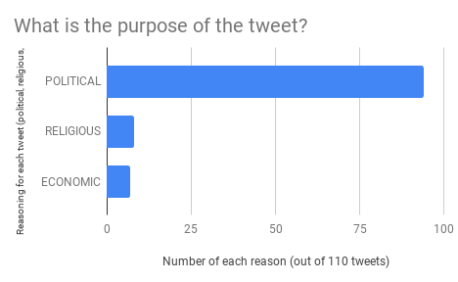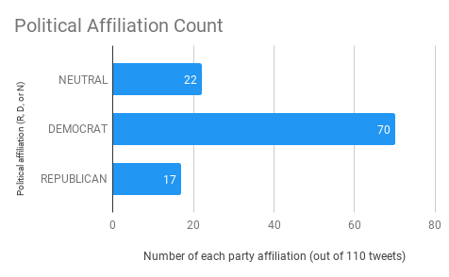



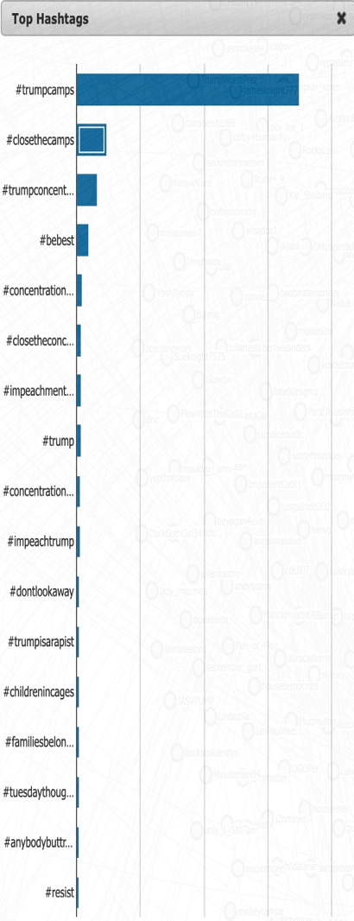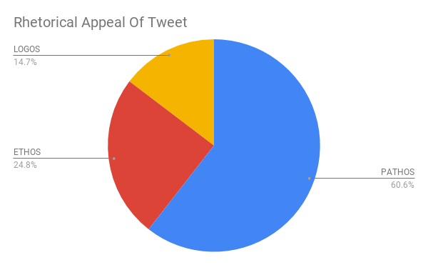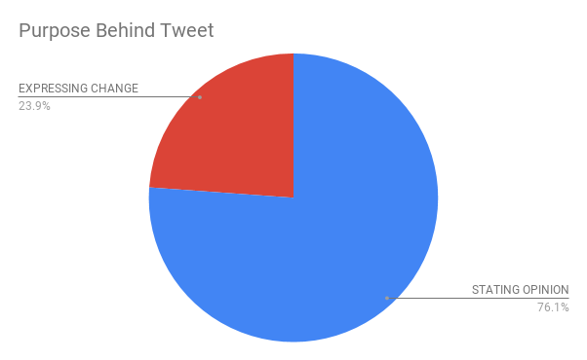



**Graph Data Analysis**

It can be inferred from figure A that the majority (64%) of the twitter users using the #Trumpcamps identify as a Democrat. From this, we can assume that majority of the people using the #Trumpcamps are people who dislike Trump’s policies and are using this hashtag as a way to communally express their negative opinions and push for change. Surprisingly though, there were more neutral tweets than republican tweets. This represents how some people that lean more towards the conservative side became neutral on the subject because of the egregious conditions that are reported from the camps. The few republican tweets that were included in the sample were expressing that if Democrats want something to be done about the conditions of the camps that they should do something about it. One Twitter user said “when are the Dems going to do something about it” implying they should work with Trump instead of disagreeing with his policies to get bills passed. In figure B when evaluated on if the tweet had political, religious, or economic reasoning 85% of the sample size was political. It can be inferred that a large majority of the tweeters were using the hashtag to express their political views as most sounded like this tweet “if you will not stand up to those monsters, we WILL elect people who will.” This person had clear political intentions advertising that if the Democrats in Congress did not stand up to Trump they would elect people that would. The purpose behind each tweet was represented in figure C either categorizing it as stating an opinion or expressing how they felt there was a need for change or reform. 75% of the tweets were stating an opinion like “Trump is destroying democracy for a few dollars in his pocket.” This is not surprising because Twitter is largely used for people to throw out their opinions rather than writing about what could be changed or advertising events or protests to actively work towards change. The results of how rhetorical appeal was used in tweets shown in figure D did not come as a surprise either because as stated before people have been using the #Trumpcamps to evoke emotion. 60% of tweets were pathos based stating impudent things like “the only thing the orange idiot hasn’t claimed so far” in response to another negative tweet about the president. An observation about rhetoric involving logos is the information was somewhat unreliable because none of the tweets that included statistics or any evidence accredited a source. When evaluating the TAGSExplorer top hashtags under #TrumpCamp the results were not surprising. The next most popular hashtags were liberal sounding, political, and emotion evoking like #closethecamps, #trumpconcentrationcamps, and #impeachment.

**Research**

9/11 escalated the topic of immigration enforcement at local, state, and national levels in a way where a problem that has been going on for years still gets thousands of tweets a week (Amuendo Dorantes & Puttitanun, 2018). In the years before and then going into Trump’s presidency there has been an unprecedented growth in inflows of unaccompanied minors from Mexico and Central America, which has grown the online discussion around the topic immensely especially now that recently more information has come out about the subject (Amuendo Dorantes & Puttitanun, 2018). Magazine articles on immigration published in the late 20th century were based upon a “Latino threat narrative” that highlighted Latin Americans as a great threat to the nation (Massey, 2013). Since then the discussion has grown and evolved with the times which has turned it to social media. Immigration enforcement officials say they are comfortable with the service and protection that is provided in these camps (Miroff & Demirjian, 2018). From what was observed in the sample of tweets regarding the subjects 81%of people would disagree with that opinion. Trump states that he will not allow the United States to be a migrant holding facility like Europe (2018). President Trump’s controversial statements result in retaliation back at him on Twitter, which is much of what we saw in this analysis of #Trumpcamps.

**Conclusion**

The twitter conversations that have been circulating about immigration since 2018 emphasizes the importance of this topic to the American people. By studying these tweets insight can be gained on what the general feelings American people have on different subjects and current events. Also, insight on how to get involved in raising awareness for change by searching for protests, charity, and educational events. The community of posters under the #Trumpcamps was overwhelmingly similar across the board in political affiliation, rhetoric, and reasoning for posting. Overall, the majority of commenters were just stating their opinion and expressing anger toward the president and his restrictive immigration policies. Twitter rhetoric is largely pathos. Twitter runs off being a reactionary platform by allowing people to evoke each other’s emotions through replies, @s, #s, and pictures.

References

Amuedo-Dorantes, C., & Puttitanun, T. (2018). Undocumented youth in limbo: The impact of america's immigration enforcement policy on juvenile deportations.*Journal of Population Economics, 31*(2), 597-626. doi:10.1007/s00148-017-0666-8

This source provides background on what as impacted and shaped immigration reform in America. It evaluates enforcement of undocumented youth at both the local and national level. It focuses heavily on determinants of judicial behavior and intensity of enforcement state to state.

Blow, & Charles. (2019). Trump’s ‘Concentration camps’. Retrieved

from <https://www.nytimes.com/2019/06/23/opinion/trump-migrants-camps.html>

This is the most recent article I found that summarizes what has been happening recently with the Trump camps. It is an opinionated article but includes good information on detailed occurrences on the topic.

Massey, D. S. (2013). America's immigration policy fiasco: Learning from past mistakes.*Daedalus, 142*(3), 5-15. doi:10.1162/DAED_a_00215

This journal discusses how policies that the US implements failed and produced counterproductive results, which ultimately brought in more documented and undocumented migration from south of the border. The author discusses how policymakers in America should shift from immigrant suppression to immigration management.

Miroff, N., & Demirjian, K. (2018, ). Migrant sites like 'summer camp'; trump official.*National Post* Retrieved from http://unc.summon.serialssolutions.com/2.0.0/link/0/eLvHCXMwpV1LS8QwEB7UvQiCKyo-Sy6yp0r62DbFg7SlRfGxlyLiZUnTdllca-3W_-8kbV1R0IOXQGEaBiZ8M8l8MwNgmedU_4YJTNCMi2zspaaTFrZj8ALjcJFnRWp6QiX0HwLr9saNAjvpyIWyNKYzd4-SCrqzVyFfzfHazhCAZcB-Wb3pco6UzLd2QzXWYYCRsytnGriP_mdeAYMJdQWzmWzDS9kPBFZuJd6G2eotpeWTqMZNpfjCs-4bNv5LzyEMJZpVvMpr4reHZQfW8nIX6N18hv6qIVJ8SRbz55yM5F8oKfhLNbogSY02J5Ou2cQenMVREl7pvRrTst96OV1pYe3DFpf0-bJRZXbZARAPcY9ylvJCVuZa3EtdjzlGjp7LEFSMD0H7fdOjvwSOYRNjDdZy505go6nf81P056XQlInUGmgw8O-vJ0_4FUQhrrEffgCwKa4T

This article discusses how Trump time after time fiercely defends his family separation policies and defends the immigration camps saying they are “more like a summer camp.” It includes points of views from immigration officers that work at the border that defend Trump’s statements.

Outcry over immigration policy that separates families; trump on separations: The U.S. will not be A migrant camp; controversy rages over separating immigrant families; compulsive gaming could be mental health problem; england playing tunisia in first match; germany and italy struggling over immigration; new italian PM meets merkel after rejects migrants; cartoonist: I was fired for making fun of trump; thomas markle opens up about missing royal wedding. aired 3-4p ET. (2018, ). *International Wire* Retrieved from <http://unc.summon.serialssolutions.com/2.0.0/link/0/eLvHCXMwpV3NbtNAEF5oe0FCoggQBVp9B64JSewmdn1AThSXiIZEjUvgVG3sdRqRrk3sHvKmPA4za1spIMGBiw_2enYynpmdzK8QVqfZavymE5yoFcsoPnUXne4isbttmZAdHqk4WXTcyAT0P_eti4-9Yd8Oq-RCLo2pPnetJY3qjtOIvebvuPG4xRaH_T773uA5UhxvrYZq7IkDOtoce18cDC7C2f1aVMe1nd6vqteqzpPgiVjunChlIonp2KSjewnWdafG_0LwUByyGstkpjbwSy55Kh4q_ezBj8kdaeEtJsTMGN3erpYlM6BsFYzwRhaYKdMbXOUwEzLob7WHcEMsgImuHzLjntFyhavmrAn24OBTWqCv4GPMYHUBjnF4GJjEeM4E2eKSNFle7l4D0ssaEXpjt6GZPLHmPHuc001aNeDB3LxB2YIIZTEVpuV0HA_VaBJM15LLuBBy0H4lMdIIVmTvYkwn0I2Hcz6X9BY-rR0RoC3MZOcl1-j_QRgPREqzjEQK0zFtroqcrptvag2fh63jUrFfK69_NiNPspmm3J_4DCPMZc4YqBhBuiEsOFCB4E5jkpR0JfKalC1wEdVagRN-clxl4Pgc4U1ywq8Yrw_mKmbTownfgLQadoZh-Fy8DYbh4EOjZpdr7kedkJmSX--YxXohHksub9CFKYOMXwq4dC61pLOQCVdOW9Jd9Fyn21ZkWbSjVnR6JI7_CvPVP56_Fo9YXDgHru28EftEa3VM1paOTsReb_6Vr1_6J5Uw_QRrQD9N>

This is a news reporting translation that discusses the situation of families being separated at the border in the US and other similar international situations. It highlights Trump’s firm stance on not wanting the US to be a “migrant camp” and “refugee holding facility.”

Trump promises US will not be a migrant camp: USA IMMIGRATION (Report). (2018, *EFE News Service,*Retrieved from <http://unc.summon.serialssolutions.com/2.0.0/link/0/eLvHCXMwpV1LS8NAEB5sexEEKyq-Wvbg0UhezeMkTUkRWkVprN7K7mZTBJvGJP5_Z9KEqgc9eNrDwjLsLN83u_vNDIBlXuvaD0zwpB5zGQ98YToisR2DJxiHSxUnwvRl9aE_D6zpxA0DO6rFhZQaU7u7QckKuuO1pFdzvLZTJRTqnXuTvWvUR4r-W-umGi3oILV5dhs6o2k0e_wOtXbNH-N9WG4fTTbCkapCUyq_CKqbyoz_MqgLXYKtjGcqZ8PNqTiAHVUcwlWUo-sYromuVQV7mjGMk99Yui6ZUIyz1esSiatkkq-yI7gch9HoVmtMWFBN4wSprlhsDbCOYY-TRD4tq1S6-ASYj9imc0_whLJvLe4L1_ccQyE7GVKXg1Po_brm2R_z57BLW046KsO7gHaZf6geMnYq-9ByX4J-7Qoa7x4mzziG8_th-AmNDKeJ>

This article highlights how since 2018 Trump has been dealing with the same issues of getting the Democrats to agree with his stance on immigration laws. It includes quotes from the president and the first lady on both of their stances on the topic and emphasizes how hard it is for the two polarized sides to agree on laws to improve the situation for everyone involved.