Jane McGrail
Digital Humanities
Digital Project Story Report
January 30, 2020

Interview with Michael Hart:
Project Gutenberg founder talks computers, books, and the future of reading

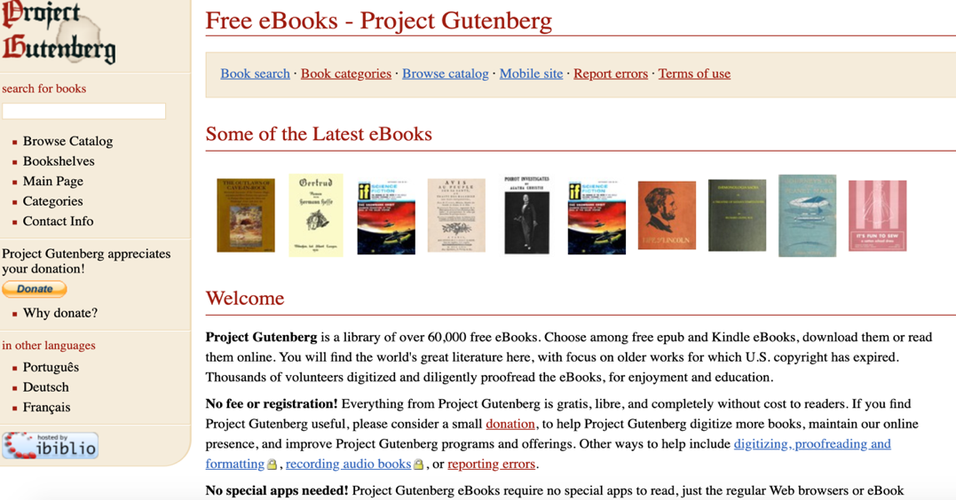
The Project Gutenberg home screen makes it easy to quickly search for an eBook.

Before you know it, you won’t be reading on paper anymore! The year is 1971 and fast-paced technology advances are keeping us all on our toes. We’re interviewing Michael Hart, founder of a technological reading platform called Project Gutenberg, who is here to share with you why books might soon be sent packing.

Jane McGrail: What do you want our readers to know about you?
Michael Hart: I was born on March 8, 1947 in Tacoma Washington. Fun fact: my mother worked as a cryptanalyst during World War II. I’m currently working in the Materials Research Lab at the University of Illinois where I study. I’m working towards a Bachelor of Science degree and I have two years left. I’m very interested in the ways in which computers and technology in general can make a difference and have tangible impacts on the lives of ordinary people, which is part of why I came up with Project Gutenberg. I’m really proud of my work and “I’m just waiting for the world to realize I’ve knocked it over.”
JM: How did you get started with inventing Project Gutenberg?
MH: I first started with the Declaration of Independence, fittingly on July 4. I typed up the text of the Declaration of Independence. I wanted to electronically mail it to everyone I could, but was told that I would crash the computers so instead of sending it by email I turned it into an electronic text that everybody could access. From there, I realized that I could do this with any text and all kinds of books could be free and infinitely available through a computer.

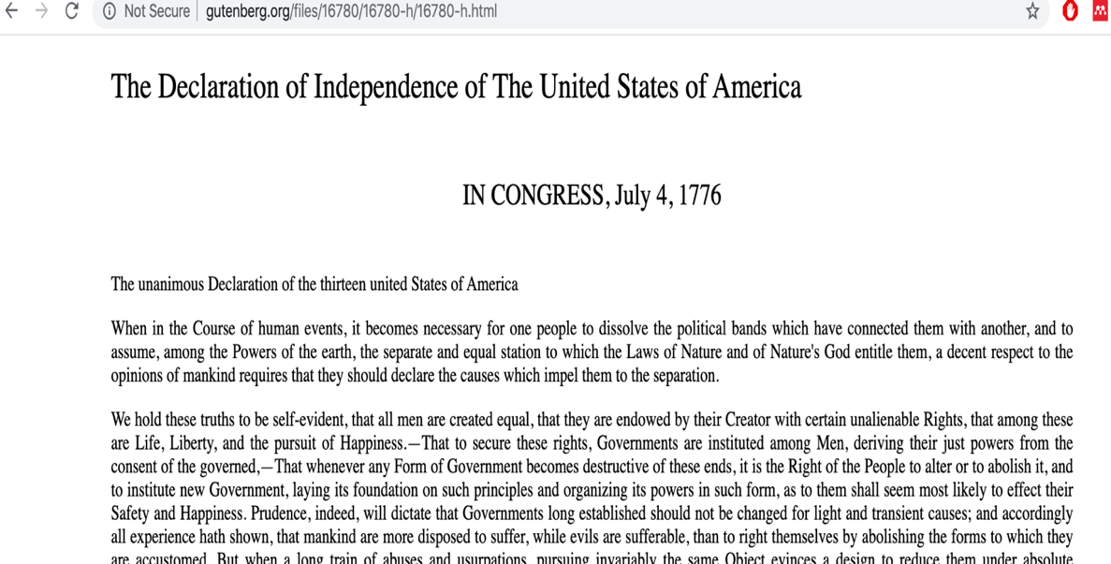
This is an image of the plain text version of the Declaration of Independence—the document Project Gutenberg began with.

JM: What inspired you to make all of these books available to the public?
MH: My philosophy is that, “the Project Gutenberg Etexts should cost so little that no one will really care how much they cost. They should be a general size that fits on the standard media of the time,” and that “the Project Gutenberg Etexts should be so easily used that no one should ever have to care about how to use, read, quote, and search them.” Essentially, I want my platform, Project Gutenberg, to create eBooks that everyone can read.
JM: Describe your new technological reading project for our readers.
MH: I’m calling it Project Gutenberg. It’s an online source where anybody can use a computer to download books. There is an unlimited number of copies of the books so while it’s like a library in that the books are free, it’s slightly different because you never have to wait for a book to become available. If it’s catalogued in Project Gutenberg, then anybody with a computer can have it the moment they want it.
JM: What more can you share with those readers who might be a little more techie?
MH: I started with an idea for replicator technology. This means that anything that is available through a computer can be replicated infinitely so anybody who wants a copy can have one. It doesn’t have to be limited. I then created a coding platform that I’m calling Plain Vanilla ASCII. ASCII stands for the American Standard Code for Information Exchange. It’s really simple and works with every possible operating system because of how simple it is so everybody who wants to download a book should be able to. It’s also easiest to search through. “It’s a paradigm shift. It’s the power of one person, alone in their basement, being able to type in their favorite books and give it to millions or billions of people.”
JM: Does Project Gutenberg have any limitations?
MH: One of the major limitations we’re working with is that the creation of Project Gutenberg electronic texts depends on books being in the public domain. This means that their copyright has to have expired before we’re able to make them into electronic books so while I’m hoping to make as many books as possible available, this is inevitably limited to books whose copyrights have expired, which means that they’re going to be older books. There are a few books we’ve been able to get some access to copyright rights for, but for the most part we’re going to have to wait until copyright expires so the books we’re making available electronically probably won’t be the latest new releases.
JM: What are some next steps you’re taking?
MH: I want to make as many books as possible electronically available. I’m hoping to include three categories of electronic texts: “heavy literature, light literature, and references.”
JM: What are your eventual goals with this project?
MH: I want to provide electronic text editions of every public domain book that exists as quickly as possible after it enters the public domain so that with the help of a computer these books can be available to everybody with every operating system. I hope that Project Gutenberg can help people in schools as well as people who just want to read for fun. With an unlimited number of copies available, it is my goal that there will always be something available for everyone.

Stay tuned, everyone, because with this new technology alongside all of the other technological advances that will happen during our lifetime, free electronic texts could be at your disposal!

To the editor:
I read your interview with this Michael Hart character with great trepidation. I am concerned about the shady dealings of this so-called Project Gutenberg, which seems like nothing more than stealing a bunch of books, pirating them, and distributing them for free. Authors work hard to write books which should not be subject to this kind of rampant, electronic theft. Further, very few people have access to computers so this piracy is really only helping the elite minority. What’s the point of this? Can’t we all continue to buy books or patronize our local libraries? Reading happens on paper as it should.
Response:
Thank you for sharing your concerns over the philosophy of Project Gutenberg. We highly value feedback from readers like you. In response to your concerns, I would like to let you and the rest of our readers know a little bit more about open access resources. Project Gutenberg falls into this category of being an open access resource, meaning that it is committed to providing materials free of charge while completely abiding by copyright law. For a material to be made available open access, the copyright holder either has to consent, or the copyright has to have expired. If either of these conditions occurs, then it is perfectly legal for the work to be made publicly available. As for your concern about whether this really is open access, I agree that very few people have access to computers at this time, but we have seen so many technological advances so far that I, like Michael Hart, firmly believe that before too long we will all have computers and we will all be able to access the exciting and innovative Project Gutenberg.
A Note from Michael Hart:
For as many people who are excited about innovations in technology, there are an equal number who feel fear and apprehension. I invented Project Gutenberg because I’m excited about all of the possibilities and the ways technology can improve our lives. With free and unlimited access to electronic texts, people will be able to have access to all sorts of materials that they weren’t able to obtain reliably before. It’s about all types of books—as I mentioned: heavy literature, light literature, and references are the three categories of texts I’m trying to make available. Additionally, according to United States copyright law, works become public domain 70 years after the author dies, or 95 years from the date of publication. As I work to build up the database of Project Gutenberg, I will of course be following copyright laws closely. The way I see it, there’s no harm Project Gutenberg can do. It’s an exciting new innovation that will only contribute to the public good by allowing for increased access to knowledge.

To the editor:
I am thrilled that you published an interview with such a clever figure. The world is changing and new writing and storytelling technologies have been evolving for thousands of years. I am excited to think about how an invention like Project Gutenberg will change the ways in which we interact with reading materials. Instead of turning pages, we will be scrolling and as we read, whatever we need might be available at the touch of a button. If Michael Hart is serious about making available all kinds of resources including both references and literature, then one day in the near future as we read we’ll be able to instantly research anything we don’t know. And with more copies of books available for free hopefully more people will read. I predict that our population will become smarter and smarter because of technology like the Project Gutenberg technology and I am excited for the changes ahead! Thank you for publishing such a fascinating interview.

Grimes, William. “Michael Hart, a Pioneer of E-Books, Dies at 64.” The New York Times. Sept. 8, 2011.
“The History and Philosophy of Project Gutenberg by Michael Hart,” Project Gutenberg. https://www.gutenberg.org/wiki/Gutenberg:The_History_and_Philosophy_of_Project_Gutenberg_by_Michael_Hart. August 1992.
Grimes, William. “Michael Hart, a Pioneer of E-Books, Dies at 64.” The New York Times. Sept. 8, 2011.
“The History and Philosophy of Project Gutenberg by Michael Hart,” Project Gutenberg. https://www.gutenberg.org/wiki/Gutenberg:The_History_and_Philosophy_of_Project_Gutenberg_by_Michael_Hart. August 1992.
Suber, Peter. “Open Access Overview.” Legacy.Earlham.Edu. http://legacy.earlham.edu/~peters/fos/overview.htm
“Teaching Copyright.” Electronic Frontier Foundation.
Van der Weel, Adriaan. “Chapter 1: Feeding Our Reading Machines: From the typographic page to the docuverse.” Digital Studies. 2017.

