Phoebe Powers
Video Transcript

1: INTRO
Hello Im Phoebe Powers and I’m going to be talking about the Me Too Movement.

2: Tarana Burke
In 2006, social activist Tarana Burke created a support group, Me Too, intended to offer help for survivors of sexual assault. Using the social media platform, MySpace, Burke began using the me too phrase to speak on instances of sexual harassment, especially perpetuated against women of color.
The #MeToo movement gained major traction and global notoriety in 2017 when well-known actresses began coming forward and publicly detailing their own personal experiences dealing with sexual assault in the film industry.

3: Harvey Weinstein
In October of 2017, the New York Times published a bombshell article alleging dozens of accounts of sexual assault stories at the hands of well-known Hollywood producer Harvey Weinstein.

4: Tweet
Ten days after the New York Times’s Weinstein expose, actress Alyssa Milano tweeted, “If you’ve been sexually harassed or assaulted write ‘me too’ as a reply to this tweet.” This ignited a global trend on social media by posters sharing their experience or simply acknowledging that they too are one of the many survivors sexual assault.

5: USA Gymnastics, Larry Nassar
A few days later, Olympic gymnast McKayla Maroney, again using Twitter as a platform, came forward with information that she was sexually assaulted by the U.S. gymnastics team doctor, Larry Nassar. Maroney was soon joined by hundreds of other victims who were also sexually assaulted by Nassar during mandatory physicals.

6: Kevin Spacey

In the weeks and months that followed, dozens of powerful figures were publicly accused of sexual abuse. The list includes but is not limited to: actor Kevin Spacey, politician Roy Moore, comedian Louis C.K., television host Matt Lauer,

7: Bill Cosby
Bill Cosby, record executive Russell Simmons, senator Al Franken, chef Mario Batali,

8: R. Kelly
musician R. Kelly, actor James Franco, Stan Lee, Morgan Freeman,

9. Christine Blasey-Ford
Supreme Court Justice Brett Kavanaugh, Donald Trump, Prince Andrew,

10. Epstein
and billionare Jeffrey Epstein.

11. Gender
Gender in the Digital Humanities
As computer science is a pre-dominantly white, male-based field, accessibility is significantly less for minorities and non-males. In an analysis of feminist digital literary archives in an article written for the Digital Humanities Quarterly, Jacqueline Wernimont says, “Digital archives unite two historically gendered fields — computer and archival sciences. Literary scholars who depend on archival or rare book materials still confront, whether they acknowledge it or not, the legacy of an institutional form through which patriarchal power exercised the authority to determine value, classification, and access.” (Wernimont).
In public health journal article “Filling in the Gender Data Gap,” author Miriam Temin warns, “Unless efforts are made to ensure that new methods of data collection account for gender, there is a risk that they will reinforce gender disparities. ‘Big data’ gathered from mobile phone users, for example, must be interpreted with caution, since they are often skewed to represent only the most vocal or well-off members of a community.” Temin specifies this saying, “Data on social determinants of girls’ and women’s health have been long neglected. These determinants include activities that dominate the lives of girls and women living in poverty, like their domestic caregiving burden and non-formal employment, which rarely feature in national statistics (World Bank 2011; Langer et. al 2015).”
Another example comes from a 2012 survey from the UN Statistics Division, and indicated that only around a third of countries track gender-related topics such as informal employment or violence against women.
As the United States operates under the epoch of a patriarchy, major media and communications tools have been mainly owned and operated by white men. As a result of this, the facility for women, LGBTQ+ folk, and minorities to report their allegations of sexual abuse and be taken seriously by the media has been an uphill battle.

Overall, the gender bias present in the tech industry is concealed through algorithms. For example, “XML, a universal data language and tool for document coding, previously used the numerical value 1 for men and 2 for women, which perhaps confirms Simone de Beauvoir’s claim that women are conceived of as the second sex” (Lovereide). So although the inequity within the world of digital algorithms may have been largely unintentional, the consequences are concrete. The institutions of sexism and racism are inherent in the creation of this country, so it follows that many new inventions will unintentionally

12. Digital Archive

#MeToo Web Archives Collection
In August of 2018, Harvard’s Schlesinger Library initiated a project on the History of Women in America by documenting the digital footprint of the #metoo movement. The web archive includes a wide range of media types, including blog posts, videos, forum threads, social media accounts, personal narratives, news articles, legislative bills, and more. The most frequent publishers include The Harvard Crimson, The Cut, Verdict, Independent Women’s Forum, Twitter, Reddit, Playboy, Medium, Essence, Feministing, the American Civil Liberties Union, and the New York Times. The website is divided into categories include but are not limited to: hospitality, Christians, contracts, sex workers, agricultural, sports, flight attendants, and more.

12. Graph on Hashtags

Impact of the Hashtag
Although these implicit biases create unequal opportunities
A key element of the #MeToo Movement is the tool known as the hashtag. The usage of the hashag (#), a meta-data tag, before any combination of characters allows easier methods of searching for messages with a certain theme or word. Because of the universal, inclusive nature of using and viewing hashtags, the gender and racial bias is much less present than in the case of digital archives.
In the context of the #MeToo Movement, the hashtag is the tool used to facilitate the message, to expand public discourse on sexual assault and offer a space for victims of abuse to share their stories.
In the following graph, the frequency with which the #MeToo hashtag has been used since October of 2017 is shown. Major spikes include Alyssa Milano’s original tweet that sparked the flame, TIME Magazine’s cover commending the ‘Silence Breakers,’ and Oprah Winfrey’s Golden Globes speech letting sexual abusers know that their time is up to continue getting away with these injustices.

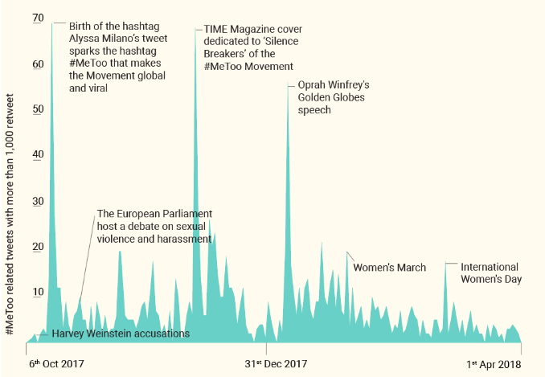

Results of the Movement
Numerous outcomes have emerged from the #MeToo Movement. One change is that states have begun to ban nondisclosure agreements that cover sexual harassment. Another is that states have begun to expand legal protection for more workers, such as independent contractors, domestic workers, and farm workers. A Legal Defense Fund called Time’s Up was also created to help victims of sexual assault seeking to bring a sexual harassment lawsuit. There has also been a further push to end the tipped minimum wage of $2.13 an hour, which creates dangerous atmospheres in which workers feel subordinate to the customer in order to receive a tip. Furthermore, Congress has reformed some processes for staffers reporting sexual harassment following a slew of scandals within Congress.
Going forward, a key aspect of closing the gender digital divide is ensuring that “researchers and national statistical agencies are making full use of available data by analyzing differences by analyzing differences by sex. Comparing girls’ and women’s rates of stunting, employment, education, HIV infection, marriage, mortality, and birth registration to those of boys and men shows where there are gender gaps, which sends a more powerful message than describing each sex separately” (Temin). Data analysis must dive deep to fully understand the way in which gender norms and power structures show the social relationship between biological sex with differing variables, such as geographic location, race, socioeconomic status, ethnicity, and more.

