- DH Project Story  By: Shawna Sheperd  E - Poetry  “Digital Poetry is a poetic practice made possible by digital media and technologies. A genre of electronic literature, it is also known as electronic poetry or E-poetry. The technologies that shape digital media are diverse, rapidly evolving, and can be used to such different effects that the term has expanded to encompass a large number of practices”  - The John Hopkins Guide to Digital Media | Dispersed Digital Poetry Project  E-Poetry  E-poetry stands for electronic poetry. Many people create e-poetry, incorporating various multimedia mediums to express their work. People who create e-poetry play with online data, algorithms, coding, photos, and other electronic platforms that produce movement, words, and art to share on the internet (Sundberg and Brennan).  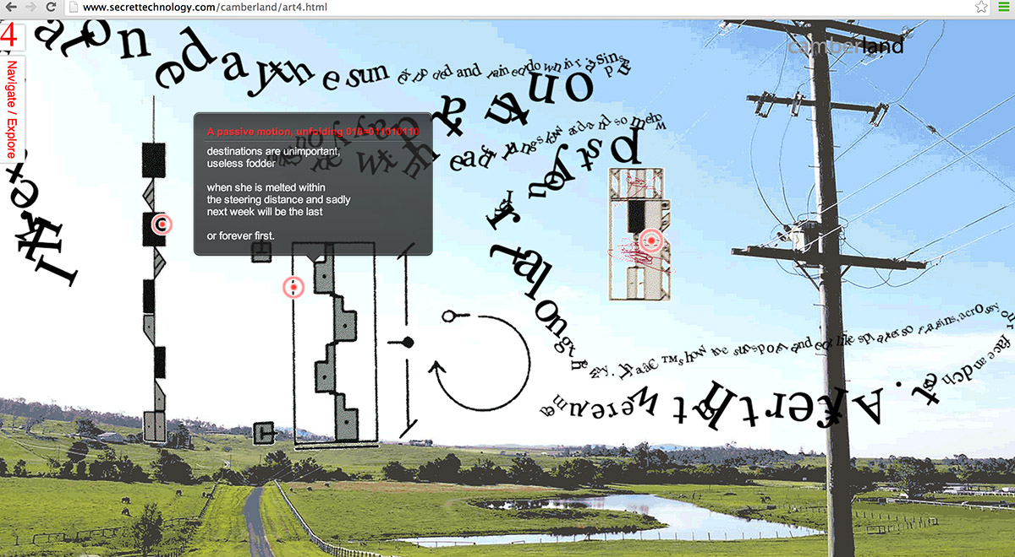  Camberland by Jason Nelson  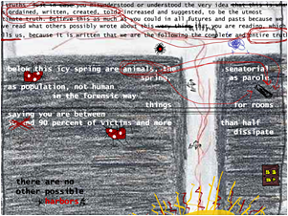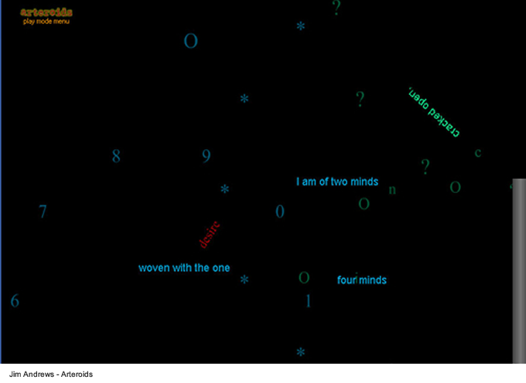  Left: Game, Game, Game, and again Game; Right: Aim, Fire, Poetry! By Jason Nelson  People who engage with e-poetry experiment with traditional poetic forms and subvert what it means to engage digitally with literature. Digital poetry isn’t just published in print on the Web, such as using word processors, because the function of that software is designed to merely replicate and produce printed copies (Ryan). Instead, e-poetry uses technology that leaves it mark on a poem, in how the poem appears or how the reader experiences the poem (Ryan). N. Katherine Hayles suggests in The John Hopkins Guide to Digital Media that e-poetry is “more than being marked by digitality, electronic literature is actively formed by it” (Ryan).  There are many different forms that e-poetry can take on (Flores).  - Generative poetry – programming algorithms that draw from corpora to create poetic lines, such as the Twitter bot  - Code poetry – written for both computer and human readers  - Visual digital poetry – comes from visual, concrete, and lettrist poetic traditions  - Kinetic poetry – allows the display of animation and changes information over time  - Multimedia poetry – uses audio, video, images, texts, etc.  - Interactive poetry – uses input from the reader in the e-poem’s expressive strategy  - Hypertext poetry – uses links to structure the poem into spaces for the reader to explore  In its early days, e-poetry was closely linked to literary hypertext (Heckman and O’Sullivan). With increasing production and advancement in technology, e-literature in general had proliferated as well (Flores “I ♥ E-Poetry”). To discover this exact timeline becomes difficult because both ambiguity and transience lends itself to the development of e-literature. Where once existed hypertext, in the future came augmented reality, etc. (Heckman and O’Sullivan).  Why does e-poetry matter?  Leonardo Flores, founder of I ♥ E-Poetry finds digital creative production or the making of e-poetry among people who never formally studied it (Berens). Thus, e-literature or e-poetry can build bridges between people on a level that other literary or artistic mediums cannot. The accessibility, freedom, and creativity that is involved in e-literature makes it an “every-man” type of game or artistic expression. Since a person doesn’t have to be formally trained to make code, anyone can play around with some form of code and share their work for thousands of people to see and interact with. e-poetry, as a humanities based field, can also open the door for people who would generally shy away from literature to experience profound art and words in a creative capacity (Januchowski-Hartley, et all. 1).  Despite e-literature becoming a popular, expressive form for the average person to engage in, there is an element of sophistication that is involved with engaging with this form of literature. Stephanie Strickland suggests, “reading e-lit requires taking an aesthetic attitude toward the textscape as an object that stimulates the sense” (Berens). In other words, many times the digital poetry comes across as difficult to understand, interpret, or make meaning of. As we will see below, Jason Nelson’s Dispersed Digital Poetry Project and his experimental, hand-built interfaces demonstrate this difficulty in defining e-poetry.  Where can you find e-poetry?  Places where a lot of electronic literature is found:  - Electronic Literature Collection  - Poems that Go  - I ♥ E-Poetry  Many expert artists promote their work on the web. Some of these artists of particular interest include Jim Andrews, Nick Montfort, Myfanwy Ashmore, and Carlos González Tardon. These poets are all focused on interactive / videogame like poetry. Jim Andrews created a game called Arteroids, in which the reader steers a space-ship through an asteroid belt. The reader must shoot down asteroids and flying saucers; through this the reader creates sound poetry. Nick Montfort uses source code to elongate and elevate nature poetry in Taroko Gorge. Myfanwy created poetry modeled after Gameboy games, and Carlos González Tardon created an interactive poem that recites “Schtzgrmn” while engaging with warfare videogames. This game, in particular, mimics the sounds of gunfire’s and detonating missiles from the trenches of World War One. These artists each have a different take on what e-poetry is to them. One thing that they do have in common is that they have inspired Jason Nelson.  Who is Jason Nelson?  Jason Nelson is a lecturer on cyber studies and digital writing and creative practices at Griffith University in Queensland, Australia. He is a digital media and hypermedia poet and artist and is best known for flash games and essays such as Game, Game, Game, and Again Game and I made this, you play this, we are enemies. Nelson merges various genres and technologies that focus on collages of poetry, images, sounds, movements, and interactions.  In an interview Nelson says, “I was always interested in how software and devices could be used in creative ways and started experimenting with how interactive interfaces, like game engines and website code, could be used to rethink how we understand poetry” (Killey).  What is the Dispersed Digital Poetry Project?  The DD-Poetry Project is a series of interactive and creative digital poems that were built by Nelson. Each poem explores interactivity, media, text, and code – all in experimental ways. It is not a collection that lives on one website; instead, it is dispersed over many websites, online journals, art portals, blogs, etc (Nelson).
- Interview Sources  Mathias Jansson Interview “Aim, Fire, Poetry!”  “Digital Poet Urges Authors to Turn Over New Leaf” by Shae Killey  First Person Scholar Interview “On E-Lit, Games, & Fuzzy Boundaries”  “An Interview with Jason Nelson” by Tom Bihn Crew | A Dialogue with Jason Nelson  Q. What kinds of videogames and poetry inspire you?  A. I’ve been fascinated by the strange stories built into cut scenes and introductory movies of 1980s Atari or Nintendo games ... their attempts to create small worlds and back-stories continue to be the inspiration for movies, games and novels thirty years later. Additionally, those early games were often messy and dysfunctional with chaotic clashes of sounds and images (Jansson).  Q. Can you talk a little bit about your process for creating new content?  A. I often scour the web for emulators and ROMS of any and all game systems. Once inside I want to rewrite the rules or alter / disrupt the graphics (Killey). I imagine inserting acerbic poetic texts into Atari tennis games, or adding my own poorly filmed cut scenes into Sega Pirate Quests. As for poetry, I continually find myself pulling / creating poems from found texts. 19th century engineering journals, old medical documents, strange maps, diagrams of computer systems, which are filled with contemporary poetry (Jansson). The language of science is often riddled with poetic descriptions or curious stories. Sometimes I filter movies, radio talk shows, political speeches through speech-to-text software (Jansson; Killey).  Q. Some people have described your work as “alienating as modern art can get” (Wall Street Journal). How do you respond to this accusation?  A. Most speech-to-text software and the resulting code is buggy and inconsistent, or filled with bias and predefined notions of language (Jansson). The outcome of the filters are pages of incoherent grammar and word couplings (Jansson). Creating digital poetry is so multi-linear and dimensional, and contains such a variety of media and poetic interactions that inspiration must come from all directions (Killey). As soon as I begin to create a new work, five new works seem to spring from the original idea (Jansson). Critics often suggest some of my works seem incomplete either in their construction or in meaning. And I would say incompletion and messiness are part of the fabric of digital poetry (Jansson; Killey).  Q. Tell me about the game entitled I made this, you play this, we are enemies?  A. I actually view most of my digital poetry creatures as game-like creations. I made this, you play this, we are enemies was one of my creations that was a response to the creature Game, Game, Game and Again Game. This creature made strong visceral reactions. Some poets exclaimed my work wasn’t truly literary and some game makers deemed my creations as easy-to-play artsy wankerism. So, I created I made this, you play this, we are enemies using screenshots from many of the sides that promoted/lauded/lambasted my work. My idea was to mark up the sites, to place a poetry game within net-based spaces, to combine sketchbook with commentary with absurd exploration (Jansson).  Q. Can you also speak about Evidence of everything exploding? It is interesting because it has such an intense story background?  A. For Evidence of everything exploding, I determined my historical moments, signifiers of our contemporary condition since in the history we study at school is defined by seminal moments. If I take you through the ten levels, I think it would explain things better.  1. Title page for an etymological dictionary, it is to understand the origin of language and how it dominates culture.  2. An early Dadaism poster. My work is heavily tinged with the surreal the Dadaist movement. I find it very influential in the 20th century.  3. Trajectory Diagram for NASA’s moon landing. I am enamored with space travel and amazed at the skill needed to travel to our nearest satellite.  4. The Bill Gates letter to Hobbyists from the Computer Brew Club newsletter. There was a moment when the software turned bad, when code became commodity, when a language became copyright.  5. A 1918 US Gov’t Warning Letter concerning the Spanish Flu pandemic. The virus seemed unstoppable. Plans were drafted to isolate a small healthy population for the survival of humanity. Consequently, as result from this virus, communities opted to avoid large congregations for the next forty years.  6. Copyright infringement notice to writer Neil Gaiman from the producers of Attack of the Killer Tomatoes. Pure absurdity and a narrow victory for public commentary.  7. A page from James Joyce. His odd confluence of words and ideas and strange inspired me to write, and began to rip fiction from its rusting cage.  8. NYC Museum of Modern art rejection letter to pre-famous Andy Warhold. It’s funny how success and fame alter a critic’s judgement.  9. Letter from a very young Fidel Castro praising America and seeking money. Rarely are megalomaniacs driven by anything other than ego.  10. The Patent for the pizza box. Just genius. A cultural symbol that just might outlast Facebook/Twitter/Googles of the world.  (Jansson).  Q. What role does the reader typically have in your games?  A. The simple left/right/up arrow movement of my poetry games allows the reader to take the role of hero. To mentally live, however briefly, within the screen. And to varying degrees, within all my creations the reader/player truly does become the writer. No, I am not giving them complete control, nor am I generating texts from their movements and/or responses/reactions. The creator’s ideas and aesthetic is still strange attractor to all my digital creatures. It’s almost as if I am offering them access to the back of my brain, letting them drive a lumbering hard to steer go-cart through poetic multimedia musings (Jansson; Killey).  Q. How do you think e-poetry has changed how readers experience poetry?  A. Video games are a language, an architecture for relaying ideas, for exploring some artistic, theoretical, poetic, educational, economic, etc. ideas (Jansson). The rise of relatively easy to code and create games that are unattached to profit wanting corporate directions has meant game creators could use these architectures to communicate / build pretty and disturbing creatures (Jansson). For the future, interactive interfaces might not replace paper or static screen poetry. But, I am confident, interactive works will soon be a critical component of the literary landscape. There is a tendency to use visual, spatial and responsive thinking and I think that it’s just going to keep getting easier and easier to read these different forms of multimedia projects (Jansson; On E-Lit Games, & Fuzzy Boundaries).  Q. What backlash, if any, has bothered you about e-poetry?  A. It bothers me that people judge the e-poetry before they try it. I’ve already seen signs of backlash towards interactive poetry and important signs of its impending dominance. I also wish that people who aren’t that experienced with the digital world would try it. Anyone can do it; for example, you could create a digital poem based on places, using text and video and images, using the rollover markers on google maps to create a basic interactive poem (Jansson). Also there are people who write not authentic e-poetry, where people use print or handwritten poetry and translate that to a digital environment (Baetens and Van Looy). So there is backlash about these “imposters,” within the digital community that feels digital poetry should be written explicitly with the screen in mind (On E-Lit Games, & Fuzzy Boundaries).  Q. What do you think your impact on e-literature has been? What are you most wary of?  A. I am overjoyed by the viral spreading my games have encountered, all my odd creations have accomplished is to slightly stretch how these frameworks could be used (“An Interview with Jason Nelson”) (Jansson). I am wary, however, and jealous honestly of static artists because their work will last beyond technology changes. One of the really little-known difficulties in being an interactive artist is having our works become obsolete within a decade or even every few years because of changes in operating systems, browsers and devices (“An Interview with Jason Nelson”).  A Look into Nelson’s Games  This is How You Will Die  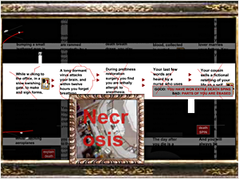  “This Is How You Will Die.”  collection.eliterature.org/2/works/nelson_thisishowyouwilldie.html.  One of Nelson’s most famous pieces. It uses a code of an online pokie game creating a slot machine for predicting death. It invokes plot points from movies and novels.  Evidence of Everything Exploding  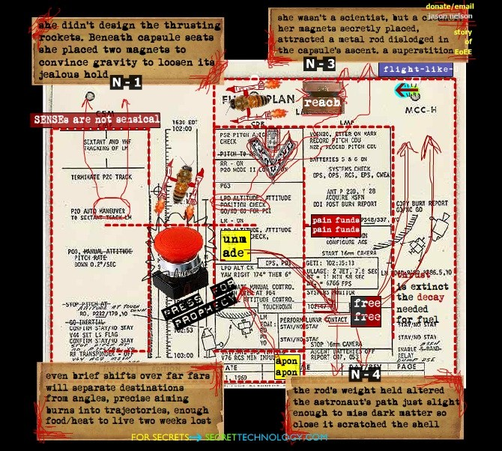  “Evidence of Everything Exploding.” U B U W E B: Jason Nelson,  www.ubu.com/contemp/nelson/index.html.  This is the third game in a sequence of poetry games. The player must navigate the surface of 10 different texts presented, see interview above.  The Poetry Cube  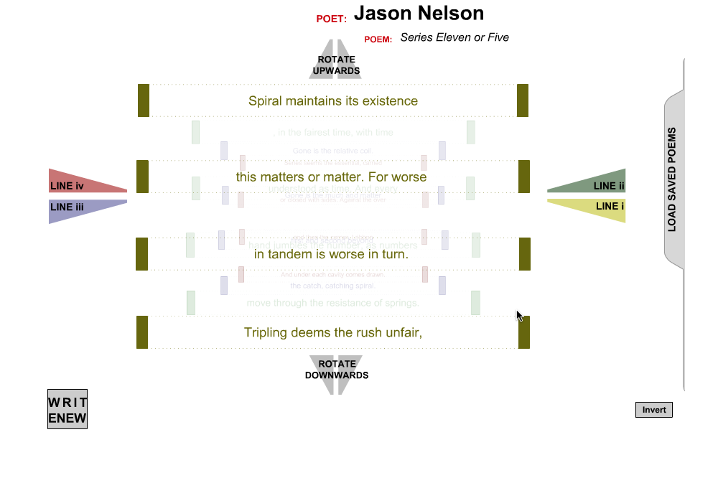  “The Poetry Cube.” U B U W E B: Jason Nelson,  www.ubu.com/contemp/nelson/index.html.  This is a learning tool. The Cube lets users to enter a 16-line poem, and those lines are placed in multi-layered sections. The buttons shift the cube, changing and recombining the poem.  Uncontrollable Semantics  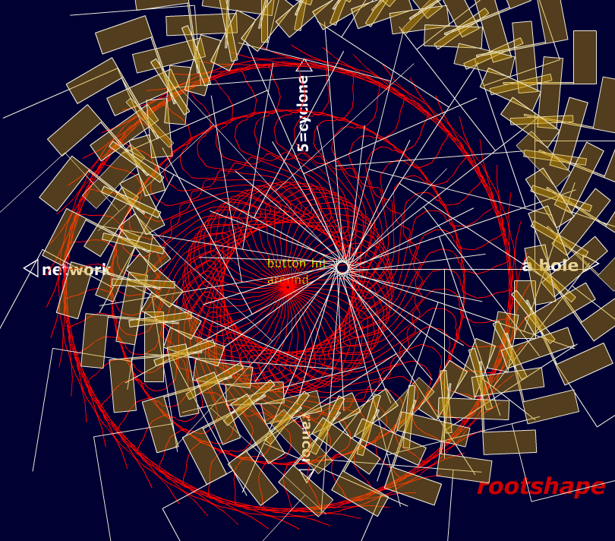  “Uncontrollable Semantics.” U B U W E B: Jason Nelson,  www.ubu.com/contemp/nelson/index.html.  This is net-art that shoots for simplicity. It utilizes the basic mouse-follower. It also pulls together over fifty sounds, images, and interactive environments.  Endings Eventually End  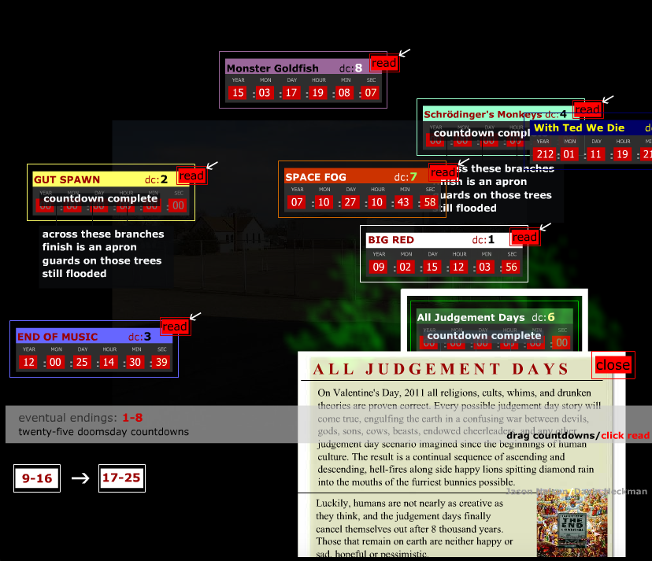  “Endings Eventually End.” U B U W E B: Jason Nelson,  www.ubu.com/contemp/nelson/index.html.  This interactive creature focuses on American culture, and speaks to anxieties that rapid cultural, economic, ecological, and technological change bring about.  Pandemic Rooms  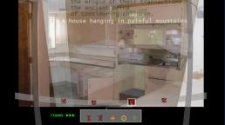  “Pandemic Rooms.” U B U W E B: Jason Nelson,  www.ubu.com/contemp/nelson/index.html.  This creature is full of real photographs of abandoned industrial and institutional buildings. The artwork uses these photographs as backgrounds to make interactive spaces to explore microscopic species killers.

Bibliography

“An Interview with Jason Nelson.” TOM BIHN,
www.tombihn.com/blogs/main/jason-nelson-interview.
Baetens, Jan, and Jan Von Looy. “Poetry: Between Image and Performance -- A Cultural
Analysis.” E-Media Studies, journals.dartmouth.edu/cgi-bin/WebObjects/Journals.woa/1/xmlpage/4/article/288.
Berens, Kathi Inman. “E-Lit’s #1 Hit: Is Instagram Poetry E-Literature?” Electronic Book
Review, 6 Apr. 2019,
electronicbookreview.com/essay/e-lits-1-hit-is-instagram-poetry-e-literature/.
“Endings Eventually End.” U B U W E B: Jason Nelson,
www.ubu.com/contemp/nelson/index.html.
“Evidence of Everything Exploding.” U B U W E B: Jason Nelson,
www.ubu.com/contemp/nelson/index.html.
Flores, Leonardo. “DIGIMAG 63 - APRIL 2011.” I Love E-Poetry, 1 Apr. 2015,
issuu.com/digicultlibrary/docs/digimag63.
Heckman, David, and James O'Sullivan. “Literary Studies in the Digital Age.” Electronic
Literature: Contexts and Poetics,
dlsanthology.mla.hcommons.org/electronic-literature-contexts-and-poetics/.
Jansson, Mathias. “Aim, Fire, Poetry! Jason Nelson And The New Literature • Digicult: Digital
Art, Design and Culture.” Digicult, 23 Jan. 2016,
digicult.it/digimag/issue-063/aim-fire-poetry-jason-nelson-and-the-new-literature/.
Januchowski-Hartley, Stephanie, et al. “Poetry as a Creative Practice to Enhance Engagement
and Learning in Conservation Science.” Oxford Academic, Oxford University Press, 4
Oct. 2018, academic.oup.com/bioscience/article/68/11/905/5103314.
Killey, Shae. “Digital Poet Urges Authors to Turn over New Leaf.” ABC News, 2 Jan. 2014,
www.abc.net.au/news/2014-01-02/digital-poet-urges-authors-to-turn-over-new-leaf/5182
306.
Nelson, Jason. “Interview with J.N. from the E.L.R.” About Jason Nelson- Digital Art and
Poetry Wonderments and Creatures, www.secrettechnology.com/about.html.
“On E-Lit Games, & Fuzzy Boundaries.” First Person Scholar, 4 Dec. 2013,
www.firstpersonscholar.com/interview-jason-nelson/.
“Pandemic Rooms.” U B U W E B: Jason Nelson,
www.ubu.com/contemp/nelson/index.html.
Ryan, Marie-Laure, et al. The Johns Hopkins Guide to Digital Media. Johns Hopkins University
Press, 2014.
Sundberg, Kennedy, and Marge Brennan. “E-Poetry.” E-Poetry Genres ,
leunereng14winter2017.pressbooks.com/chapter/e-poetry/.
“The Poetry Cube.” U B U W E B: Jason Nelson,
www.ubu.com/contemp/nelson/index.html.
“This Is How You Will Die.”
collection.eliterature.org/2/works/nelson_thisishowyouwilldie.html.
“Uncontrollable Semantics.” U B U W E B: Jason Nelson,
www.ubu.com/contemp/nelson/index.html.

