1: Tarana Burke  introduce creator of “Me Too” phrase  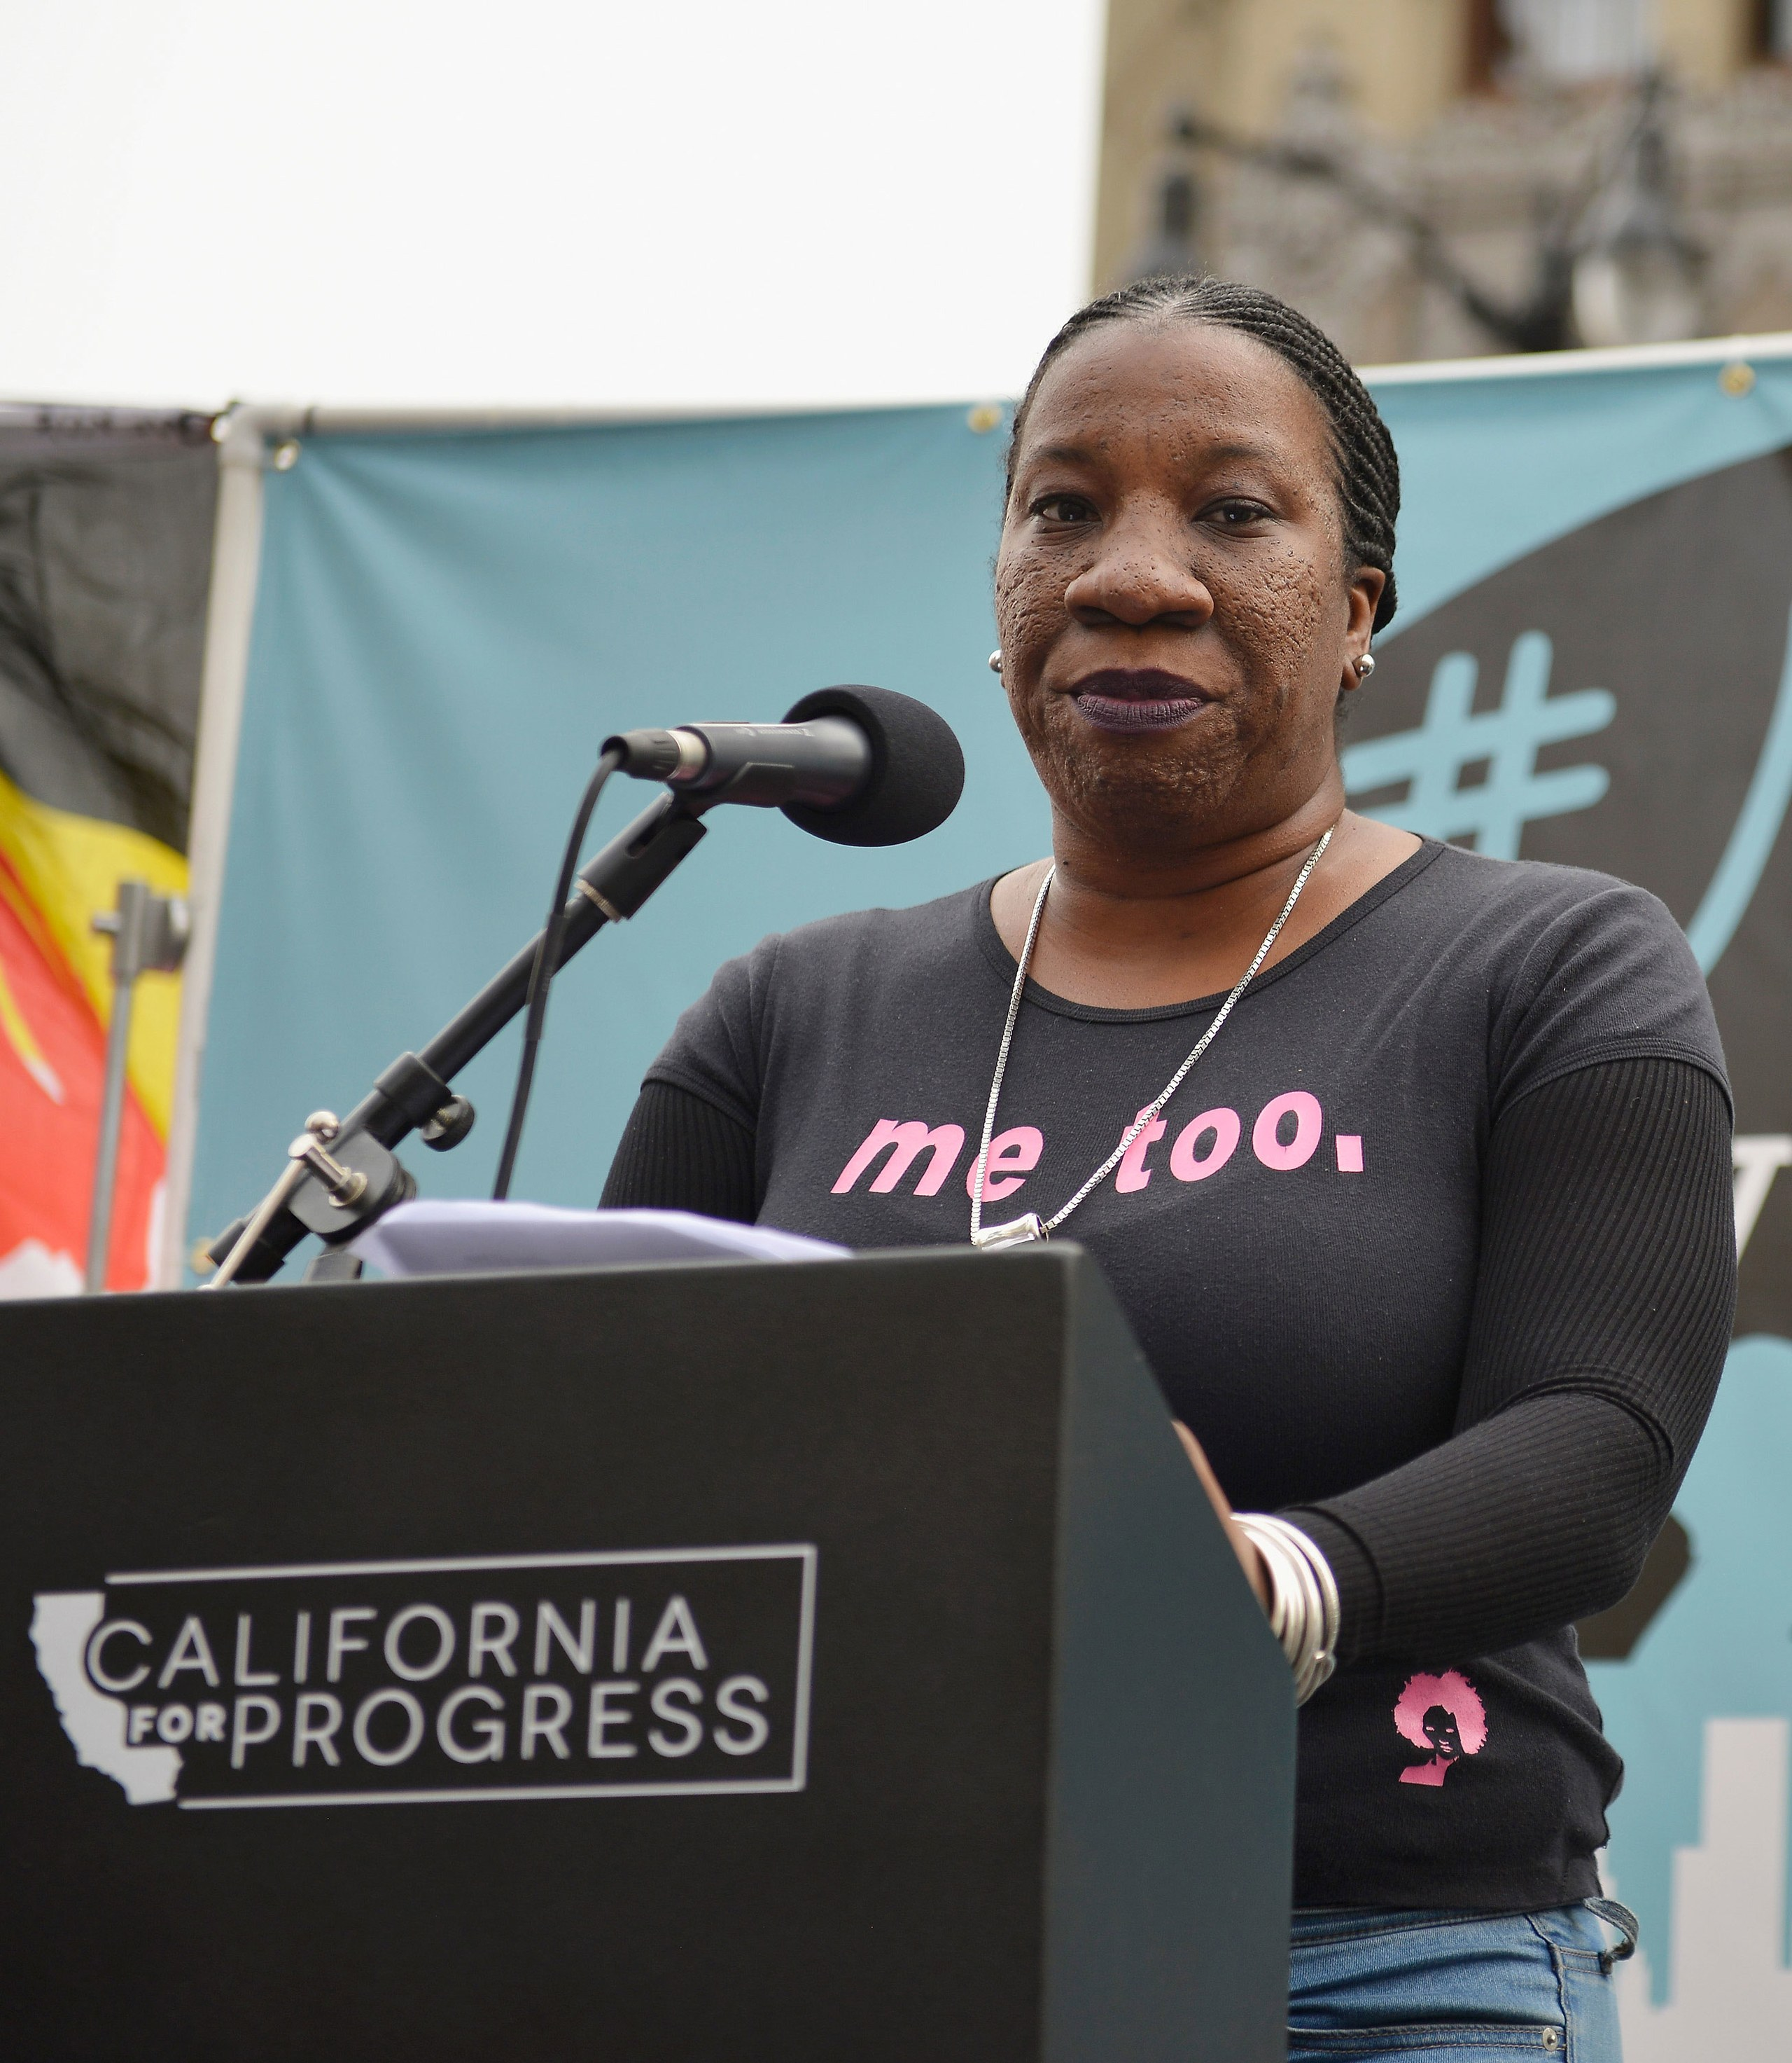 | 2: NYT Harvey Weinstein article expose  detail 2017 bombshell article  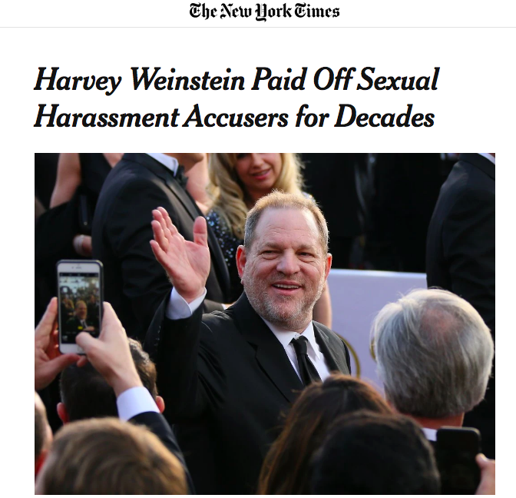 | 3: Alyssa Milano’s tweet  sparks global trending hashtag #metoo  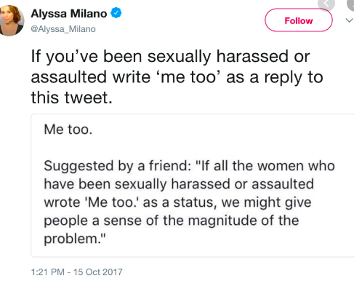
4: Larry Nassar – USA gymnastics controversy  USA gymnastics team doctor Larry Nassar is accused by hundreds of girls of molesting them during treatments.  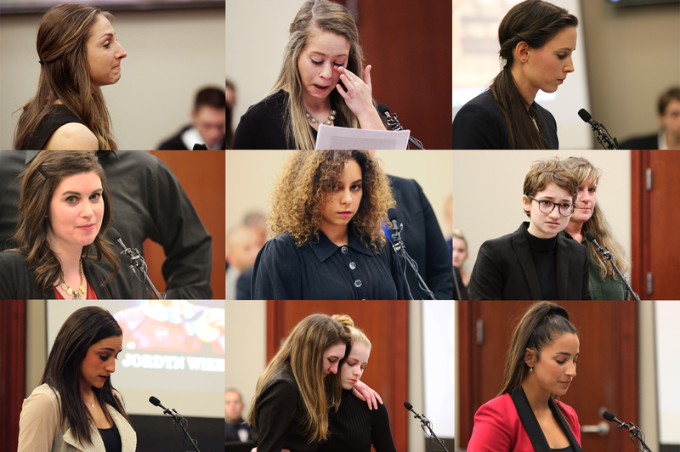 | 5: Kevin Spacey accused of molesting young boy  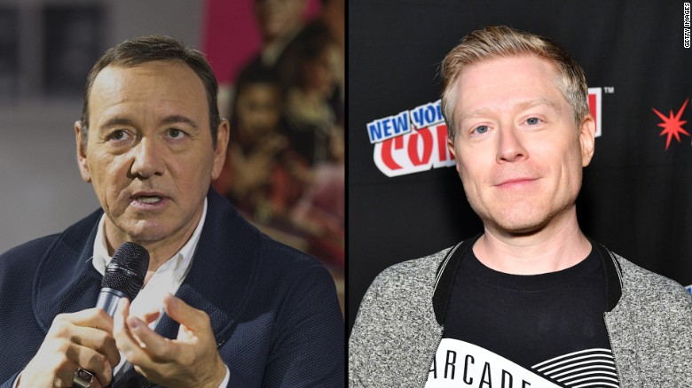 | 6. Bill Cosby  Convicted of felony accounts for drugging and sexually assaulting hundreds of women  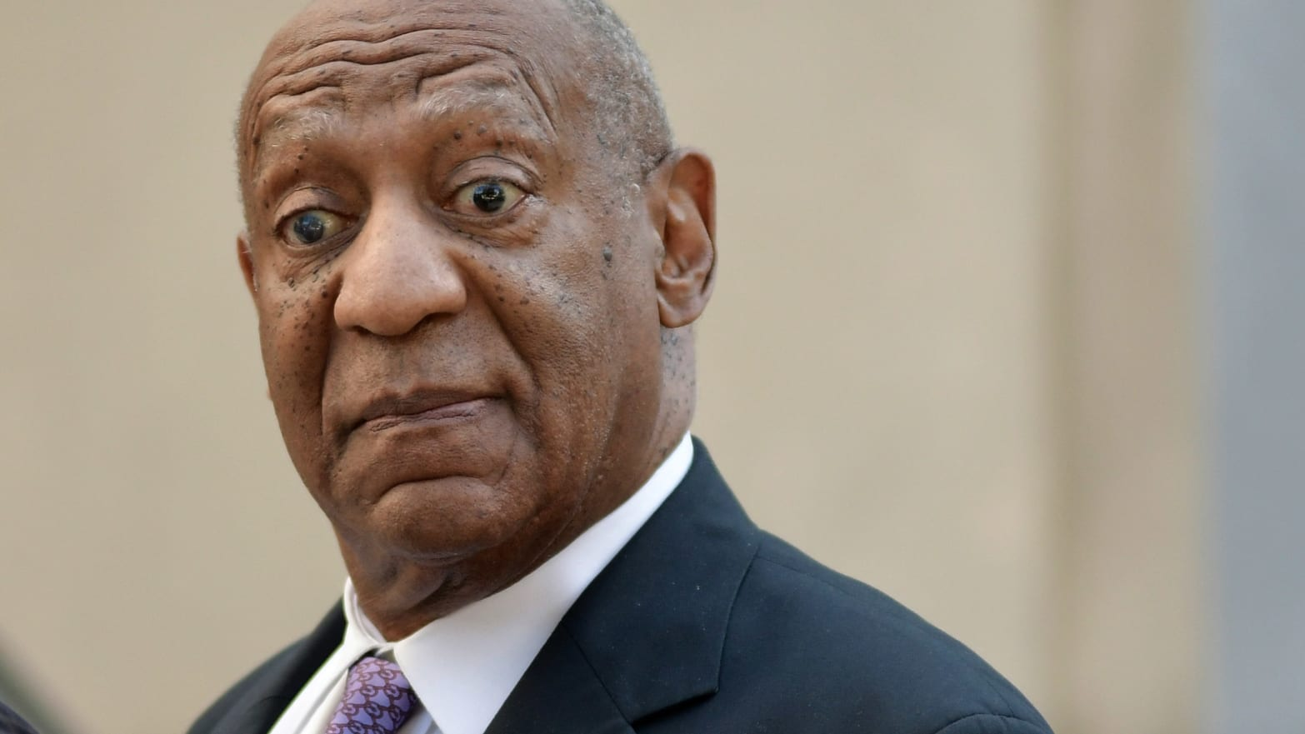
7. R Kelly – charged for child prostitution and running a sex ring often involving underage girls  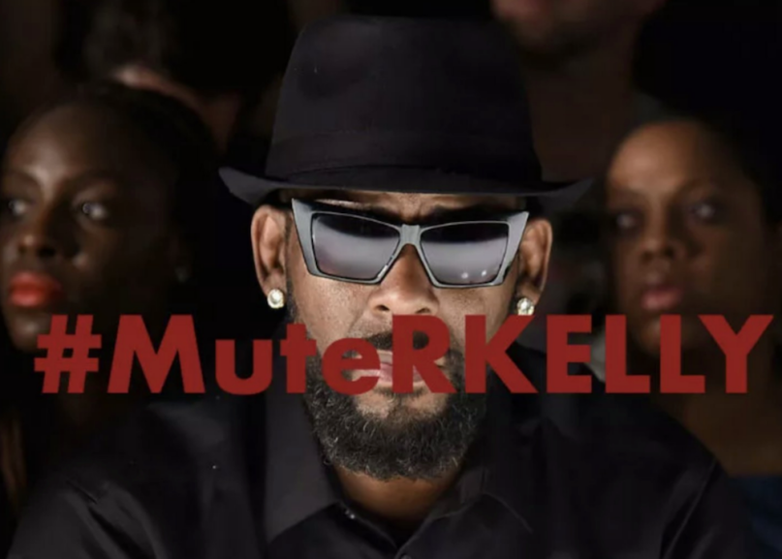 | 8. Kavanaugh vs. Christine Blasey Ford  public trial of Chrstine Blasey Ford accusing soon-to-be Supreme Court Justice Brett Kavanaugh of sexual assault. Kavanaugh appointed to the Supreme Court.  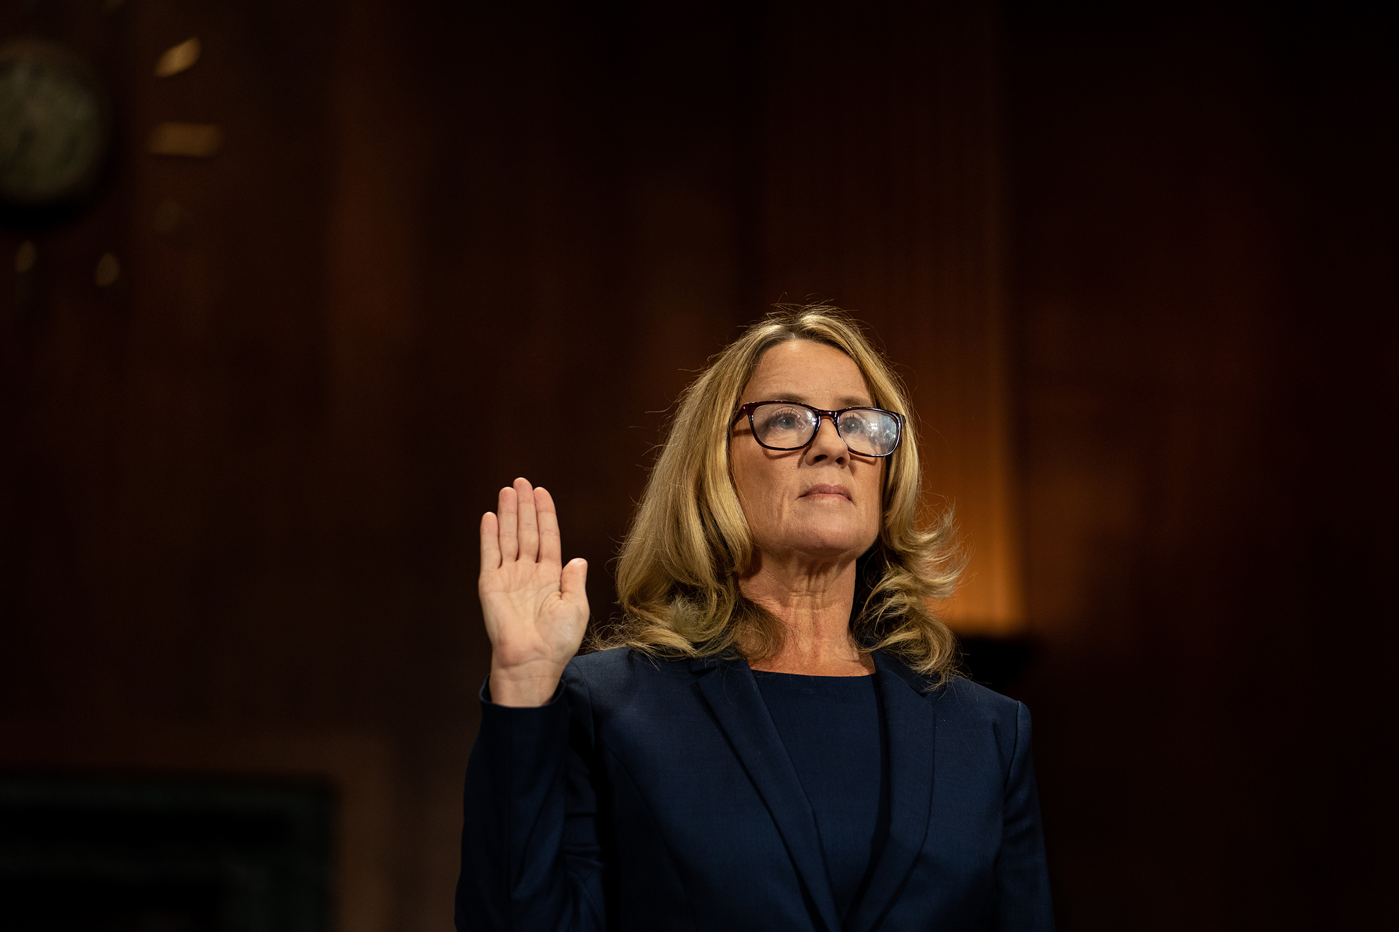 | 9. Jeffrey Epstein  Billionaire arrested for running a sex ring of underage girls out of his NY apartment. Many famous politicans known to have been close to him, including Trump, Bill Clinton, and Prince Andrew. Epstein died in jail under… suspicious… circumstances.  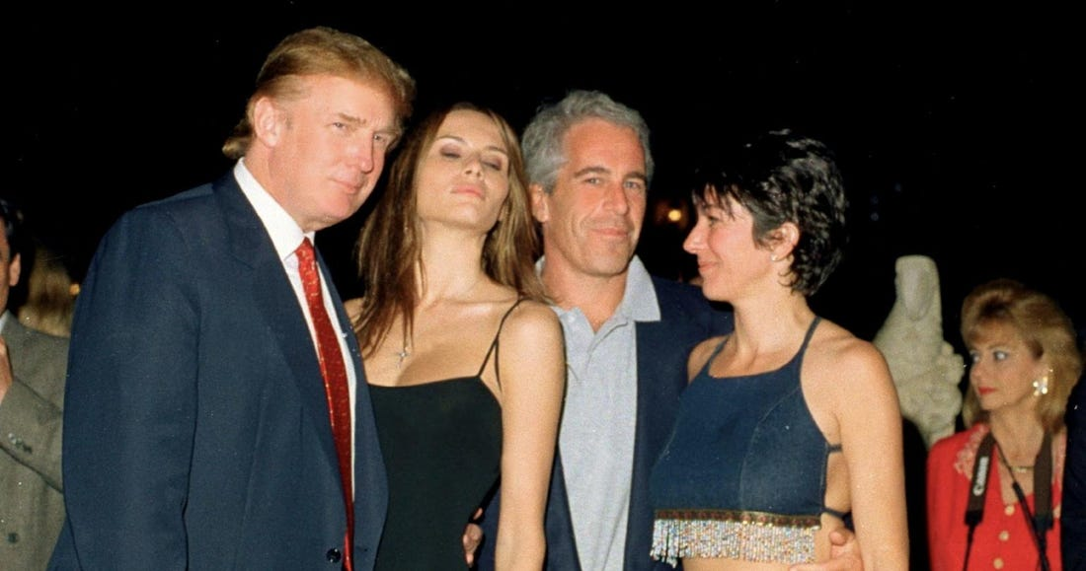
10: Gender in the Digital Humanities  Discussion of a predominantly male-based field of technology | 11. Harvard’s Web Archive Collection of the #MeToo Movement  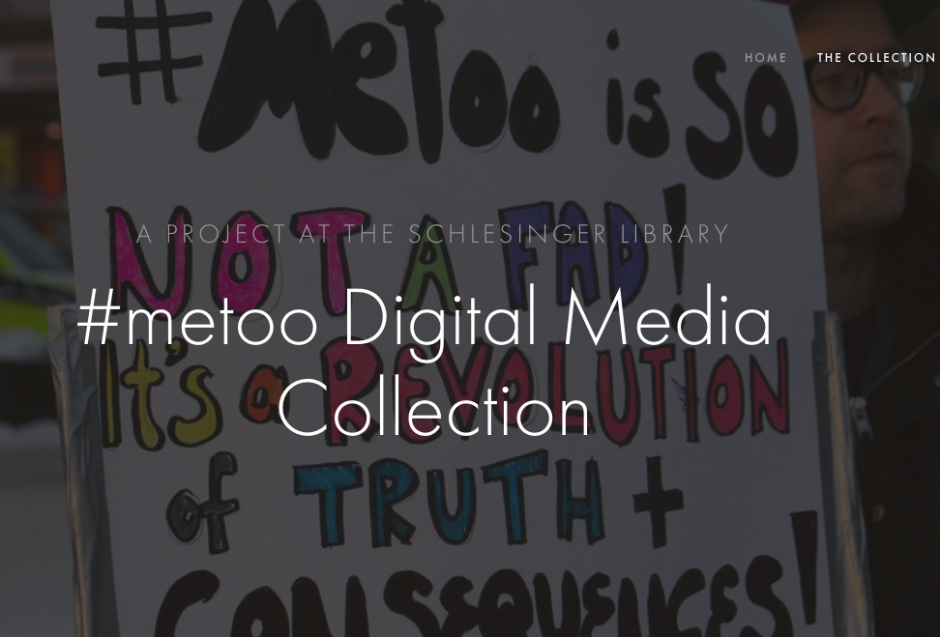 | 12. Impact of the #MeToo Hashtag  