Nataly Valdibia
Professor Anderson
ENGL 480
January 25, 2020
The Digitization of William Blake
William Blake is an artist from the eighteenth-century who practiced in a multitude of artistic disciplines, such as engraving, printing, crafting poetry, sketching, painting, and writing prose. Across the span of his lifetime, Blake created an abundance of engraving plates and works of poetry and prose that corresponded with his visual images of the stories, and his engravings were in a constant state of evolution and progression as his work was never complete in his eyes. William Blake produced a myriad of variations of each specific plate with alterations in color and detail, all of which can be found on the William Blake Archive. The archive is a digitization of all of William Blake’s collected work, both published during his lifetime and posthumously. As a result of revolutionary technology in recent decades, the development of the internet and digitizing tools that allow the expansion of knowledge across the world-wide platform, the field of humanities has experienced a growth in possibilities and and recognition. The William Blake Archive is an ongoing project in the digital humanities that exemplifies the benefit of digitization and the overall advantage technology presents to academic disciplines and fields.
William Blake used his art as a method of commenting on the time in which he lived in, condemning society and promoting change for humanity. One collection of poetry by Blake is titled “Songs of Innocence,” including arguments made by Blake against societal standards and practices such as child labor, sexism, organized religion, and urbanization. “London” focuses on the city in England whose population is climbing while diminishing the mental and societal states in the city as a consequence of city life and oppression of citizens perceived to be in lower standing to white men, such as women. Women were not provided with as much opportunity as men, leading to the mentioned issue of prostitution. In “Holy Thursday,” Blake asks his readers to contemplate the true values of Christianity and what it means to be a “good” Christian who upholds God’s views and wishes, challenging the idea of acting as a herded sheep who blindly follow teachings of the church rather than developing a personal and true relationship with God. The collection takes pure ideas and images and incorporates Blake’s personal beliefs throughout the work. The cover plate depicts a beautifully innocent image from “The Nurse’s Song” to set the tone for the collection of poetry. As displayed in the plates below, only three of many, a progression is seen in the details of the image as well as the colors and the intensity of each component in the plate. The disparity conveys the constant improvements and alterations made by Blake, resulting in a large assortment of engravings for each work.

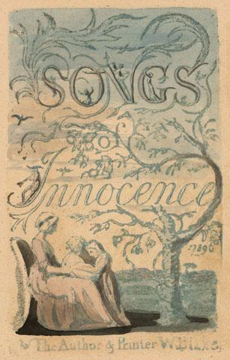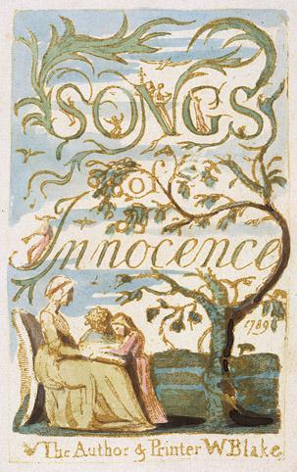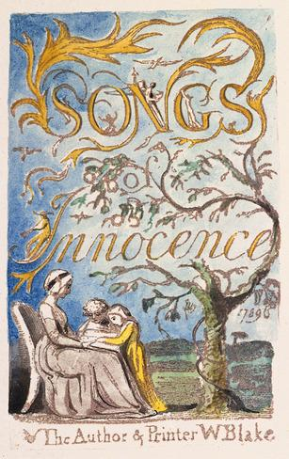
On account of technological advancements, the process of digitizing sanctioned the potential to form large-scale humanities projects that transported information to a greater extent than scholarly book publications had ever permitted. The artistic products amassed by Blake by his own hand amounted to a desire to provide world-wide access to the plates and text rather than requiring travel to The Library of Congress or Harvard University to examine pieces that have been greatly spread out. The motivations of providing greater accessibility to William Blake’s work and ideology paired with the aspiration of scholars to compare the vast amount of editions of each object to one another prompted the creation of one of the first digital humanities projects in 1993: The William Blake Archive (Jones). The ability to compare versions of the same engraving prompts the rise of questions as to the purpose of the variations, and having access to the plates allows questions to be more effectively researched and answered. The archive provides readily available access to all versions of Blake’s plate engravings, as well as his prose and poetry with their transcriptions (Glass).
In order to obtain the photographs of the engravings and works that are widely spread out around the world, the team working on the archive partners with institutions and acquires permission to the photos for the archive, photos which are intricately taken to capture coloration and detail as precisely as possible. However, due to incompatibility between the perception of the human eye and a camera or computer, team members such as Joe Fletcher must manually alter coloration to accurately display Blake’s work and intention. Those who work on the website, spend a great deal of time manually transcribing text that is not accurately accounted for or registered by computers, in addition to creating the markup and tagging for images and text to allow the proper access to all of Blake’s material as a computer cannot recognize what the human eye can and therefore will not efficiently transcribe or tag as it may not register an image of a rose the way the eye does.
Although computers are a wildly advantageous tool, they are not capable of completing all the same functions as a human. “Digitization is the process of changing from analog to digital form,” however, digitization still requires the manual labor of humans to fully render a source (Bloomberg). Upon searching the word “rose” in the search engine of the archive, categories appear, allowing a more specific search of titles that include “rose,” or photos or transcriptions that have been tagged with the word. After clicking on the desired object, such as the poem “The Sick Rose, ” the object will be the focus on the screen in addition to the transcription of the text in the image.
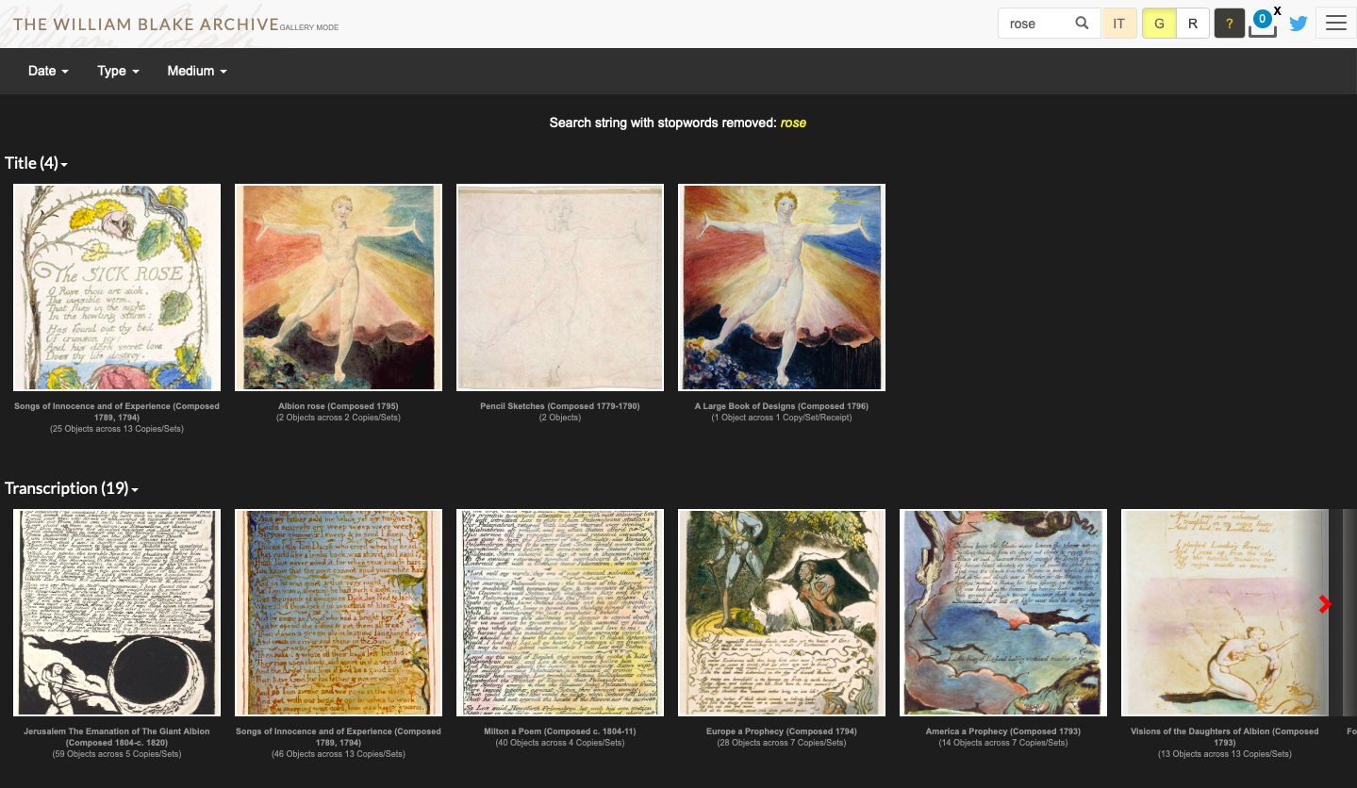
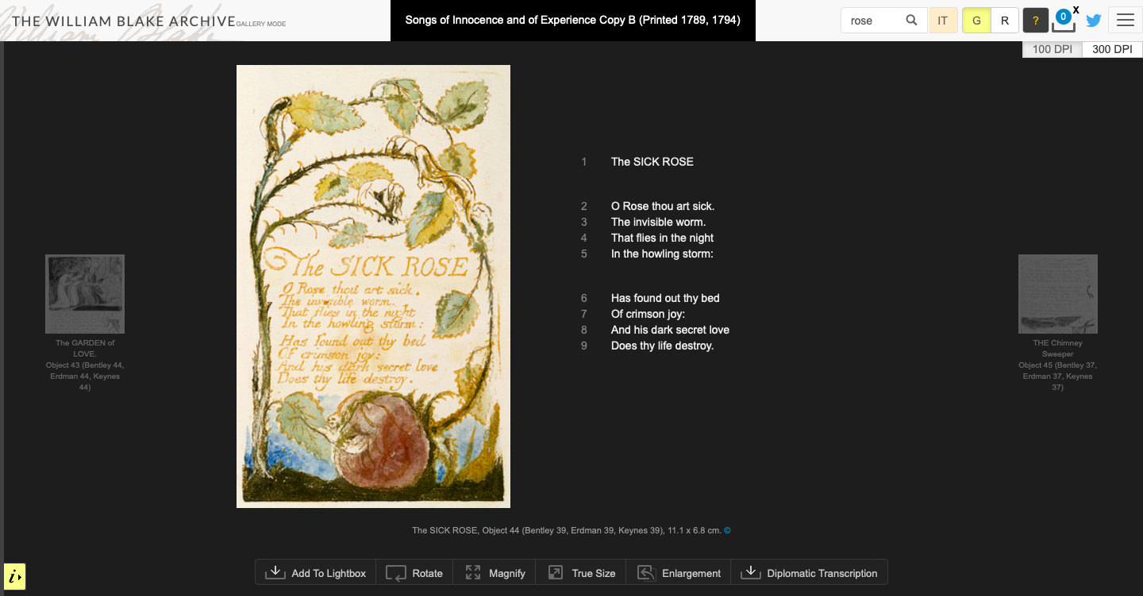
Additionally, functions are provided that permit the comparison of objects with matching matter, useful in comparing different editions of Blake’s work to analyze the progression in the piece as it evolved with detail and color choice or pigmentation. A computer may not identify every component of a digitized record; therefore, the tagging and markup is done by a member working on the archive to correctly display all available information and sources; moreover, the core task for the archive is describing images as computers are not fully capable (Glass). Digitization makes the archive possible, but technology is not adequate enough to eliminate the need for project members to finish the task that a computer cannot wholly fulfill.
The digital humanities is a field that represents “cultural artifacts in a digital format,” and it complicates what is deemed as scholarship (Glass). Scholarship, prior to the digital age, was accredited to published text in book format, however, the Blake Archive was the first scholarly project to be awarded in the digital humanities. The benefit of digitizing extends not only to expanding the breadth of knowledge distributed by the humanities, but also to broaden the scope of the humanities and what it means to work in the department regardless of the discipline incorporated in the scholarly humanities work.

Works Cited
“The William Blake Archive.” The William Blake Archive, www.blakearchive.org/.
Jones, Steven E. “The William Blake Archive: An Overview.” Literature Compass, vol. 3, no. 3, 2006, pp. 409–416., doi:10.1111/j.1741-4113.2006.00331.x.
Bloomberg, Jason. “Digitization, Digitalization, And Digital Transformation: Confuse Them At Your Peril.” Forbes, Forbes Magazine, 17 May 2018,
www.forbes.com/sites/jasonbloomberg/2018/04/29/digitization-digitalization-and-digital-
transformation-confuse-them-at-your-peril/#24b99cb12f2c.
Grant Glass - In-person interview

