Between Page and Screen

You type “augmented reality” into Google and are given about 115,000,000 results in 0.67 seconds. You get a definition, an example, a news article, a hot take. You switch tabs and search the same term in the Electronic Literature Database, a page you bookmarked a little over a year ago when you were taking a break. Symbol making, using, misusing; “augmented reality.” You hit enter. You find a project called Between Page and Screen and click on it. You see a screenshot, an artist’s statement, a link to somewhere else. You click. You are curious. You seek out a book that is not meant for you. You think you can find it in the library. You do. You hold a small, red paperback with no words on its pages. You flip through, you cannot read. You were expecting this. Black Quick Response (QR) codes mark the center of each page, pixelated hieroglyphs meant for a different reader. You open your computer, a new window, you type in the address. You see yourself, your webcam is on, it has to be. You’ve had a smudge of pen on your cheek. No one told you. You wipe the smudge, spreading it out, not really removing it.
You hold the book in front of your face. You hold it towards the camera, like you’re showing a picture book to a classroom of kindergartners sitting on a scratchy, durable rug. Black text appears, your face an opaque background. It’s backwards, you cannot read. You were not expecting this. You frown, you can see yourself. You turn the book back towards you, as though you could read it. Left to right. You prop your elbows up, so you can be seen trying to read. Black text appears, right side around this time.
A letter, a love letter, a make-up letter, after maybe a break-up letter. You flip through. Page and Screen have a lot to say to one another, you watch. They like to send things—material things—back and forth. Letters move. You’re in control, making letters move. You’re just watching, though, too. You see yourself. You see page and screen, Page and Screen, their moving letters. The address where all the movement happens. The computer you bought refurbished from the Apple store on West 14th Street. The programming of it all.
In an alliterative, cryptic letter from Page to Screen, Page writes:

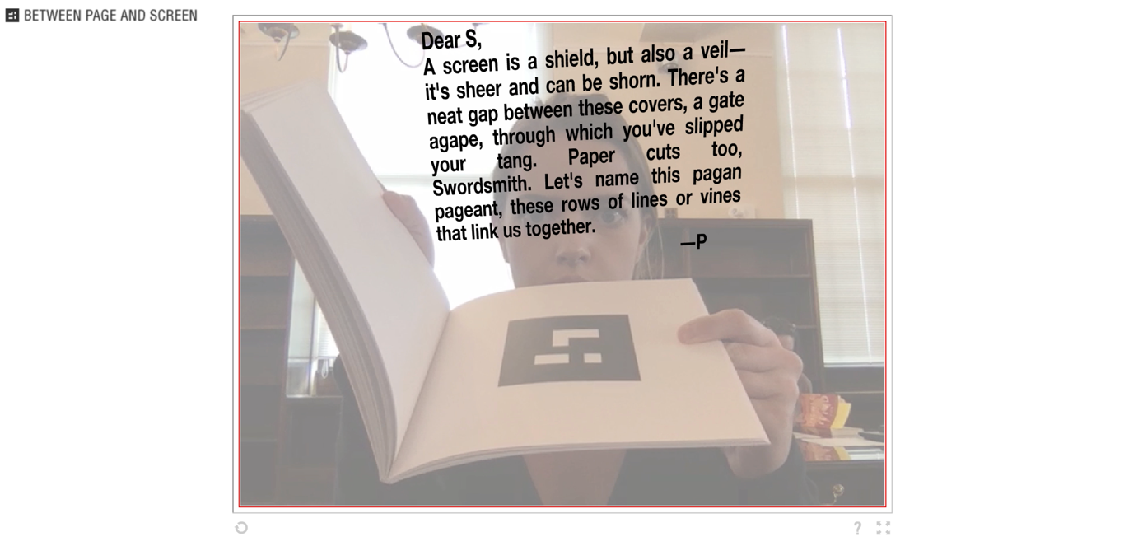
(author’s own photo, Between Page and Screen, Borsuk)

Through your screen Page says, “A screen is a shield, but also a veil—it’s sheer and can be shorn…” Page makes a point. Your screen is not Screen, not not Screen either. Both Screen and your own are material, contingent. Page knows the same thing about themselves, asking later to “name this pagan pageant, these rows of lines or vines that link us together.”
Page and Screen both need language, text, to act, alone or together. In a subsequent plea, Screen implores: “Page, don’t cage me.” Screen says, later, “We share text’s fleshy network—your trellis and my tendency to excoriate, your fang and my carnassials.”
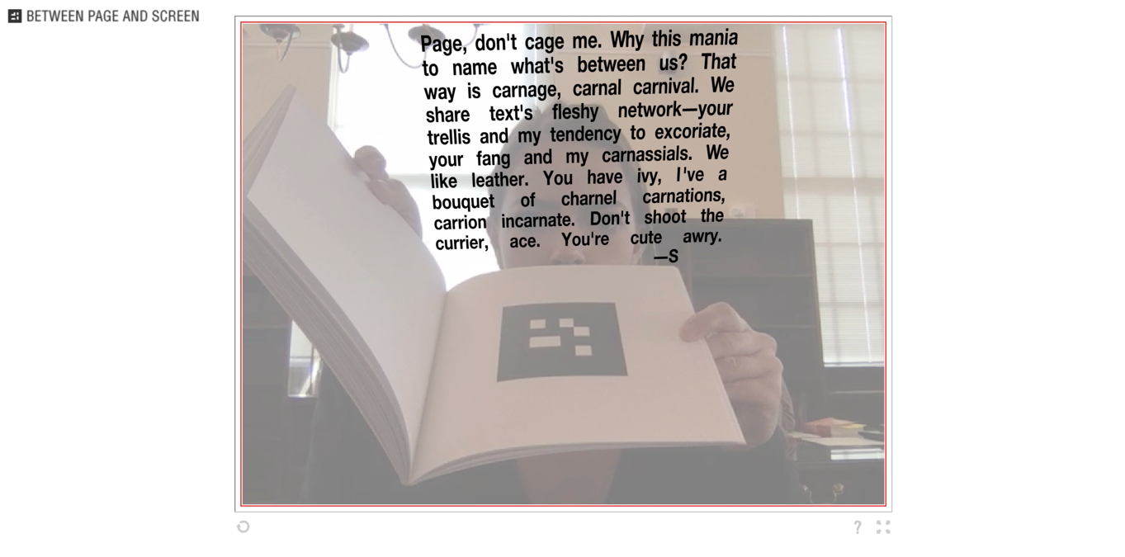

(author’s own photo, Between Page and Screen, Borsuk)

Screen places page and screen on opposite sides of the same coin—their shared “text’s fleshy network,” language as symbolic action unites them. Text to them both is different. Page’s text is not the same as Screen’s. Text is Page’s “trellis.” It is a structure to climb upon and grow. It reverses what it mean to print. Text is also Screen’s “tendency to excoriate.” Text is an act, a “tendency,” a dynamic opportunity to be critical and cutting. Text needs Page and Screen to make symbolic meaning, to enable symbolic action.
Page makes explicit what you have been led to conclude all along. The “trellis” of text for the page is a metaphor, just as text is “tendency to excoriate” for Screen. You remember something you read this week, about metaphor, about metaphor as a different color filter lens through which to see. You think that might be what’s happening.
Page, in the next letter you see, blurs the different color filters, a two-way lens, perspective upon one another. Page sees “text,” “trellis,” and “metaphor” all at once. They are all in terms of one another. Each is its own node in text’s “fleshy network.”

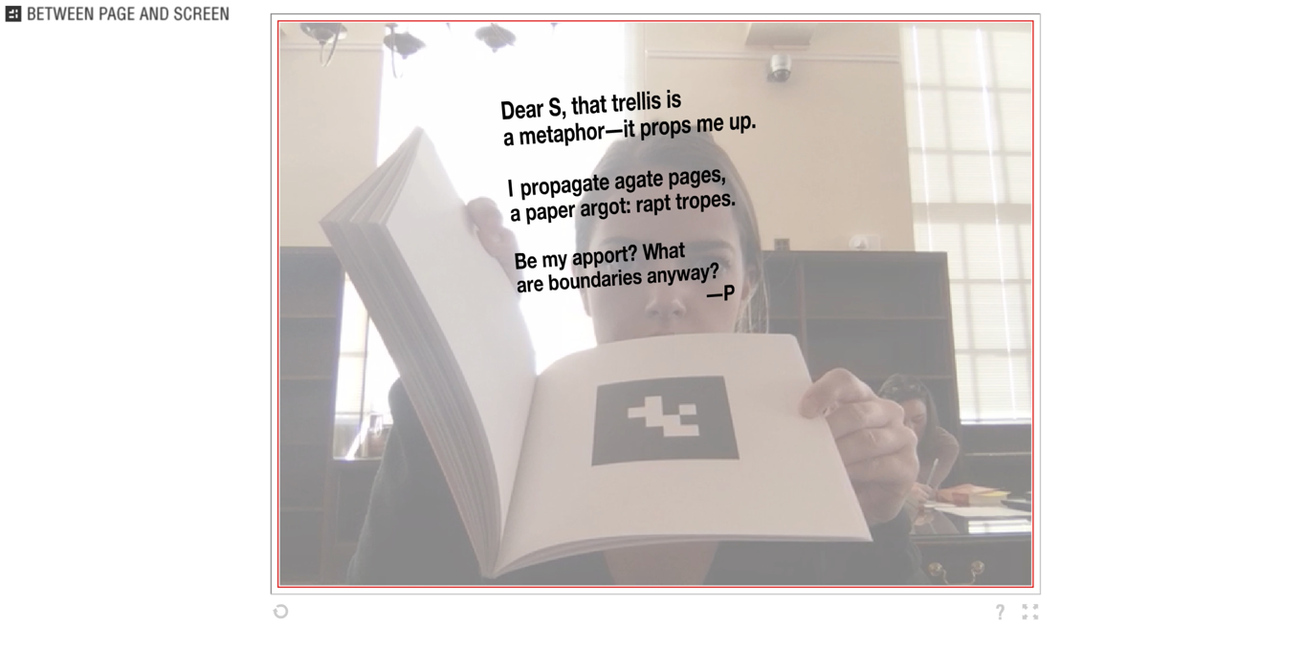
(author’s own photo, Between Page and Screen, Borsuk)

Page ends their letter, asking “What are boundaries anyway?” You ask yourself too. Of Page, of Screen, of page, of screen, of your own face coming back into focus as you close the book. The boundaries of both Page and Screen, pages and screens, are material, are symbolic. The digital-virtual space is legible, it invites you in. You start to understand and play with these materials that do the work of symbols. You start to understand the symbols that do the work of materials.
You see yourself, the room behind you. The big double-paned windows, the girl sitting flipping through an older and larger rare book. You close the window. You check your email. You rub the spot on your cheek, where Page signed off, hoping to smear the ink enough to make it not visible. You remind yourself to go to the bathroom before that meeting. You flip through the book one more time. You use the arms of the chair to stand up slowly. Your foot is asleep. An afternoon sunbeam hits the right angle through the window, temporarily blinding you. Your foot and your vision are the same for a moment. Muted, variable, pixelated. You turn the book in.

Works Referenced

Borsuk, Amaranth, and Brad Bouse. “Between Page And Screen, a Digital Popup Book.” Between Page And Screen, 2012, www.betweenpageandscreen.com/.
Burke, Kenneth. Language as Symbolic Action Essays on Life, Literature, and Method. Univ. of California Press, 2013.
Hayles, N. Katherine. “How We Read: Close, Hyper, Machine.” ADE Bulletin, 2010, pp. 62–79., doi:10.1632/ade.150.62.
Manovich, Lev. “The Poetics of Augmented Space.” Visual Communication, vol. 5, no. 2, June 2006, pp. 219–240, doi:10.1177/1470357206065527.
“Modern Poetry.” Performance by Amaranth Borsuk, YouTube, University of Washington, 2017, www.youtube.com/watch?v=ZlbTKd0-hHM.
Pressman, Jessica. “Reorienting Ourselves toward the Material: Between Page and Screen as Case Study.” Comparative Literature, vol. 70, no. 3, 2018, pp. 317–336., doi:10.1215/00104124-6991733.
Rapatzikou, Tatiani G. “Reading Machines and Reading Subjects in Amaranth Borsuk and Brad Bouse's Between Page and Screen,” War on the Human: New Responses to an Ever-Present Debate. Cambridge Scholars, 2017.

Kenneth Burke famously writes in the “Definition of Man” that “Man is the symbol-using (symbol-making, symbol-misusing) animal, inventor of the negative (or moralized by the negative), separated from his natural condition by instruments of his own making, goaded by the spirit of hierarchy (or moved by the sense of order), and rotten with perfection” (Burke, 6).
“You open its covers and realize immediately that this is not for you” writes Jessica Pressman in “Reorienting Ourselves toward the Material: Between Page and Screen as Case Study:” (Pressman, 317).
Tatiani Rapatzikou, in “Reading Machines and Reading Subjects in Amaranth Borsuk and Brad Bouse's Between Page and Screen,” notes that “The readers here are caught up in a self-mirroring but virtual effect: what they see on the computer screen is a digitally-constructed, rather than a merely reflective, image of themselves—which in turn appears to co-habit the same virtual space as the text activated in it” (Rapatzikou, 103).
Pressman writes of Between Page and Screen that “this work’s text appears through not only linguistic but also programmatic acts of translation; furthermore, when it does appear, it comments upon the materiality of text and textual media” (Pressman, 317).
Kenneth Burke in his essay “Terministic Screens,” writes: “Even if any given terminology is a reflection of reality, by its very nature as a terminology it must be a selection of reality; and to this extent must function also as a deflection of reality” (Burke, 45).
Kenneth Burke in “Four Master Tropes” writes that “metaphor tells us something about one character as considered from the point of view of another character. And to consider A from the point of view of B is, of course, to use B as a perspective upon A” (Burke, 422).
N. Katherine Hayles writes that “it is time to rethink what reading is and how it works in the rich mixtures of words and images, sounds and animations, graphics and letters that constitute the environments of twenty-first-century literacies” in her article “How We Read: Close, Hyper, Machine” (Hayles, 78).
Lev Manovich in “The Poetics of Augmented Space” writes that, “The space that symbolizes the Information Age is not the symmetrical and ornamental space of traditional architecture, the rectangular volumes of modernism, nor the broken and blown-up volumes of deconstruction. Rather, it is space whose shapes are inherently mutable and whose soft contours act as a metaphor for the key quality of computer-driven representations and systems: variability” (Manovich, 234).

