Language, Vaccines, and Tweets, Oh My!

Exploring the Influence of Twitter and Language on the Vaccine Debate

THE RUN DOWN

How many characters does it take to influence an opinion? Twitter gives you 280, but do you even need that many? Up to this point, I’ve already used around 130. Nothing profound came out of those 130 characters, but they do make an interesting point about how complex language can be within a simple tweet.
I say we play a game. First, I’m going to write an informative report (or try to) about the influence of language and what I’m going to call “feigned” language on social media surrounding vaccinations. Then, I’m going to slowly reduce the same report down to the length of a single tweet in an attempt to show how language can be both limited and divisive.

PURE “ACADEMIA”

To many, the Twitter-verse seems like a hodgepodge of mediocre humor and politically fueled outbursts. In a sense, it is, but these Twitter scuffles people laugh at and retweet influence how we view others with different beliefs and can act to further polarize discussion. I’m not arguing that Tweets completely alters one’s viewpoints, evidenced by R. Kelly Grant’s study on the subject, but I am arguing that people tend to follow, like, and retweet things they already agree with, strengthening a person’s existing beliefs.^{[1]}
Twitter bots aim to do just that. These programmable, variably annoying, little critters exist for a myriad of reasons, but the most famous involve politics. Bots can perform all the actions of a real person on Twitter, but their functionality has a distinct purpose. By subjecting users to “echo chambers,” or spaces where a person’s own opinions are represented in the content they see, Twitter bots solidify certain ideologies.^{[2]} Conversely, these bots can also inject themselves into an opposing chamber, rousing frustration by the opposition that further divides groups. The more stubborn the person, the more effective the bot. As humans, we love to have a sense of belonging, and bots give us that. However, they also do the opposite, which makes them dangerous.
With the frequency of annual, “trendy” outbreaks of disease, it becomes very easy for misinformation to spread. Evidenced by the Ebola epidemic around 2015, the pure frequency and discourse about the ailment on social media was staggering. Outbreak control becomes extremely important in instances like this and even the ongoing coronavirus epidemic. In many cases, health information circulating on social media platforms can potentially save lives, with misinformation flowing at very low rates.^{[4]} The difference between these outbreaks and vaccination roots itself in purpose. Twitter bots have little reason to spread misinformation on the coronavirus or Ebola outside of driving traffic to news outlets for potential profit. There is no political gain to be had and the outbreak will (hopefully) be cured soon after Patient X is identified, killing any longevity the trend will have. The vaccination debate remains an outlier. Adam Wakefield’s notorious, and since debunked, “medical” report linking vaccinations to autism in children almost 20 years ago has acted as a catalyst and vehicle for ongoing debate, and bots are partly to blame for its continuation.
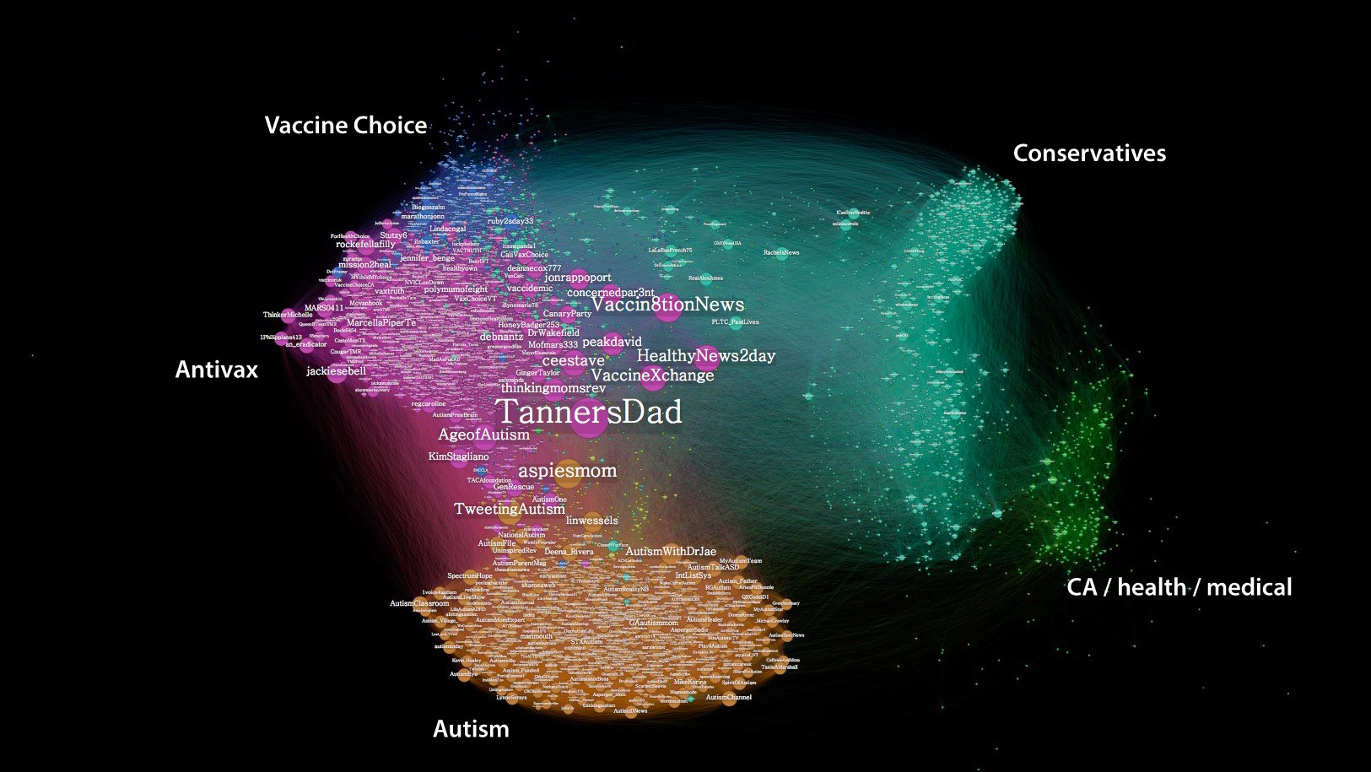
Using an existing issue as the “clickbait,” bots link these disputes with other controversial topics to further engage users. Politics are arguably the most divisive entity in modern history. Everyone has an opinion or has at least familiarized themselves with certain aspects of the new reality show that is United States politics. So, tying disruptive words like “Conservatives” and “Choice” to a Tweet creates more tension and interaction than one only incorporating “Antivax”. The above diagram links trends and relevant groups to establish a network of discourse, allowing us to view various kinds of interactions and evaluate why certain trends occur.
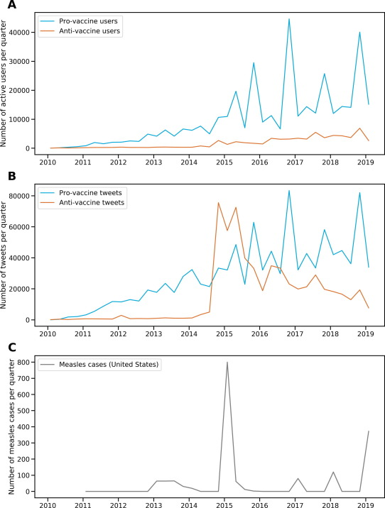
As evidenced by the graphs above, there was a strong relationship between Anti-vaccine tweets and Measles cases in 2015. However, as the number of Pro-vaccine tweets trounces Anti-vaccine tweets, the Anti-vaccine base continues to grow. By enabling these aforementioned “echo chambers,” social media has created a certain amount of ideological isolation. Many interactions between pro and anti-vaxxers stem from other, politically charged debates, continuing a cycle of unapologetic divergence that is unlikely to be remedied within the current climate. Furthermore, people tend to follow trends in their thought processes. If they believe one conspiracy, they are likely more susceptible to similar belief systems. This point reigns true for the dangerous spread of health misinformation. If a group blatantly distrusts a source on one front, why would they turn to them for other information? Someone’s political beliefs may interfere with their trust in health resources, enabling trends like the ones shown above. Utilizing this distrust to their advantage, Twitter bots not only encourage misinformation spread, but they pit people against one another to create a virtual “scene.”
Bots are not necessarily smart, but they are manipulative. In recent years, there have been numerous counterprograms to identify bots, and more recently to identify them in any language. Sites like Botometer make these Twitter bots easily detectable by monitoring an account’s frequency, language, and time of activity. You can program a bot to act “human” by having it sleep between certain hours or limit its frequency of tweets on certain days, but that does not make it real. As I said, they may not be smart on their own, but they remain abundantly divisive. Their use of “feigned” language, or programmable discourse and action surrounding a topic, allows them to continue dividing the online climate. Twitter culture allows for choppy sentences and non-existent grammar, allowing many bots to effortlessly pass as a real person without much coordination.
Twitter and social media as a whole are dangerous. But, in many cases, they are a necessary evil. With the demographics on Twitter being incredibly wide, information can reach an incredibly large audience very quickly. As previously mentioned, there are dangers to having an unchecked information system, which Twitter and other outlets have begun to remedy by marking certain tweets and articles as potentially misleading. However, the ability to know where a disease is most prevalent, where the latest incident occurred, and how something can be prevented is invaluable. But, the vaccination issue and others like it are directly affected by the weaknesses of social media and its ongoing unethical enablement. Trying to identify Twitter bots using this “feigned” language, although fairly simple, is not something most of the population is cognizant of while aimlessly scrolling through Twitter. Herein lies our biggest problem, we like to isolate ourselves. We see the retweets of our friends and people we trust and take that information at face value, only seeing the oppositions responses when it directly conflicts with our own in a very public way. Divisive language engages us because we don’t like being opposed, which further empowers these bots to suppress neutral, civilized arguments and replace them with disruptive instances that get people talking.

CONDENSED “ACADEMIA”

Twitter bots have become a nuisance in the last decade, controlling flow of conversation online and creating divisive conversation between real people online. Things like “echo chambers,” wherein people mainly interact with those with similar belief systems are partly to blame for this continued bad blood within the vaccination debate. Anti-vax Twitter users have been on the rise despite increasing Pro-vax users. The language and ties to other divisive entities has allowed Twitter bots to thrive. With the auto-pilot nature of these bots, they can incessantly create conflict. They may be able to mimic certain behaviors of real users, but new programs have enabled a quick way to distinguish bot from human based on language and frequency of activity. In short, Twitter bots can enable isolation in ideology through “feigned” language and conduct, but they are inherently poor at spreading health misinformation. Because of this, Twitter remains a quick and important source of information for a large demographic, despite its enablement of prolonged division on issues like vaccination, where hard evidence counters the oppositions cries of deception.

TWEET: 280 CHARCTERS (CIRCA 2020)

Ever since Twitter bots became a thing, infuriating tweets have become more and more common. Anti-vaxxers don’t care about hard evidence. New programs were invented to detect them, but most people are too lazy to use them or don’t care enough to check.

TWEET: 140 CHARACTERS (CIRCA 2016)

Twitter bots suck. They make people even more spiteful and unwilling to change. They allow Anti-vaxxers to continue being a nuisance.

CITATIONS

“Bots and Russian Trolls Influenced Vaccine Discussion on Twitter, Research Finds.” ScienceDaily, ScienceDaily, 23 Aug. 2018, www.sciencedaily.com/releases/2018/08/180823171035.htm.

“Social Media Has Remarkably Small Impact on Americans' Beliefs, Research Finds.” ScienceDaily, ScienceDaily, 27 Mar. 2019, www.sciencedaily.com/releases/2019/03/190327142108.htm.

“The American Journal of Public Health (AJPH) from the American Public Health Association (APHA) Publications.” American Public Health Association (APHA) Publications, ajph.aphapublications.org/doi/full/10.2105/ajph.2018.304567.

Aalto University, Science X. “2.7 Billion Tweets Confirm Echo Chambers in Twitter Are Very Real.” Phys.org, Phys.org, 24 Apr. 2018, phys.org/news/2018-04-billion-tweets-echo-chambers-twitter.html.

Fung, Isaac Chun-Hai, et al. “Social Media's Initial Reaction to Information and Misinformation on Ebola, August 2014: Facts and Rumors.” Public Health Reports (Washington, D.C. : 1974), Association of Schools of Public Health, 2016, www.ncbi.nlm.nih.gov/pmc/articles/PMC4869079/#B21.

Garimella, et al. “Political Discourse on Social Media: Echo Chambers, Gatekeepers, and the Price of Bipartisanship.” ArXiv.org, 19 Feb. 2018, arxiv.org/abs/1801.01665.
Garrett, R. Kelly. “Social Media's Contribution to Political Misperceptions in U.S. Presidential Elections.” PLOS ONE, Public Library of Science, journals.plos.org/plosone/article?id=10.1371/journal.pone.0213500.

Gunaratne, Keith, et al. “Temporal Trends in Anti-Vaccine Discourse on Twitter.” Vaccine, Elsevier, 9 July 2019, www.sciencedirect.com/science/article/pii/S0264410X1930876X.

Lotan, Renee DiResta and Gilad. “Anti-Vaxxers Are Using Twitter to Manipulate a Vaccine Bill.” Wired, Conde Nast, 3 June 2017, www.wired.com/2015/06/antivaxxers-influencing-legislation/.

Trethewey, Samuel P., et al. “Medical Misinformation on Social Media.” Circulation, 30 Sept. 2019, www.ahajournals.org/doi/full/10.1161/CIRCULATIONAHA.119.041719.

