Phoebe Powers
ENGL 480
DH Project
#MeToo Movement
Inception of #MeToo
In 2006, social activist Tarana Burke created an activist group, Me Too, intended to offer support for survivors of sexual assault. Using the social media platform, MySpace, Burke began using the me too phrase to speak on instances of sexual harassment, especially perpetuated against women of color.
The #MeToo Movement gained major traction and global notoriety in 2017 when well-known actresses began coming forward and publicly detailing their own personal experiences dealing with sexual assault in the film industry. In October of 2017, the New York Times published a bombshell article alleging dozens of accounts of sexual assault stories at the hands of well-known Hollywood producer Harvey Weinstein.
Ten days after the New York Times’s Weinstein expose, actress Alyssa Milano tweeted, “If you’ve been sexually harassed or assaulted write ‘me too’ as a reply to this tweet.” This ignited a global flood of posts on social media of survivors of sexual assault sharing their experience or simply acknowledging that they too are one of the many survivors sexual assault.
A few days later, Olympic gymnast McKayla Maroney, again using Twitter as a platform, comes forward with information that she was sexually assaulted by the U.S. gymnastics team doctor Larry Nassar. Maroney is soon joined by hundreds of other victims who were also sexually assaulted by Nassar during mandatory physicals.
In the weeks and months that followed, dozens of powerful figures were being publicly accused of sexual abuse. The list includes but is not limited to: actor Kevin Spacey, politician Roy Moore, comedian Louis C.K., television host Matt Lauer, record executive Russell Simmons, senator Al Franken, chef Mario Batali, actor James Franco, Bill Cosby, Stan Lee, musician R. Kelly, Morgan Freeman, Supreme Court Justice Brett Kavanaugh, billionaire Jeffrey Epstein, Donald Trump, Prince Andrew, and more.

#MeToo Web Archives Collection
In August of 2018, Harvard’s Schlesinger Library initiated a project on the History of Women in America by documenting the digital footprint of the #metoo movement. The web archive includes a wide range of media types, including blog posts, videos, forum threads, social media accounts, personal narratives, news articles, legislative bills, and more. The most frequent publishers include The Harvard Crimson, The Cut, Verdict, Independent Women’s Forum, Twitter, Reddit, Playboy, Medium, Essence, Feministing, American Civil Liberties Union, and the New York Times. Subject categories include but are not limited to: hospitality, Christians, contracts, sex workers, agricultural, sports, flight attendants, and more.

Gender in the Digital Humanities
As computer science is a pre-dominantly male-based field, the accessibility
In her analysis of feminist digital literary archives in an article written for the Digital Humanities Quarterly, Jacqueline Wernimont says, “Digital archives unite two historically gendered fields — computer and archival sciences. Literary scholars who depend on archival or rare book materials still confront, whether they acknowledge it or not, the legacy of an institutional form through which patriarchal power exercised the authority to determine value, classification, and access.” (Wernimont).
As the United States operates under the epoch of a patriarchy, major media and communications tools have been mainly owned and operated by white men. As a result of this, the facility for women, LGBTQ+ folk, and minorities to report their allegations of sexual abuse and actually be taken seriously be the media has been an uphill battle.

Impact of the Hashtag
A key element of the #MeToo Movement is the tool known as the hashtag. The usage of the hashag (#), a meta-data tag, before any combination of characters allows easier methods of searching for messages with a certain theme or word. In a blog post titled “Where’s the Beef? Does Digital Humanities Have to Answer Questions?,” Tom Scheinfeldt writes, “One of the things digital humanities shares with the sciences is a heavy reliance on instruments, on tools. Sometimes new tools are built to answer preexisting questions. Sometimes, as in the case of Hauksbee’s electrical machine, new questions and answers are the byproduct of the creation of new tools.”
In the context of the #MeToo Movement, the hashtag is the tool used to facilitate the message, to expand public discourse on sexual assault and offer a space for victims of abuse to share their stories.
In the following graph, the frequency with which the #MeToo hashtag has been used since October of 2017 is shown. Major spikes include Alyssa Milano’s original tweet that sparked the flame, TIME Magazine’s cover commending the ‘Silence Breakers,’ and Oprah Winfrey’s Golden Globes speech letting sexual abusers know that their time is up to continue getting away with these injustices.

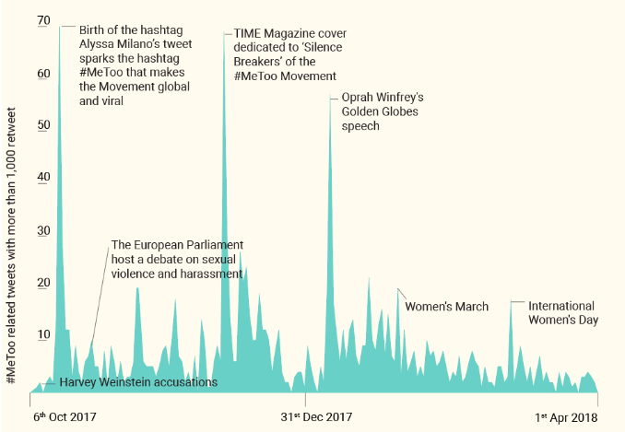

Results of the Movement
Numerous outcomes have flooded out of the #MeToo Movement. One change is that states have begun to ban nondisclosure agreements that cover sexual harassment. Another is that states have begun to expand legal protection for more workers, such as independent contractors, domestic workers, and farm workers. A Legal Defense Fund called Time’s Up was also created to help victims of sexual assault seeking to bring a sexual harassment lawsuit. There has also been a further push to end the tipped minimum wage of $2.13 an hour, which creates dangerous atmospheres in which workers feel subordinate to the customer in order to receive a tip. Furthermore, Congress has reformed some processes for staffers reporting sexual harassment following a slew of scandals within Congress.

Works Cited

“#Metoo Web Archives Collection.” Archive-It, Schlesinger Library, 2018, archive-it.org/collections/10866/?show=Sites&collectionIds=10866.
Brockes, Emma. “#MeToo Founder Tarana Burke: 'You Have to Use Your Privilege to Serve Other People'.” The Guardian, Guardian News and Media, 15 Jan. 2018, www.theguardian.com/world/2018/jan/15/me-too-founder-tarana-burke-women-sexual-assault.
D'Efilippo, Valentina. “The Anatomy of a Hashtag - a Visual Analysis of the MeToo Movement.” Medium, Muzli - Design Inspiration, 27 Sept. 2018, medium.muz.li/the-anatomy-of-a-hashtag-a-visual-analysis-of-the-metoo-movement-ba4ecf9b130b.
“Me Too. Movement.” Me Too Movement, metoomvmt.org/.
“Me Too: Sexual Harassment Awareness & Prevention.” Maryville Online, 23 Jan. 2020, online.maryville.edu/blog/understanding-the-me-too-movement-a-sexual-harassment-awareness-guide/.
North, Anna. “7 Positive Changes That Have Come from the #MeToo Movement.” Vox, Vox Media, 4 Oct. 2019, www.vox.com/identities/2019/10/4/20852639/me-too-movement-sexual-harassment-law-2019.
Wernimont, Jacqueline. “Whence Feminism? Assessing Feminist Interventions in Digital Literary Archives.” Digital Humanities Quarterly, Scripps College, 2013, digitalhumanities.org:8081/dhq/vol/7/1/000156/000156.html.

