Analyzing the “Defund the Police” Twitter Community

Mariah Warner

University of North Carolina at Chapel Hill

ENGL 105

June 29, 2020

**Introduction**

The Black Lives Matter movement is a cause that has been going strong since it was first founded in July of 2013. This multi-dimensional movement has made its mark on the lives of millions of Americans over the years. Though controversial to some, Black Lives Matter has continued to be the topic of discussion around the world. From this movement, several subtopics have also come into light as the motives of the powerful movement has made its way into the spotlight. We have seen movements like Blackout Tuesday in which social media users posted a black screen on their Instagram pages as a protest against the death of black Americans in the hands of police. We have seen movements like Black Trans Lives Matter that aimed to emphasize that black transgender lives should be included in the Black Lives Matter movement as well. Most popular, however, would have to be the most recent Defund the Police movement. This hashtag began to flourish after the death of 46-year-old George Floyd, who was killed by police while being arrested for a fraudulent check. The Defund the Police hashtag has circulated through twitter for months now. Millions of users used this hashtag to express either their support or disapproval for the idea that police funding should be reduced and resources allocated elsewhere. In the midst of the recent protest, more and more tweets using the term #DefundThePolice have surfaced. There have been ample discussions about the motives of this movement on all news forms including Twitter, CNN, Fox News, and MSNBC. These tweets have given us large amounts of data that can be analyzed in order to understand the community of users using the hashtag. These tweets can also be used to analyze online conversations, social dimensions, and social issues that are acknowledged through social media. This essay will focus on analyzing and explaining the conversations associated with the #DefundThePolice movement while also researching social subtopics that are rooted from this particular cause.

**Methods**

The method I used to analyze #DefundThePolice tweets included scraping tweets through a website called TAGS. This was done by searching Twitter in order to find a hashtag that I felt was dynamic enough to analyze further. Once I found one I was comfortable with, I entered the hashtag into the TAGS spreadsheet, which pulled more than 31,500 tweets into my generated spreadsheet. In order to get a smaller pool of tweets, I applied several filters. First, I began to focus on removing tweets that included “RT” which stands for “retweet” in the twitter world. Doing this made it easier for me to find tweets that were authentically generated by the user and not tweets that were responses to other tweets. After doing this, I read through thousands of tweets in order to narrow it down to 100 tweets that I felt most accurately represented both sides of the Defund The Police movement, making sure to save a copy so that I did not lose my original tweet collection. After sifting through the thousands of tweets and narrowing it down to 100, I was now able to separate the tweets into several categories. These categories included a) Type of Appeal: Logical, Emotional, or Ethical b) Type of Communication: Informing, Provoking, or Querying c) Stance on the Topic: Pro or Con d) Rationale: Political, Financial, Informative, Safety, or Opinionated e) User Age: 15-20, 20-30, 30-40, or 40-50 f) Political Leaning: Left or Right. I felt that these six categories would most accurately analyze the 100 tweets. In order to make things easier and keep some consistency, I created a dropdown for each category. Doing this eliminated the possibly of misspelled words or mild discrepancies that could have made it harder to view the tweets as whole. Once the categorization was complete, I was now able to look at a more filtered, uniform version of the tweets that I collected in the beginning. The dropdowns made it easy to recognize patterns within the tweets. Lastly, I worked on creating visuals that put the tweets into a physical chart. I used three types of charts that included pie charts, bar graphs, scatter plots, and pivot tables. Creating the graphs was another reason that the consistency from the dropdowns was crucial. To generate the charts, I chose columns on the excel spreadsheet that I felt were most important to analyze. I felt that the bar graph to represent the stance on the topic was the best because it truly emphasized the political gap between those leaning left and those leaning right within the tweets. Using the pie chart for the type of communication gave a better understanding the goal of each of the tweets. I felt that the use of the scatter plot to represent age because it showed the vast gap between age and thought.

**Data Analysis**

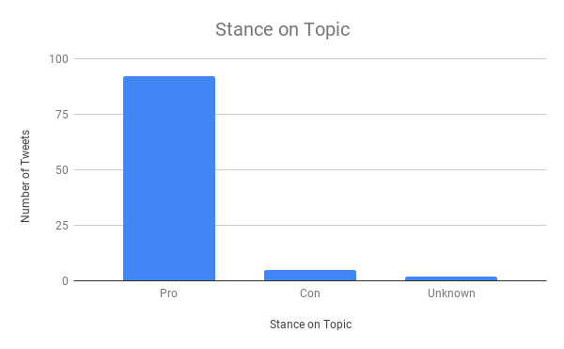After all data was collected, I was finally able analyze my categories. As shown in *Figure 1,* we can see that most people who tweeted “#DefundThePolice” were in favor of the movement. After reading through the tweets, I concluded that this was likely was because the hashtag “Defund the Police” was probably created by someone who felt that the police should be defunded. The only instance of the hashtag being used in opposition to the movement were from two users. In each case, it appeared that the hashtag was only used to grab the attention of those who were in favor of the movement. For example, in a tweet by user @Jessaell58, she used the hashtag to debunk or demean the tweet in which she was responding to. I concluded that this was because she wanted her stance to be seen by the person she was responding to, as well as others searching the hashtag. This same theory goes for the user @AnnaJoon0707 who questioned why defunding the police should be a thing in a place like Chicago, which she emphasized was the murder capital of the world. The use of the hashtag and the mention of Chicago in particular gave me a similar conclusion to the user I mentioned before. Each of the users aimed to express an opinion to those in favor of the movement by using a hashtag that they knew those in favor would use. This strategy was likely used to gain more of an audience about the particular topic while also increasing their tweet reach. I found the chart on the stance on the topic to be interesting because it somewhat contradicted an article I read. In the article, “Most Americans do not Want to Defund the Police” by The Economist, it explained that most Americans felt that there were other ways to control the police. The article explains that 88% felt that better training was required, 87% believed that body cameras should solve the issue and that 67% thought that restraining suspects necks would solve the issue (The Economist, 2020). During my analysis, this confused me because my collection of tweets showed that most people felt that defunding the police was the right solution. I felt this way because 98% of the tweets were in favor of defunding the police. Those opposed failed to use the Twitter hashtag. The analyzation made me wonder how the results of the pro/con graph may have differed if those opposed had used the hashtag as well.

Figure

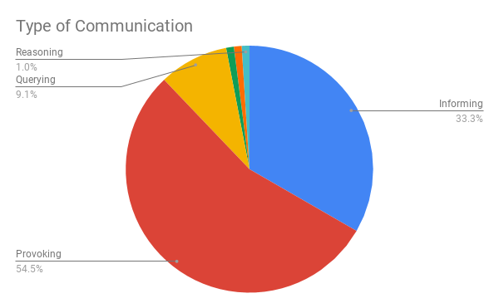 As shown in *Figure 2,* we can see that the results of the type of communication skewed towards “Provoking” the Twitter users. More than 54% of the tweets were aimed to provoke users to hop onboard the Defund the Police movement. This provoking was done by users using different kinds of rhetorical strategies. For example, some users tried to provoke others to join the movement by appealing to emotion. The tweet by @AceBolick states “#DefundThePolice #AbolishICE #BlackLivesMatter it's simple we protect EVERYONE and make the world a better place, instead of tearing others down and feeding the rich”. This user appealed to emotion by saying that going with this movement will “make the world a better place” and that we should not be “tearing each other down”. About 33% of users were there to inform people through the use of logic and facts. This was done by using statistics and numbers. For example, the user @Antonette0491 states “#NewYork crime is up 350%. So, how’s the #DefundThePolice going for ya?”. She used logic in order to satirically state that the movement may not be a good idea. Roughly 9% of users were confused or questioning the movement. They used to hashtag to ask questions and gain more information. Only about 1% of users communicated through reasoning or what I call the “If this, then that” concept. This means that users felt that a reasonable action should come after some other action. For example, *if* the police killed someone, *then* they should be held accountable for their actions or, *if* police are abusing resources, *then* we should defund them to stop this sort of thing from happening. In *Figure 3,* I choose to look further into the age of users by using a scatter plot. I decided that this was best to show that most of the people who were in favor of defunding the police were around the ages of 20-30. Further analysis allowed me to believe that this had to do with the age demographic of the Democratic Party as well as the age demographic for twitter users as a whole. According to Gallup, Democratic affiliation is most popular among those between the ages of 20 and 30 years 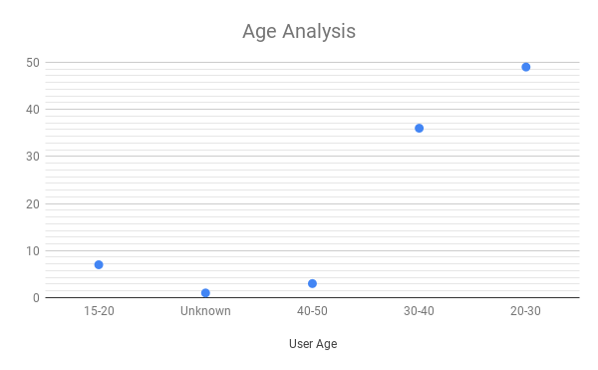of age. Therefore, the Democratic tilt is consistent with those within that age group (Gallup, 2014).

Figure

Figure

**Conclusion**

# Through the extensive analyzation, I was able to conclude several theories related to Twitter conversations, and more specifically Twitter conversations related to #DefundThePolice. I concluded that Twitter allows us to engage in social issues on a completely different level. Through Twitter, we are able to spread information, both positive and negative, about topic we feel passionately about. The use of hashtags makes it easier for users to engage with one another by creating a sort of chatroom related to those specific topics. Twitter allows users to voice their issues directly to those in power. Through this analysis, I was able to conclude that even those in power either have misconceptions about important social movements, or do not support the movements at all. For example, in the article titled “United States : Sens. Cruz, Cotton, Colleagues Introduce Resolution Calling for Justice for George Floyd and Opposing 'Defund the Police'”, Cruz states that he knows that law enforcement has an “important responsibility in upholding our criminal justice system” and that “defunding and abolishing police departments will undoubtedly take us backwards in that endeavor.” (MENA Report, 2020). This misconception that #DefundThePolice is working to abolish the police is important because Republicans hold a lot of power in office. If they believe that this is the motive behind the movement, then those in favor of defunding the police will have a hard time implementing the change they believe in. In the article titled “When it Works to Defund the Police”, Nicolas Kristof emphasizes that defunding the police does not mean getting rid of cops. Instead, it focuses on using the resources elsewhere, like in the school system (Kristof, 2020). I found that defunding the police is rooted from a much deeper cause. In “We Are All Oscar Grant” by Jack Taylor, the root of the #DefundThePolice movement in indirectly explained. The community behind the movement is frustrated and concerned about black lives being killed at a rate that is disproportionate to others. Taylor explains, “We are all Oscar Grant” in that we are all experiencing emotional trauma, death, and mourning in the hands of the police (Taylor, 2020). Like Taylor, the Twitter users feel that the justice system is unfair and does not work in favor of most Americans, especially those of color. With the motives of the movement evident to most, I was able to conclude that those who opposed defunding the police may not have a real concern for the people. I found this shocking, especially when I found that someone who does not support it is Presidential Candidate, Joe Biden. With the #DefundThePolice movement containing predominately-Democratic affiliates, I was taken aback by Biden’s decision to not support the movement. Biden believes that the way to change is through giving federal aid based on whether or not certain standards are met with “decency and honorableness” (Morning Edition, 2020). Seeing this made me question how this movement may turn out. Finally, I was able to conclude that the stance on the movement was likely directly correlated with one’s place in society. Those who did not believe that defunding the police should occur where white, either in a place of power, or both. The use of other hashtags like #BlackLivesMatter, #BlackTransLivesMatter, #BlackExcellence, and #BlackYouthLivesMatter allowed me to conclude that this is more than just defunding the police. Instead, this is a group of people coming together in order to fight for the basic, human right to live.

# Works Cited

Inc, G. (2014, July 10). Party identification varies widely across the age spectrum. Gallup.Com. https://news.gallup.com/poll/172439/party-identification-varies-widely-across-age-spectrum.aspx

Kristof, N. (2020, June 11). When It Works to 'Defund the Police'. *New York Times*, p. A26(L). Retrieved from <https://link-gale-com.libproxy.lib.unc.edu/apps/doc/A626259806/SCIC?u=unc_main&sid=SCIC&xid=750a58fd>

Most Americans do not want to “defund” the police: Daily chart. (2020, Jun 18). The Economist (Online), Retrieved from <http://libproxy.lib.unc.edu/login?url=https://search-proquest-com.libproxy.lib.unc.edu/docview/2414880534?accountid=14244>

Political Organizer On Biden Not Supporting Calls To Defund Police. (2020, June 9). *Morning Edition*. Retrieved from <https://link-gale-com.libproxy.lib.unc.edu/apps/doc/A626804088/SCIC?u=unc_main&sid=SCIC&xid=1a947d82>

Taylor, J. (2013). We Are All Oscar Grant. Retrieved June 27, 2020, from https://anthrosource-onlinelibrary-wiley-com.libproxy.lib.unc.edu/doi/full/10.1111/traa.12010

United States : Sens. cruz, cotton, colleagues introduce resolution calling for justice for george floyd and opposing 'defund the police'. (2020). MENA Report, Retrieved from <http://libproxy.lib.unc.edu/login?url=https://search-proquest-com.libproxy.lib.unc.edu/docview/2412433058?accountid=14244>