Understanding Discussion of Internet Addiction by Twitter Service Mechanism

Tomas Pierce
UNC Chapel Hill
ENGL 105
Daniel Anderson
July 2, 2020

Introduction
Twitter in the context of internet addiction is unusual in that Twitter acts as a means by which information and support can be aquired, yet Twitter contains mechanisms by which internet addiction is entrenched and becomes more difficult to heal.
Methods
In order to analyze twitter discussion, a sample of tweets was taken using the TAGS spreadsheet tool. This sample consists of tweets containing the hashtag #internetaddiction that were posted between July 15 and July 25. The tweets in this sample were then organized into categories. These categories were then charted in order to analyze aspects of the use of twitter for communication on internet addiction. In addition, outside research was referenced when relevant. There are some disputes ovr the best way to characterize internet addiction (Block, 2008). For our purposes, we can use a simplified definition that internet addiction occurs when people are no longer able to control their internet usage, and this does demonstrable harm to themselves or others.
Discussion
Deliberate usage of Twitter appears to be done in part to help deal with internet addiction. As such, usage of the service tends to follow a taxonomy where users act as sources of information, friends, or seekers of information (Honey, 2009). Tweets on this subject can be more specifically divided into tweets that focus on subconcerns related to gaming, lived experiences of the posters and those close to them, connecting to fictional media, connecting to informational media, discussion of consequences including sleep-related ones and others, humor, giving advice, subconcerns related to pornography, connecting to available research, as well as some non-productive activity such as inciting fights (“troll” being a slang term for a poster who does this),
and arguing. Figure 1 shows the percentage of the tweets from the sample in each category.
Figure 1
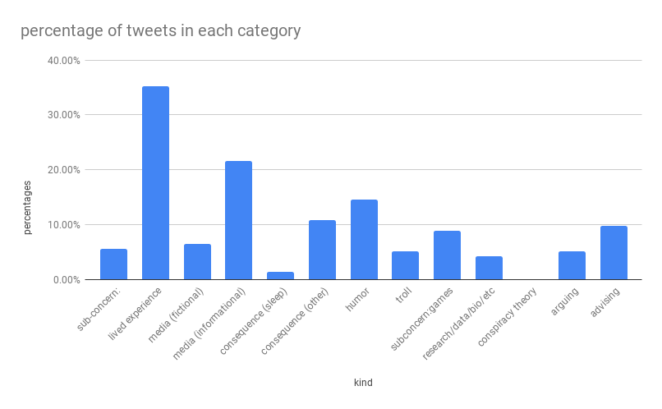
This deliberate usage interacts with the simultaneous usage of the service for continuing function under internet addiction. Multiple tweets within the sample complain of how Twitter compounds the effects of internet addiction. There is at least one that describes being unable to permanently stop use of the service. This is consistent with relapse, a component of addiction where the internet addict tends to resume usage of the service despite actively wanting to stop usage (Kuss, 2014). As can be seen from Figure 1, around 10% of the posts in the sample were discussing consequences of internet addiction, and this group overlaps with the section of tweets detailing lived experiences. Figure 2 shows the direct and indirect consequences of internet addiction that were complained of in the sample.
Figure 2
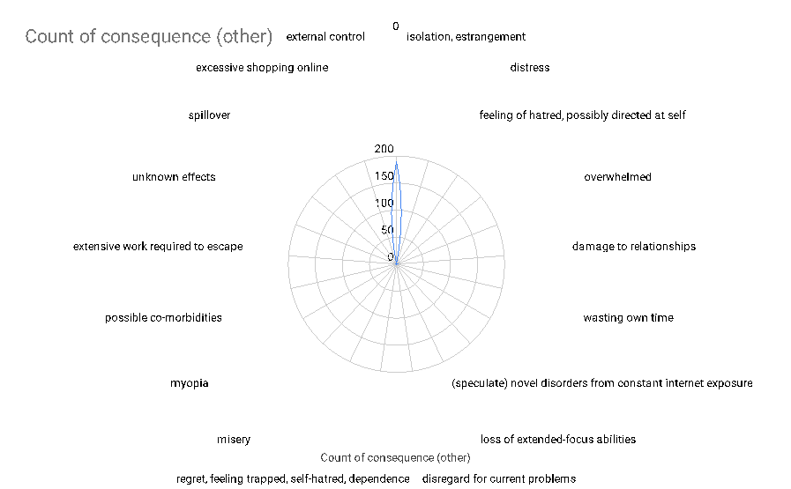
Another effect of internet addiction is sleep deprivation. Sleep deprivation is one of the effects of internet addiction (Shaw, 2008). Multiple tweets within the sample complain of lack of sleep and relating it to internet addiction. Graphing the occurrence of these tweets with respect to time in Figure 3 shows that all tweets in the sample about sleep deprivation occur at night.
Figure 3
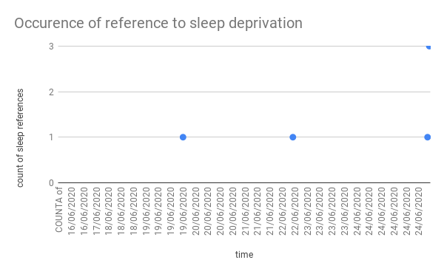

In this subset of the sample, Twitter is used in response to external stimuli. The fact that these complaints about sleep occur during night-time also reflects that Twitter can contribute to internet addiction, on the basis of it being used at night to discuss the effects on sleep.
The various deletorius effects reported appear to generally be effects of internet addiction, whether those effects are direct or indirect. Part of the problem is that, whatever the cause, internet addiction tends to persist. The disorder is resistant to treatment and has high relapse rates (Block, 2008). The reason may have to do with an addiction-derived impariment to impulse control, as this impedes attempts to reduce or stop internet usage. A study using fMRI techniques demonstrated differences in the activation of certain regions of the brain (specificially the anterior and posterior cingulate cortices) that indicates impaired inhibitory control among the study’s sample (Dong, 2012). This would also correspond with the articles referenced by tweets categorized as connecting to informational media.
Connections to media appear to provide mechanisms for understanding and contextualizing experiences related to the topic of internet addiction. Around 20% of the tweets relate to informational media, and about 8% of the tweets relate to fictional media. References to informational media occurred at a much higher frequency than references to fictional media, as shown in Figure 3 and Figure 4.
Figure 4
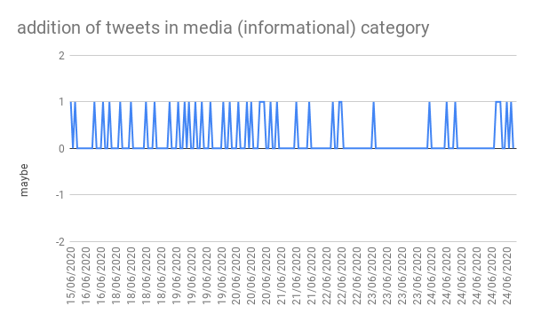

Figure 5

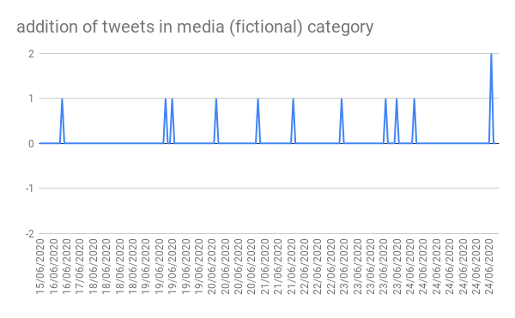

This difference in frequency is most likely due to the subject matter and possibly the timing of the sample rather than some underlying principle. Both kinds of media provide information that allows Twitter users to add external context to their own experiences.
The primary potential benefit of Twitter in the context of internet addiction is that it can enable otherwise isolated sufferers to talk to each other, and possibly help themselves thereby. As can be seen in Figure 5, 28% of the tweets in the sample are discussions of people’s experiences with internet addiction.

Figure 6
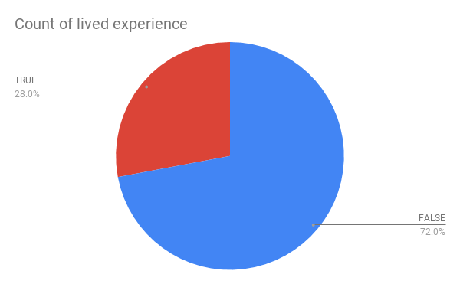

It should be noted that certain aspects of internet addiction, such as an accurate description and category are disputed as of 2012 (Dong).
Conclusion
Given the modern prevalence of the internet, internet addiction may become more common, neccessitating further research on its nature and treatment. That Twitter is used for multiple kinds of communications has been demonstrated, and the irony of its role as mediator and source of solace has been shown. Internet addiction may become more common as internet usage increases among previously disconnected populations. This would necessitate further research into the nature and treatment of internet addiction, as well as a formal definition that merits full inclusion into future versions of the DSM.

References

Block, J. J. (2008). Issues for DSM-V: Internet addiction.

Article is useful because it discusses some of the issues with formulating diagnostic
and clinical criterion for the subject. Connects to discussions about existence of disorder in twitter sample.

Dong, G., DeVito, E. E., Du, X., & Cui, Z. (2012). Impaired inhibitory control in ‘internet addiction disorder’: A functional magnetic resonance imaging study. Psychiatry Research: Neuroimaging, 203(2), 153-158. doi:10.1016/j.pscychresns.2012.02.001

Article is useful becaues of quantitative neuroscience approach that should provide
some information on possible mechanisms for internet addiction to occur and persist. May connect to complaints in twitter sample of different types of reduced function.

Honey, C., & Herring, S. C. (2009, January). Beyond microblogging: Conversation and collaboration via Twitter. In 2009 42nd Hawaii International Conference on System Sciences (pp. 1-10). Ieee.

Article uses grounded theory approach to show how twitter is used for communication, and is thus useful to reference for interpretation of tweets collected on internet addiction.

Kuss, D. J., Kuss, D. J., Shorter, G. W., Shorter, G. W., van Rooij, A. J., van Rooij, A. J., . . . Schoenmakers, T. M. (2014;2013;). Assessing internet addiction using the parsimonious internet addiction components Model—A preliminary study. International Journal of Mental Health and Addiction, 12(3), 351-366. doi:10.1007/s11469-013-9459-9

Article is useful for showing diagnostic and definitional items of internet addiction, and providng a model that may explain formation of internet addictions.
Connects to discussions in sample of nature of internet addiction.

Obeid, S., Saade, S., Haddad, C., Sacre, H., Khansa, W., Al Hajj, R., . . . Hallit, S. (2019). Internet addiction among lebanese adolescents: The role of self-esteem, anger, depression, anxiety, social anxiety and fear, impulsivity, and Aggression—A cross-sectional study. The Journal of Nervous and Mental Disease, 207(10), 838-846. doi:10.1097/NMD.0000000000001034

Article is useful for relating internet addiction to other problems which may provide ways to
address internet addiction using strategies developed for other disorders. Connects to discussions of consequences of internet addictions in twitter sample. May connect to arguments on subject seen in twitter sample.

Shaw, M., & Black, D. W. (2008). Internet addiction: Definition, assessment, epidemiology and clinical management. CNS Drugs, 22(5), 353-365. doi:10.2165/00023210-200822050-00001

Article is useful as high-level overview of the subject of internet addiction and provides strategies that can be used to address internet addiction. Connects to discussion of difficulties dealing with internet addiction in twitter sample.

Young, K. S. (2004). Internet addiction: A new clinical phenomenon and its consequences. American behavioral scientist, 48(4), 402-415.

Article is useful because it characterizes the subject of internet addiction and explains the consequences of this disorder. Connects to the fictional and informational media referenced by elements of the twitter sample.

