Analyzing the “Defund the Police” Twitter Community
Mariah Warner
University of North Carolina at Chapel Hill
ENGL 105
June 29, 2020

Introduction
The Black Lives Matter movement has been going strong since it was first founded in July of 2013. This multi-dimensional movement has made its mark in no small part through the use of hashtags like #BLM or #BlackLivesMatter on social media. Though controversial to some, Black Lives Matter has continued to be a topic of discussion around the world. From this movement, several subtopics have also made their way into the spotlight. We have seen movements like Blackout Tuesday in which social media users posted a black screen on their Instagram pages as a protest against the death of black Americans in the hands of police. We have seen movements like Black Trans Lives Matter that aimed to emphasize that black transgender lives should be included in the Black Lives Matter movement as well. Most popular, however, would have to be the most recent Defund the Police movement. This movement and the associated hashtags began to flourish after the death of 46-year-old George Floyd, who was killed by police while being arrested for a fraudulent check. There have been ample discussions about the motives of this movement on all news forms including Twitter, CNN, Fox News, and MSNBC. The Defund the Police hashtag has circulated through twitter as millions of users express either their support or disapproval for the idea that police funding should be reduced and resources allocated elsewhere. There tweets have given us large amounts of data that can be analyzed in order to understand the community of users posting with the hashtag. These tweets can also be used to analyze online conversations, and social issues that are acknowledged through social media. This essay will focus on analyzing and explaining the conversations associated with the #DefundThePolice movement while also researching subtopics that are linked with this particular cause.
Methods
The method I used to analyze #DefundThePolice tweets included scraping tweets through a tool called TAGS. This was done by entering the hashtag into the TAGS spreadsheet, which pulled more than 31,500 tweets into my generated spreadsheet. In order to get a smaller pool of tweets, I applied several filters. First, I began to focus on removing tweets that included “RT.” which stands for “retweet” in the twitter world. Doing this made it easier for me to find tweets that were authentically generated by the user and not tweets that were responses to other tweets. After doing this, I read through thousands of tweets in order to narrow it down to 100 tweet that I felt most accurately represented both sides of the Defund the Police movement, making sure to save a copy so that I did not lose my original tweet collection. After sifting through the thousands of tweets and narrowing it down to 100, I was now able to separate the tweets into several categories. These categories included a) Type of Appeal: Logical, Emotional, or Ethical b) Type of Communication: Informing, Provoking, or Querying c) Stance on the Topic: Pro or Con d) Rationale: Political, Financial, Informative, Safety, or Opinionated e) User Age: 15-20, 20-30, 30-40, or 40-50; and f) Political Leaning: Left or Right. I felt that these six categories would most accurately capture aspects of the 100 tweets. In order to make things easier and keep some consistency, I created a dropdown for each category. Doing this eliminated the possibly of misspelled words or mild discrepancies that could have made it harder to view the tweets as whole.
Once the categorization was complete, I was now able to recognize patterns within the tweets. Lastly, I worked on creating visuals that put the tweets into charts. I used three types of charts that included pie charts, bar graphs, scatter plots, and pivot tables. Creating the graphs was another reason that the consistency from the dropdowns was crucial. To generate the charts, I chose columns on the spreadsheet that I felt were most important to analyze. I felt that the bar graph to represent the stance on the topic was the best because it truly emphasized the political gap between those leaning left and those leaning right within the tweets. Using the pie chart for the type of communication gave a better understanding the goal of each of the tweets. I felt that the use of the scatter plot to represent age because it showed the vast gap between age and thought.
Data Analysis
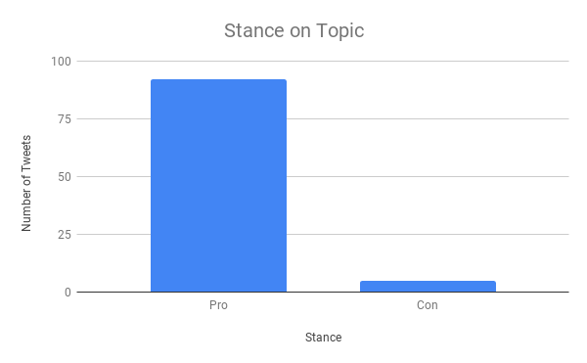
After all data was collected, I was finally able analyze my categories. As shown in Figure 1, most people who tweeted “#DefundThePolice” were in favor of the movement. After reading through the tweets, I concluded that this was likely because the hashtag “Defund the Police” was linked with the activist movements currently enjoying strong support. The only instance of the hashtag being used in opposition to the movement were from two users. In each case, it appeared that the hashtag was only used to grab the attention of those who were in favor of the movement. For example, a tweet by user @Jessaell58 used the hashtag to debunk or demean the tweet in which she was responding to. I concluded that this was because she wanted her stance to be seen by the person she was responding to, as well as others searching the hashtag. This same theory goes for the user @AnnaJoon0707, who questioned why defunding the police should be a thing in a place like Chicago, which she emphasized was the murder capital of the world. The use of the hashtag and the mention of Chicago in particular gave me a similar conclusion that this strategy was likely used to challenge the opposing side while also increasing their tweet reach. I found the support for the topic to be interesting because it somewhat contradicted a popular reporting. The article, “Most Americans do not Want to Defund the Police” by The Economist, explains that most Americans felt that there were other ways to control the police. The article notes that 88% felt that better training was required, 87% believed that body cameras should solve the issue, and that 67% thought that banning chokeholds would solve the issue (The Economist, 2020). These figures run counter to the analysis, which found that 98% of the tweets were in favor of defunding the police. Perhaps those opposed were using a different Twitter hashtag. Alternatively, perhaps the demographics of this particular community favor this stance.
Figure 1
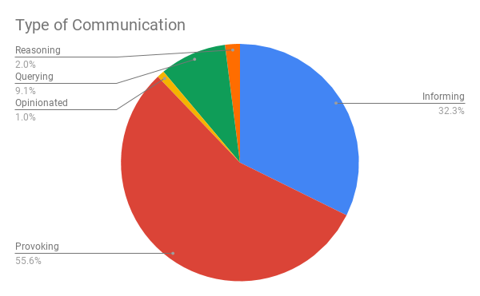
As shown in Figure 2, we can see that the results of the type of communication analysis skewed towards “Provoking” other Twitter users. More than 55% of the tweets were judged to provoke users to hop onboard the Defund the Police movement. This provoking was accomplished through different kinds of rhetorical strategies. For example, some users tried to provoke others to join the movement by appealing to emotion. The tweet by @AceBolick states, “#DefundThePolice #AbolishICE #BlackLivesMatter it's simple we protect EVERYONE and make the world a better place, instead of tearing others down and feeding the rich”. This user appealed to emotion by saying that going with this movement will “make the world a better place” and that we should not be “tearing each other down”. About 33% of users were there to inform people by logic and facts. This was done by using statistics and numbers. For example, the user @Antonette0491 states “#NewYork crime is up 350%. So, how’s the #DefundThePolice going for ya?”. She used logic in order to satirically state that the movement may not be a good idea. Roughly 9% of users were confused or questioning the movement. They used the hashtag to ask questions and gain more information. Only about 1% of users communicated through reasoning or what I call the “If this, then that” concept. This means that users felt that a reasonable action should come after some other action. For example, if the police killed someone, then they should be held accountable for their actions or, if police are abusing resources, then we should defund them to stop this sort of thing from happening.
Figure 2
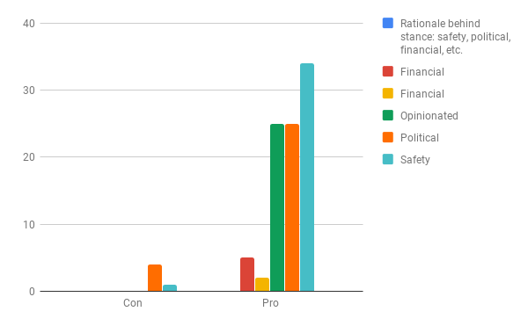
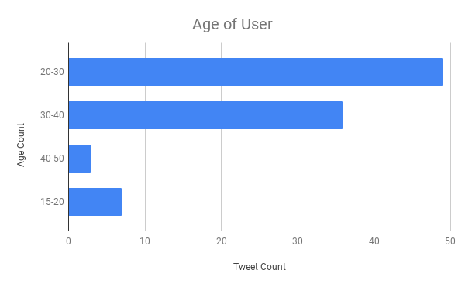
In Figure 3, I choose to look further into the age of users by creating a bar graph. I decided that this was best to show that most of the people who were in favor of defunding the police were around the ages of 20-30. Further analysis suggests that this may be linked with the age demographic of the Democratic Party as well as the age demographic for twitter users as a whole. According to Gallup, Democratic affiliation is most popular among those between 20 and 30 years of age. Therefore, the Democratic tilt is consistent with those within that age group (Gallup, 2014). Figure 4 cross references all the data mentioned above, giving a better understanding of how each of the categories relate to one another as a whole.
Figure 3

Figure 4
Conclusion

Through the analysis, I was able to develop several conclusions related to Twitter conversations, ad more specifically Twitter conversations related to #DefundThePolice. It is clear that Twitter allows us to engage in social issues. The use of hashtags makes it easier for users to engage with one another by creating a sort of chatroom related to those specific topics. It also became clear that the attitudes shared around the hashtag might be disharmonious with those in power. For example, in the article titled “United States : Sens. Cruz, Cotton, Colleagues Introduce Resolution Calling for Justice for George Floyd and Opposing 'Defund the Police',” Senator Ted Cruz states that he knows that law enforcement has an “important responsibility in upholding our criminal justice system” and that “defunding and abolishing police departments will undoubtedly take us backwards in that endeavor” (MENA Report, 2020). The misconception that #DefundThePolice is working to abolish the police is important because Republicans hold a lot of power in office. If they believe that this is the motive behind the movement, then those in favor of defunding the police will have a hard time implementing the change they believe in. In the article titled “When it Works to Defund the Police,” Nicolas Kristof emphasizes that defunding the police does not mean getting rid of cops. Instead, it focuses on using the resources elsewhere, like in the school system (Kristof, 2020). I found that defunding the police is more complex. In “We Are All Oscar Grant” by Jack Taylor, the root of the #DefundThePolice movement in indirectly explained. The community behind the movement is frustrated and concerned about black lives being killed at a rate that is disproportionate to others. Taylor explains, “We are all Oscar Grant” in that we are all experiencing emotional trauma, death, and mourning in the hands of the police (Taylor, 2020). Like Taylor, the Twitter users feel that the justice system is unfair and does not work in favor of most Americans, especially those of color. With the motives of the movement made evident, I was able to conclude that while some of those who opposed defunding the police may not have a real concern for the people unjustly killed, others may not fully understand or endorse the implications of the movement. I found this shocking, especially when I found that someone who does not support it is Presidential Candidate, Joe Biden. With the #DefundThePolice movement containing predominately-Democratic affiliates, I was taken aback by Biden’s decision to not support the movement. Biden believes that the way to change is through giving federal aid based on whether or not certain standards are met with “decency and honorableness” (Morning Edition, 2020). Seeing this made me question how this movement may turn out. Finally, I was able to see that those engaging on Twitter with the topic and those taking a stance on the movement raised questions about one’s place in society. Those who did not believe that defunding the police should occur where white, either in a place of power, or both. The use of other hashtags like #BlackLivesMatter, #BlackTransLivesMatter, #BlackExcellence, and #BlackYouthLivesMatter allowed me to conclude that this is more than just defunding the police. Instead, this is a group of people coming together in order to fight for the basic, human right to live.

Works Cited
Inc, G. (2014, July 10). Party identification varies widely across the age spectrum. Gallup.Com. https://news.gallup.com/poll/172439/party-identification-varies-widely-across-age-spectrum.aspx
Kristof, N. (2020, June 11). When It Works to 'Defund the Police'. New York Times, p. A26(L). Retrieved from https://link-gale-com.libproxy.lib.unc.edu/apps/doc/A626259806/SCIC?u=unc_main&sid=SCIC&xid=750a58fd
Most Americans do not want to “defund” the police: Daily chart. (2020, Jun 18). The Economist (Online), Retrieved from http://libproxy.lib.unc.edu/login?url=https://search-proquest-com.libproxy.lib.unc.edu/docview/2414880534?accountid=14244
Political Organizer On Biden Not Supporting Calls To Defund Police. (2020, June 9). Morning Edition. Retrieved from https://link-gale-com.libproxy.lib.unc.edu/apps/doc/A626804088/SCIC?u=unc_main&sid=SCIC&xid=1a947d82
Taylor, J. (2013). We Are All Oscar Grant. Retrieved June 27, 2020, from https://anthrosource-onlinelibrary-wiley-com.libproxy.lib.unc.edu/doi/full/10.1111/traa.12010
United States : Sens. cruz, cotton, colleagues introduce resolution calling for justice for george floyd and opposing 'defund the police'. (2020). MENA Report, Retrieved from http://libproxy.lib.unc.edu/login?url=https://search-proquest-com.libproxy.lib.unc.edu/docview/2412433058?accountid=14244

