Twitter controversy: The right to wear a mask
Gabi Smith
English 105
Professor Anderson

Introduction:
In the age of technology, it seems like we are always on the web. Constantly sharing, liking, posting, and commenting about the latest news. This is largely made possible by the expansion of technology within the early 2000s. This technological wave has changed everything, from the way we conduct business to the way we communicate. We are more connected to each other and one recent key to that connection has been the hashtag. Through the use of hashtags people can communicate with one another about a specific topic. For example, let’s say you are writing a post about the Kansas City Chiefs winning the Super Bowl. You could add #superbowl54 to your post, which would share it with other people who search the same hashtag. People often use these hashtags to comment on something they are passionate about or a controversial topic. In this report, I will discuss the hashtag known as masksdontwork.
There is a debate over whether or not people should be required to wear masks during the coronavirus pandemic. Most health officials say that wearing a mask will reduce the spread of COVID-19, since it is able to block out the droplets of saliva whenever someone coughs or sneezes. At the same time, there is little scientific evidence to back up this claim since this is new territory for all of us. Most places do not require you to wear a mask in public, even though it is strongly recommended. Furthermore, some people believe that making masks mandatory is infringing on their rights as a US citizen. For these reasons, there are many who choose not to wear a mask. I wanted to take a look at these peoples’ perspectives, which is why I chose to study the #masksdontwork on Twitter. This hashtag is linked with tweets relating to the reasons why some people believe they should not be required to wear a mask, and even some evidence that cloth masks are entirely ineffective.
Methods
In order to begin coding tweets, I had to use the Twitter Archiving Google Spreadsheet, or Tags, to collect all the tweets that had the hashtag #masksdontwork in them. This tool collected tweets in a spreadsheet, so it was easy for me to go through each individual tweet and code it. When I first looked at the spreadsheet, there were over 3000 tweets. This comes as no surprise since masks have become a very controversial and current topic because of the pandemic. Instead of reading all of the tweets, I randomly chose 100 tweets to use in my coding and analysis. Before coding, I came up with a few categories that I thought would be useful. For example, one category was based on whether or not the person used emotion or logic to get their point across. Another category I kept track of was the intended audience for the tweet, whether this was replying to someone specific, or just talking to the general public. I also added an open code category, so I could keep track of miscellaneous items that I thought could be helpful later. As I was coding, I noticed that I had to adjust some of the categories as a few of them ended up being insignificant. An example of this is when I found that 97 out of my 100 tweets were from people who were against wearing masks. This should have been obvious from the beginning, as my hashtag specifically came from people who did not like wearing masks. Regardless, I continued coding more categories that I thought would be important in my analysis. Although coding was tedious, is was a very important step since it yielded my results.
Discussion
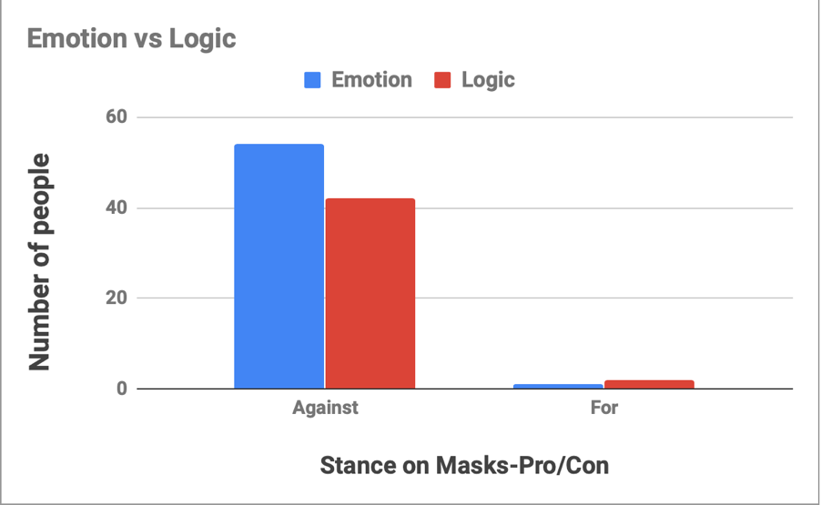
After I was finished coding, it was time to take a look at my results. However, in order to do this, I needed to make charts, so it would be easier to see my data. The first chart I made related to the emotion vs logic category. I also decided to separate the number of people who were for and against wearing a mask, so you could visually see the makeup of the people who were using this hashtag. As we can see in Figure 1, the majority of the people are opposed to mask wearing, which comes as no surprise. However, what is surprising is the number of people who used logic in their tweet. Given that the data was collected from a social media platform, we might readily expect tweets with high levels of emotion. Usually social media is a form where people can express their opinions on certain topics, but not always in a rationale or coherent sense. I investigated a little deeper into this and found that there were a lot of people who have been using Twitter specifically to reach out to a larger number or people. According to the article “National Politics on Twitter,” Julian Ausserhofer says that even politicians have been using twitter as a way to get their point across. As I was coding, I noticed that a significant percentage of the people who used logic added an article or picture to show evidence that wearing a mask is not effective and can even be detrimental to your health. These articles and videos make their argument more credible and thus are more likely to persuade people to not wear a mask. One initial conclusion is that people tweeting with the #masksdontwork hashtag are quite often using logic as well as emotion.
Figure 1- Stance’s on Mask
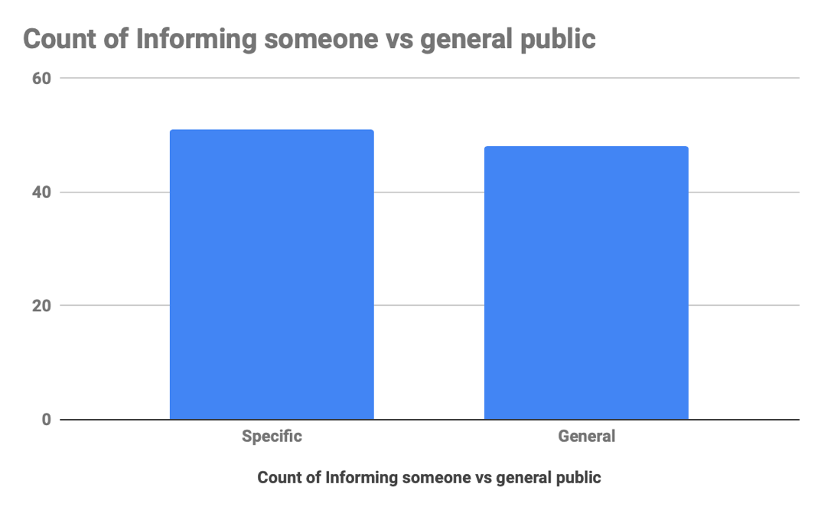
One other category that I examined was whether or not the person tweeting was replying to someone specific or writing to the general public. In figure 2, we see a pretty even split. However, I found that the type of tweets were quite different. For instance, when someone was speaking to the general public, they would usually give their opinion while using logic to explain their point of view. In contrast, most of the people who were replying to someone specific, were using emotion or pathos. One example of this is when Twitter user @Natural_S_Vegan says “the more we cooperate, the more they will try to take our human rights away.” Here the user is implying that wearing a mask in public should not be mandatory as it contradicts the rights of citizens.
Figure 2- Tweet intended for public or specific person
Americans have always felt like their rights are one of the most important things to them. This makes sense as that’s part of what this country was founded upon, and the controversy over masks is no different. There are many Americans who feel like the government should not require people to wear a mask. One Twitter user wrote that he would never go in any stores that required them to wear one! In contrast, another person wrote that it is legal to require masks, since not wearing a mask can potentially enhance the transmission of the virus and harm others. I found out that this is accurate since one of the primary reasons for wearing a mask is “not to protect you from others, but to protect others from you,” says Christopher Labos, writer of the article “Cloth masks get the thumbs-up, but do they work?” The “wearing a mask” controversy can be related to the ban on smoking in certain areas, as smoking can be detrimental to others. Another important point anti-mask critics bring up is the fact of who is in charge of the facility in the first place. Chuck Stebbins from the article “No-smoking laws erode personal freedoms” argues that if “you own it, you decide what to do with it.” A similar debate can be tied to whether or not people should be legally required to wear seatbelts in cars. However, wearing masks and smoking are slightly different then the seatbelt law since the only person you are hurting is yourself if an accident were to occur (Curtis 2017). As Miller James from the article “Taking away personal freedoms” likes to put it, “[I] don't see how you are putting others at danger by not wearing your own seat belt.”
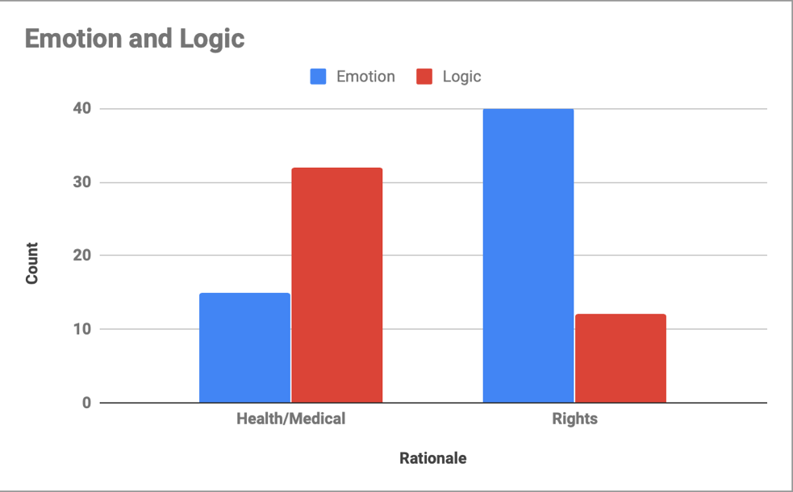
Another category I took note of was the rationale behind the Twitter post. In this category, I labeled the tweet as either for a health/medical reason, or for rights purposes. When I first developed this data into a chart, I found that there was a 50/50 split between these two groups. However, I found the data more interesting when I made a pivot chart and combined this category with my emotion vs logic section. Figure 3 models the data I have analyzed, and as you can clearly tell, there is a difference in the rationale between each group. For the people who were using their rationale for health/medical reasons, they were mainly using logic in their tweet. An example of this is when twitter user @nomadedliv writes, “This is what happens when you spray deodorant thru a mask.” The user attached a video of someone proceeding to spray deodorant directly at a mask and you could see it go through one side and out the other. This user is using logic to purvey his message that masks do not protect the virus. On the flip side, most of the tweets that came from Twitter users who used the rationale of rights were mostly using emotion. Just like when twitter user @lisa_dresden says, “Stop trying to force a mask on someone who doesn’t desire to wear one.” Here, the user is responding to critics who say that all people should wear a mask when they are out in public. This user explains that political leaders need to stop requiring face masks in public because it is against human rights. She is using emotion in her tweet to get her point across. Therefore, my analysis shows that people tweeting due to medical/health reasons often used logic whereas the people who focused on the rights of individuals primarily used emotion in their rationale.
Figure 3- Rationale of Tweet and Emotion/Logic
f
In total, I found a lot of surprises when working with the hashtag #masksdontwork. For example, it was interesting to see the breakdown of the rationale behind the tweets and I found that it was surprisingly fairly even between health and rights. In addition, it was also fascinating to see that even though the people did not believe in wearing masks, they were still willing to give logical facts to support their reasoning instead of just expressing their opinion. What I found most intriguing however, was the political leanings category as the majority of the people sided with conservatives. This data can be linked to the President of the United States, who is a conservative, as he is not seen wearing a mask most of the time. Ultimately whether or not masks should be required remains a controversial topic with strong opinions on both sides. Hopefully science will eventually prevail over emotion as we collect more data on the spread of the COVID virus moving forward.

Works Cited
Ausserhofer, J., & Maireder, A. (2013). National Politics on Twitter: Structures and topics of a networked public sphere. Information, Communication & Society: AoIR Special Issue, 16(3), 291-314. doi:10.1080/1369118X.2012.756050
Curtis, K.M., Rodi, S. W., & Sepulveda, M. G. (2007). The lack of an adult seat belt law in New Hampshire:Live free and die? Accident Analysis and Prevention, 39(2), 380,383. Doi:10. 1016/j.aap.2006.06.008
Friedman, L. C., Cheyne, A., Givelber, D., Gottlieb, M. A., & Daynard, R. A. (2015). Tobacco industry use of personal responsibility rhetoric in public relations and litigation: Disguising freedom to blame as freedom of choice. American Journal of Public Health, 105(2), 250-260. doi:10.2105/AJPH.2014.302226
Labos, C. (2020, April 14). Cloth masks get the thumbs-up, but do they work?; There's little evidence about their effectiveness. Shoreline Beacon. Retrieved from https://search- proquest-com.libproxy.lib.unc.edu/docview/2389535219?pq-origsite=summon
Miller, J. (2019, January 26). Taking away personal freedoms' -- Sheriff Lee not a fan of seat belt proposal. Retrieved, from https://wwwsciencedirect.com.libproxy.lib.unc.edu/science/arti cle/pii/S0001457506001497?via=ihub

