#whitelivesmatter: White Conservative Backlash to the Black Lives Matter Movement

William Fink Weinberg

University of North Carolina Chapel Hill

ENGL 105

7/1/2020

Introduction
Throughout the past decade the mass adoption of social media site Twitter has changed the way people across the world interact and get their news. Global movements have arisen and evolved with people’s changing communications and media habits such as the Black Lives Matter movement which has been at the forefront in the fight for equality with growing support ever since 2013 after the death of Trayvon Martin. Social tensions have been on the rise within the US for a variety of reasons, chiefly the fight for gender and racial equality. As Generation Z has come of age with an increasingly radical leftist mindset, an equally radical rightwing movement has arisen to counter it. Since the rise of Black Lives Matter, white nationalist, or the alt-right has kept pace with significant milestones as the election of Donald Trump, the Charlottesville riots, and a surge of violent mass shootings against minority groups (Pulse Nightclub, the Pittsburgh Synagogue, and the El Paso Shooting to name a few). Many of these shootings were orchestrated by right wing radicals over social media. Platforms like Twitter, 4chan, and 8chan are home to communities of white nationalists that create bubbles of extremist content that radicalize more moderate conservatives. Through the collection of the data on the twitter hashtag whitelivesmatter, I have done grounded research connecting the movement with notions of fear mongering, societal delusions and calls for violence.
Methods
Through a collection of tweets containing the hashtag whitelivesmatter I collected a random sample of 100 out of a body of over 7,000 all posted to twitter on Tuesday, June 23rd, 2020. I then sorted the tweets into three basic categories based on 1. the political stance of the author, 2. their tone, and 3. any logic they apply, or lack thereof.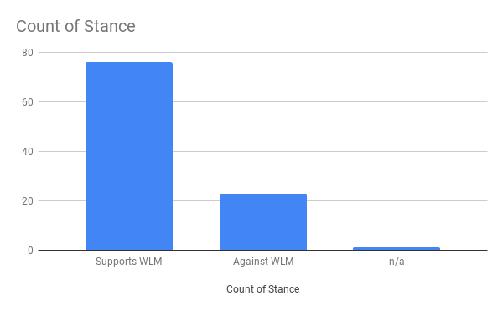Of the 100 tweets in my sample 76 were definitely in support of the whitelivesmatter (wlm) movement, with 23 tweets using the hashtag in a trolling capacity; one user's tweet could not be determined as it was in an unidentifiable language. In regard to tone, the majority of the sampled tweets were short, straightforward posts only containing the hashtag, usually directed at another user. 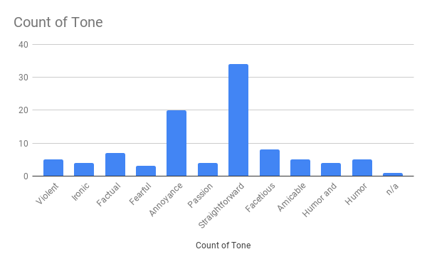The second largest group in the tone category were the “annoyed” users who expressed a feeling that Black Lives Matter or Society at large was wronging white people in some regard. Commonly users would express anger and annoyance that a Black Lives Matter post would be celebrated, while White Lives Matter is met with general ridicule, positioning them as the real oppressed class. These annoyed users also made up most of the “ignorance” and “double standard” groups in my logical reasoning category as seen in the abridged pivot table. I will mention that while trying to code these posts into reasonably sized categories I was forced to do as much generalizing as I possibly could to prevent twenty different categories within my data. While making for more understandable charts, this took some nuance out of the tweets. In order to curb any biases I had while making my sample I elected to minimize as many conditions for collecting the tweets, this is why so many of the posts were basic echoes of the hashtag, and though they add little incite to group they keep the sample true to the population as a whole. 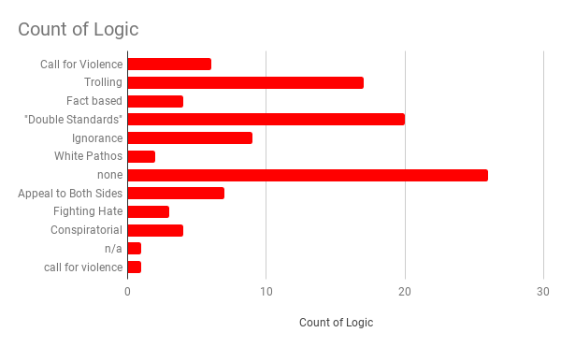These users are all similar in their flawed reasoning when trying to compare the Black Lives Matter movement to their own White Lives Matter. For example, user @william1980 posted “How the fuck is Black Lives Matter acceptable yet White Lives Matter and All Lives Matter deemed as racist. What a joke. If a plane flew over with Black Lives Matter last night it would be treated as inspirational and a milestone. Media are a joke. #WhiteLivesMatter #Burnley”. This tweet was in direct response to an incident on June 23rd when a plane with a banner reading WHITE LIVES MATTER BURNLEY flew over a football stadium by an unknown pilot , stirring controversy across the UK. The Burnley Football Club condemned the act, fueling the firestorm of twitter users rushing the pilot’s defense. william1980’s post illustrates a blindness by him and millions of others around the world who fail to recognize their own white privilege, and the purpose of the Black Lives Matter movement. “Indeed, several social psychological theories propose that high-status groups are motivated to maintain their high-status advantage by oppressing low-status groups (Verkuyten& Yogeeswaran, 2017), and critical race theorists propose that White Americans are motivated to deny the existence of racism and White advantage, and the need for hierarchy-reducing policies(e.g.,affirmative action and welfare), because doing so legitimizes their own social status(DiAngelo, 2012; Helms, 1992)” (Rizzo & Roberts, 2020). By calling attention to the inequalities of western society, some white people, rather than recognizing their privilege, further close off their already narrow worldview. To these people, it is more pleasant to believe society is equal, and racism is not institutionalized because the alternative would mean benefitting from a system that oppresses minority groups. By stating white lives or all lives matter, these people resist any notion their worldview is incorrect. Of course, this defensive reaction does not only mean dismissing people who speak contrary to their beliefs, but state that any threat to the system as it exists is a threat to their race. It should be remarked that the notable minority of nearly one quarter of users posting the wlm hashtag were using it in protest, either posting tweets like RC_Reacts’ “and people say #BlueLivesMatters #WhiteLivesMatter #AllLivesMatters Well you know All lives CAN'T AND WON'T MATTER until #BlackLivesMatter THIS, THIS right here is the reason we march, protest, &amp; unite against #RacialProfiling #RacialPolicing amongst other things. #Truth #Fact”. By co-opting the hashtag, they were able to post a poignant counter to most of the sentiment already on the feed. Others on the left elected rather than arguing the hashtag, overwhelm it with K-Pop. On June 22nd, the day before my tweet collection, reports of #whitelivesmatter was taken over by thousands of users posting images and videos of their favorite K-Pop artist effectively drowning out any other post, I was surprised to see 9% of my sample continue with the trend. Though humorous, the effects of the siege did not make for any real change as within twenty four hours wlm was back in order.
Though less common, the hashtag whitegenocide was persistent enough in my sample to be of note. The hashtag was only used by three different users out of the one hundred sampled, making up a small minority, but a frightening one regardless. User @MauiRheeder posted “@VGeorge2k18 @schiopu_necula and @hassanlr4eva That is so true. #WhiteLivesMatter so stop #WhiteGenocide and #FarmAttack in #SouthAfrica”. MauiRheeder is replying to several users' posts on recent reports of South African Farmers being attacked. Researching these attacks, it is extraordinarily difficult to find any consistent details, but the basic thread goes that white farm owners are being attacked and killed by black assailants. Reactionaries like @MauiRheeder and his peers jump to the conclusion that these attacks are racialized, but South African policing expert, Johan Burger, says “It is true that, if you look at just farmers, it is still mostly white farmers who get attacked. But that does not mean that black farmers and black workers are not killed.” If these attacks were truly racialized the victims would be a vast majority, if not all white, but the facts say otherwise. That does not prevent some conservative minded people from drawing the conclusion that with the rise of black movements and random violent acts that the very existence of the white race is in jeopardy. The very nature of Twitter, grouping hashtags and sensationalizing whatever is most eye catching means these dangerously misinformed posts garner the attention of more and more people.
Twitter and social media are designed to surround you in a bubble of like-minded content designed to keep you scrolling as long as possible. An unintended effect of this is the slow radicalization of beliefs. If a user with moderate beliefs searched #alllivesmatter it would not be long until #whitelivesmatter and #whitegenocide came into their feed. “These groups exploit the fear of erasure felt by white men to slowly inoculate them to increasingly extremist ideology (Condis, 2019).” (Fairchild, 2020). On August 3rd, 2019, Patrick Cruisius drove approximately nine hours from his home in Allen Texas to the largely Hispanic populated El Paso where he shot and killed twenty-three unarmed civilians. Cruisius’ attack was racially motivated, choosing to drive such a long distance solely to attack a majority Hispanic area. Before the shooting investigations found that Cruisius was a regular user of 8chan, a radically “free speech” forum page where he received help and planning his attack from other radical white supremacists. “8chan has been under increased public scrutiny after a string of violent firearm incidents in late 2018 and 2019 were attributed to the website’s lack of moderation and hegemonic far-right politics: the perpetrators of racially- or religiously-motivated massacres in Christchurch, New Zealand, San Diego, and El Paso have all been linked to 8chan, particularly its /pol/ board, [...] especially since the latter was motivated by xenophobia and theories of demographic replacement also present on 8chan. (Hagan, 2019). It can be argued that the connectivity of social media has allowed for increased radicalization on both sides of the political spectrum, and in the case of the right, radical, violent, racist beliefs shared on social media have the real possibility of creating real world racialized violence.
Conclusion
Twitter and other social media platforms are allowing people the unprecedented opportunity to share and discuss with millions of people all around the world. This sounds as though people would come together with a deeper more empathetic understanding of each other, but due to some tragic flaw in human psychology we choose to remain in our ingroups, and other outsiders; making increasingly bubbled internet experiences that further radicalize thoughts and opinions. In the case of conservative twitter users, the use of hashtags like alllivesmatter, algorithmically lead to whitelivesmatter, then possibly to whitegenocide. My research gives insight that most users believing the statement white lives matter are blind to their own white privilege, or worse yet subscribers to ideologies of hate that manifest into the real world as violence. Our presence on the internet shapes our perspective and our actions. It is vital as users of the internet we be skeptical of all information, open-minded, and empathetic to others.

Works Cited
Herstory. (2019, September 07). Retrieved June 26, 2020, from https://blacklivesmatter.com/herstory/

Voytko, L. (2020, June 22). Twitter Categorizes #WhiteLivesMatter As K-Pop Trend As Fans Flood It With Gifs, Memes. Retrieved June 23, 2020, from https://www.forbes.com/sites/lisettevoytko/2020/06/22/twitter-categorizes-whitelivesmatter-as-k-pop-trend-as-fans-flood-it-with-gifs-memes/

Fairchild, T. (2020.). It’s Funny Because It’s True: The Transmission of Explicit and Implicit Racism in Internet Memes. Virginia Commonwealth University. Retrieved 2020, from https://scholarscompass.vcu.edu/cgi/viewcontent.cgi?article=7444&context=etd

Rizzo, M., & Roberts, S. (2020). The Psychology of American Racism. Retrieved June 23, 2020, from https://osf.io/w2h73

Denita, A. (2017, October 26). 'More black farm workers are killed than white farm workers' &nbsp;- Johan Burger. Retrieved June 28, 2020, from
http://www.702.co.za/articles/278024/more-black-farm-workers-are-killed-than-white-farm-workers

Hagen, Sal, et al. “Infinity's Abyss: An Overview of 8chan.” OILab, 8 Sept. 2019, https://oilab.eu/infinitys-abyss-an-overview-of-8chan/.

