Hashtag Colin Kaepernick: Analyzing the Twitter Conversation of Professional Athletes Fighting Racial Injustice
Sydney J Reed
University of North Carolina – Chapel Hill
ENGL 105
June 29, 2020

Introduction:
Although many people believe that Twitter is mainly used as a source for entertainment, it has become a major platform for individuals to express their opinions on social and political matters while also discussing such with others. The several options used to do so include hashtags, mentions, and retweets. Hashtags in particular, though, are the main way for conversations to be sorted by a specific topic. For example, if someone were to search the hashtag ‘BlackLivesMatter’, a list of tweets regarding the movement would show: from articles and podcasts to opinions and responses – all with the same tag.
The purpose of the research that I have compiled is to further analyze the discussion about professional athletes fighting racial injustice. By using a coding and data collecting spreadsheet, tweets were filtered to show those that used the hashtag ‘ColinKaepernick’, allowing for further analysis on what Twitter users’ opinions are on the subject.
In 2016, Colin Kaepernick, an American football player who formerly played for the San Francisco Forty-Niners, peacefully protested against police brutality and racial injustice by kneeling during the National Anthem. He received lots of negative backlash and was even released from his team and not re-signed for the next season. With the Black Lives Matter movement being more prominent than ever after the murder of George Floyd by police in Minneapolis, Minnesota, Kaepernick – along with other professional athletes – has continued to fight for change in our society by using his large platform and also taking part in other protests across the country.
Methods:
To begin the research, I used a Twitter Archive Google Spreadsheet (TAGS) in order to gather tweets with the hashtag of my choosing (hashtag ‘ColinKaepernick’). Once all of the tweets using the tag were compiled, I filtered the data so that it removed tweets that contained ‘RT’ in front of it, showing that it was a retweet. Once the risk of duplicate tweets was eliminated, I then individually coded about one hundred tweets using different categories in order to organize the data. After that, I created multiple visuals to display my research so that it was easy to comprehend and pleasing to the eye. In order to assess similarities in the tweets, the following categories were used in the coding process.
The type of communication was one of the main factors that drove not only the conversation but also the research. As shown in Figure 1, most of the tweets were degrading athletes, whether that be Colin Kaepernick himself or another professional athlete, usually Bubba Wallace, which is further discussed in another visual. By describing the type of communication that the tweets were, it proved which direction the conversation was going.
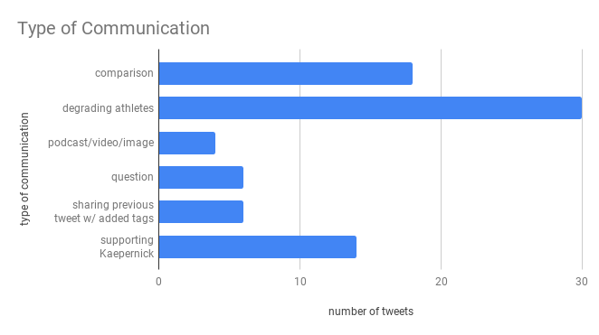
Figure 1 – Type of communication of the tweets found under hashtag ‘ColinKaepernick’.
Another major category that was vital to my research was whether the tweet mentioned Bubba Wallace or NASCAR, and Figure 2 displays how often they were mentioned in tweets. This category was important to my research because of the recent scandal with Bubba Wallace, one of the only black NASCAR drivers. Several Twitter users compared Wallace to Kaepernick in their tweets, thus driving the conversation towards the comparison of the two athletes.
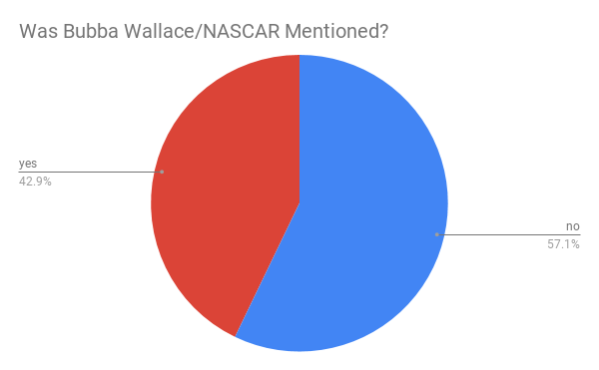
Figure 2 – Whether or not Bubba Wallace and/or NASCAR was mentioned in the tweets
According to the visual, even though the majority of the tweets did not mention Bubba Wallace or NASCAR, a large percent of the tweets did, which is interesting since the hashtag is the name of a different athlete who plays a different sport.
Next, I made a visual that separated the racist and anti-racist tweets. Figure 3 shows that the majority of the tweets under the tag are discriminating Kaepernick – and often Wallace – solely because of their skin color. The criteria for a tweet to be considered anti-racist was mainly if it was uplifting Kaepernick’s protest, used another hashtag to support the movement – such as ‘BlackLivesMatter’ – or if was educating other users on the history of black athletes enacting social change as far as racial injustice in society.
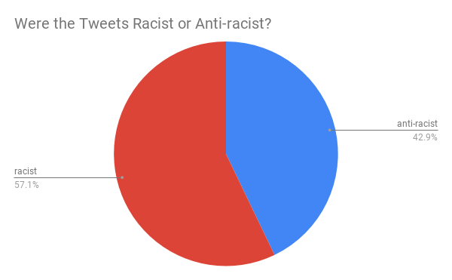
Figure 3 – Whether or not the tweets were racist or anti-racist.
The last category I used was whether or not the tweet was an opinion or factual information in order to educate others. More often than not, though, the tweets were opinions, so I decided to focus more on the other categories within those opinions.
Discussion:
According to an article published by the International Journal of Communication, professional athletes tend to receive major negative backlash for discussing social issues and fighting against injustices, especially when it involves race (Smith, 2019). The research from the tweets gathered continue to display this stigma in many of the users, such as a tweet created by a user that goes by @TexasJul: “.@JJWatt: "I am not going to stand up to show pride in a flag for a country that oppresses black people and people of color," — #ColinKaepernick The first time I see or hear about a @dallascowboys', a @HoustonTexans' or any other @nfl player kneel —That team is dead to me. 🇺🇸” (Sharp, 2020). This user responds to NFL player JJ Watt of the Houston Texans, insisting that he should not kneel before the flag because it is disrespectful. This is only one tweet that opposes professional athletes protesting against racial injustice. Most people who specifically are against Colin Kaepernick’s kneeling during the National Anthem do not understand the reason why. Smith’s article includes a direct quote from Kaepernick discussing why he peacefully protests: “I am not going to stand up to show pride in a flag for a country that opposes Black people and people of color. To me, this is bigger than football and it would be selfish on my part to look the other way. There are bodies in the street and people getting paid leave and getting away with murder” (Smith, 2019). Kaepernick is specifically talking about police brutality and how there isn’t enough accountability for police officers when they kill unarmed black men and women. This quote is from an interview in 2016, and unfortunately in 2020 it is still relevant. Kaepernick, though, is not the only black athlete – or athlete at all, for that matter – who has stood up against racism. After the murder of Trayvon Martin in 2012, NBA players such as Chris Bosh, Dwayne Wade, and Lebron James took to social media using the hashtag ‘WeWantJustice’, according to a 2017 article published by the International Social Science Review (Online). These NBA players and others continued to engage in activism after the deaths of Freddie Gray, Michael Brown, Eric Garner, Tamir Rice, among others by warming up in t-shirts with the phrase “I Can’t Breathe” written across the front (Anonymous, 2017). In all of these cases, though, the public was outraged, immediately tweeting and using other social media platforms to tell professional athletes to “shut up and play” and to “keep politics out of sports” (Anonymous, 2017). This further proves that many spectators and fans of both the NFL and NBA are majorly opposed to these athletes participating in the fight against racial injustice in society.
Conclusion:
To summarize, the research goes to show that many Twitter users are opposed to the idea of professional athletes using their platform to speak out against social issues and would rather they simply just play their sport. Whether it be through a racist comment, a comparison of two athletes, or merely degrading an athlete for their beliefs on a topic, users do not want to see them supporting any movement that enacts social change. In order to change the conversation from shaming athletes to encouraging them to continue to use their large platform, it is vital that there be more Twitter users who spread awareness on the subject and educate other users about the history of how athletes have successfully sparked change in society.

References
Policy point-counterpoint: Do African American athletes have an obligation to fight against
racial injustice? (2017). International Social Science Review (Online), 93(2), 0_1,1-9. Retrieved from http://libproxy.lib.unc.edu/login?url=https://search-proquest-com.libproxy.lib.unc.edu/docview/1985134906?accountid=14244

Sharp, J. (2020). Twitter. Retrieved from https://twitter.com/TexasJul/status/1275504803565776903

Smith, L. R. (2019). Stand Up, Show Respect: Athlete Activism, Nationalistic Attitudes, and
Emotional Response. International journal of communication [Online], 2376+. Retrieved from https://link-gale-com.libproxy.lib.unc.edu/apps/doc/A610340535/LitRC?u=unc_main&sid=LitRC&xid=e3622dc2

