Tweeting about Suicide: The Effects of Twitter on Depression

Sam Hankley
PID: 730435749
University of North Carolina at Chapel Hill
ENGL 105
July 2, 2020

Introduction:
In many ways, depression is among the worst diseases one could ever have. For instance, it is not too uncommon to hear from a cancer patient that his or her terrible condition regardless resulted in a greater appreciation for family, friends, and life. However, when a disease directly produces the inability to feel pleasure and positive emotion, silver linings are often hard to come by. Depression’s primary symptom, known as anhedonia, is just that: the absence of positive emotion. Consisting of “key dysfunctions in brain circuitries mainly supporting emotion regulation and cognitive control” (Brakowski et al. 2017), depression is not simply an extended period of negative feelings, but rather the result of a fundamental flaw in the brain’s wiring. Unfortunately, the long-term nature of this horrible condition often compels self-harm and suicide: “the World Health Organization reports that 1 person dies every 40 second” in this way (Davidson et al. 2018). Given the extent of tragic destruction caused by depression, it is imperative that all potential solutions for this health crisis are seriously considered and investigated.
Social media has undoubtedly revolutionized the way humans communicate with each other. Following the introduction of Facebook, Twitter, and other forms of social media, both communication and the exchange of information were made virtually instantaneous. Consequently, complex societal issues and conflicts have been directly influenced by this novel technology. Twitter, and by extension social media, could thus act as a powerful tool against the blight that is depression. With its hashtag (#) system of grouping online conversations into topics, Twitter facilitates the development of digital communities centered around specific issues. Focusing on #suicideprevention, I will attempt in this paper to analyze aspects of Twitter conversations associated with combatting depression.
Methods:
Using the TAGS program to collect tweets under the hashtag #suicideprevention, I gathered close to 2,000 tweets. After applying a filter to exclude retweets, I was still left with around 1,000 tweets. From here, I selected a sample of 100 tweets in the filtered set to be coded. Looking back, more filters may have helped to winnow down the set of tweets. Additionally, a more randomized sample might have been selected with more filters. However, I was still able to accomplish the main task: applying codes to tweets in order to better analyze the Twitter discussion around suicide prevention.
“Appeal” was the first category I coded for, denoting the use of either ethos, logos (logic), or pathos (emotion). For example, I coded the following tweet under Emotion: “What is #depression like? It’s like drowning, except everyone around you is breathing?” Any tweets I found to use logos were coded as Logic, and any with ethos as Ethos.
“Type of Communication” was the next criteria coded for, involving gerunds to describe the diction used by Twitter users when conversing about depression. The adjectives I settled on to satisfy the Type of Communication were Advising, Encouraging, Exposing, Informing, Pleading, and Questioning.
“Method of Prevention” denoted the different ways in which the users sought to combat depression and suicide. These included “Spreading Positivity,” “Reach Out,” “Hotline,” and “Destigmatization.” Tweets coded under Reach Out compelled those suffering with depression to contact friends, family, and any others willing to talk. Hotline captured tweets that included a suicide prevention hotline. Spreading Positivity included tweets that encouraged hope and optimism, and Destigmatization primarily consisted of users deploring the tendency to vilify those suffering with depression.
“Poster” characterized the user type as either a Person or Organization. When I deemed the user to be a person, I then coded for “User Age” and “User Gender.” Admittedly, the latter two categories induce some arbitrary judgements on my part into the data, yet I believe the information garnered about the users was still helpful.
The final two areas of coding were “Rationale Behind Prevention” and “Relation to Depression.” The former included the user’s reasoning for advocating the specific Method of Prevention, including “Life is Hard But Worth It,” “Readily Accessible Treatment” (often paired with Hotline), and “To Raise Awareness” (often occurring with Destigmatization). For Relation to Depression, I coded the users as either a Supporter (i.e. a person supporting the depressed) or a Sufferer (a user claiming to have depression).
Analysis/Discussion:
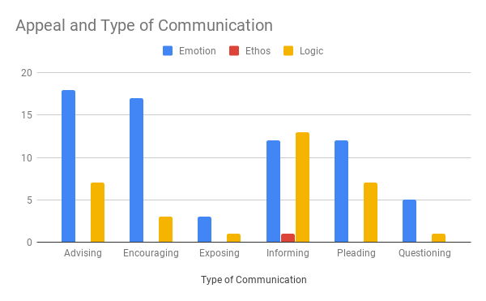 Figure 1
As Figure 1 points out, Emotion was the primary appeal adopted by users, followed by Logic, and finally Ethos. Given the emotional impact of depression, these results were unsurprising. Furthermore, when the Method of Communication was Informing, Logic was understandably adopted more than Emotion by users.

Figure 2

Figure 2 shows that more relatively young (20-40 years) users tweet about depression than old (40-60 years) users. This finding was also expected, as “it is generally agreed upon in the literature that there is a strong relationship between adolescent anxiety disorders and depression” (Soleimani et al. 2017). Although I would not consider 20-40 years adolescent, I think it is fair to assume that users who decide to post about depression will likely be young.
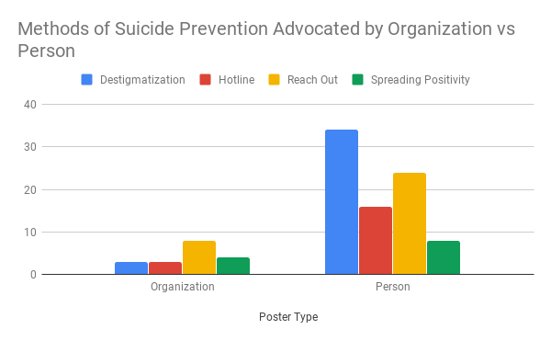Figure 3
Figure 3 compares the Methods of Prevention advocated by organizations and people. Although there were fewer organizations posting about depression in my hundred tweets compared to people, both user types emphasized Reach Out as a primary method. However, people advocated most for Destigmatization, while organizations emphasized this method the least. However, I think this difference is due to the lack of a representative number of organizations within my 100 tweets.
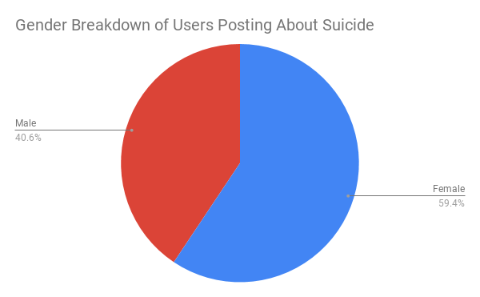Figure 4
Figure 4 presents the gender difference among users posting about depression, showing that 59.4% were females, and 40.6% were males. However, these results are likely subject to the most variance. Gender determinations were made by examining aspects of user profiles. For instance, perhaps more females than males use a self-portrait as a profile picture. Or perhaps a user identifies with a gender that does not correspond to a typical male or female profile picture.
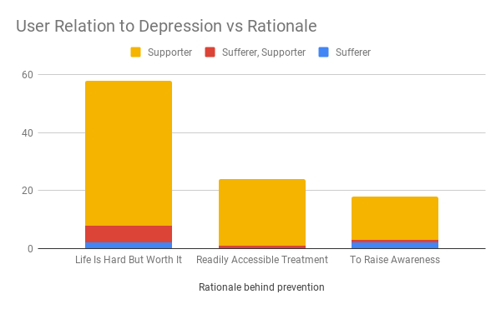Figure 5
Figure 5 compares the rationale of suicide prevention adopted by users who have experienced depression (“Sufferer”) versus users who I assumed haven’t experienced depression (“Supporters”). Life is Hard But Worth appeared to capture the most users, whether they had depression or not. I believe this finding supports the idea that everyone, regardless of any experience with depression, knows that life can be unforgiving and cruel. This knowledge implies that every human has the capacity to empathize with the depressed. As user @BrieflyJLynn states, “I've been struggling with feelings of wanting to not wake up but I've been here before &amp; it doesn't last forever, eventually things do get better.” By recognizing this human familiarity with suffering and pain, people could better relate to the depressed.
Conclusion:
Twitter is inarguably a powerful outlet for communication, yet it is not always clear whether this power is constructive or destructive in nature. In terms of the benefits of Twitter, Figure 1 shows how almost all tweets on #suicideprevention refrain from promoting suicide in any way, an action that results in “exacerbating suicide risk” (Mann et al. 2005). Furthermore, the social connectedness that the various twitter communities can provide could be instrumental in helping people cope with the suicides of loved ones. For instance, user @AchillesWG displays the compassion common to many of the tweets that I coded: “I love all of you. Anyone ever need someone to talk to the DMs are open. I hate seeing notifications on my phone so I can guarantee you that I'll reply back in no time. Remember: If it doesn't challenge you it won't change you #OneLove #SuicidePrevention.” Twitter could be helpful in postvention, or the efforts taken to “destigmatize the tragedy of suicide and to assist with the recovering process; and to serve as a secondary prevention effort to minimize the risk of subsequent suicides” (Erlich et al. 2017). Despite the positive aspects of Twitter, there are some downsides to this social media regarding suicide prevention.
Firstly, online harassment is unfortunately a common occurrence on social media. A survey of college students found that “45.5% report[ed] cyberbullying on Twitter,” roughly 4 times the prevalence on Instagram (McHugh et al. 2018). Given the relative anonymity that social media provides, online harassment is to be expected on Twitter. Although I could not find any instance of cyberbullying among my sample of tweets, online toxic behavior is nonetheless prevalent on Twitter.
Additionally, a phenomenon known as the Werther effect – where media coverage of a celebrity suicide is followed by an increased population suicide rate – is especially common to Twitter. Researchers measuring the strength of the effect in Twitter versus traditional media concluded that “prominent suicide deaths were followed by an increase in population suicides only when they generated a large reaction from Twitter users” (Ueda et al. 2017). Given the tragic extent of cyberbullying and the influence of the Werther effect, I believe more research is needed to examine the effects of Twitter on depression. In fact, a study sponsored by the National Institute for Mental Health “identified a strong and significant association between social media use and depression” (Brahmakumar 2017). I think the only conclusion one can make is that – like almost everything – Twitter can be both helpful and harmful. In terms of its role with suicide prevention, Twitter can provide valuable and supporting communities to help remove the stigma and isolated feelings attached to depression. However, it is the job of the user to find these positive online circles while avoiding the toxic ones.

References
Brakowski, J., MD, Spinelli, S., PhD, Dörig, N., PhD, Bosch, O. G., MD, Manoliu, Andrei, MD, PhD, Holtforth, M. G., PhD, & Seifritz, E., MD. (2017). Resting state brain network function in major depression – depression symptomatology, antidepressant treatment effects, future research. Journal of Psychiatric Research, 92, 147-159. doi:10.1016/j.jpsychires.2017.04.007.
Davidson, J. E. , Zisook, S. , Kirby, B. , DeMichele, G. & Norcross, W. (2018). Suicide Prevention. JONA: The Journal of Nursing Administration, 48(2), 85–92. doi: 10.1097/NNA.0000000000000582.
Erlich, M. D. , Rolin, S. A. , Dixon, L. B. , Adler, D. A. , Oslin, D. W. , Levine, B. , Berlant, J. L. , Goldman, B. , Koh, S. , First, M. B. , Pabbati, C. & Siris, S. G. (2017). Why We Need to Enhance Suicide Postvention. The Journal of Nervous and Mental Disease, 205(7), 507–511. doi: 10.1097/NMD.0000000000000682.
Mann, J. J., Apter, A., Bertolote, J., Beautrais, A., Currier, D., Haas, A., . . . Hendin, H. (2005). Suicide prevention strategies: A systematic review. Jama, 294(16), 2064-2074. doi:10.1001/jama.294.16.2064.
McHugh, M. C., Saperstein, S. L., & Gold, R. S. (2019). OMG U #Cyberbully! an exploration of public discourse about cyberbullying on twitter. Health Education & Behavior, 46(1), 97-105. doi:10.1177/1090198118788610.
Mohammad, A. S., Saeed, P. S., Bahrami, N., Yaghoobzadeh, A., Allen, K. A., & Mohammadi, S. (2019). The relationship between anxiety, depression and risk behaviors in adolescents. International Journal of Adolescent Medicine and Health, 31(2) doi:http://dx.doi.org.libproxy.lib.unc.edu/10.1515/ijamh-2016-0148.
Ueda, M., Mori, K., Matsubayashi, T., & Sawada, Y. (2017). Tweeting celebrity suicides: Users' reaction to prominent suicide deaths on twitter and subsequent increases in actual suicides. Social Science & Medicine, 189, 158-166. doi:10.1016/j.socscimed.2017.06.032.
Whittaker, E., & Kowalski, R. M. (2015). Cyberbullying via social media. Journal of school violence, 14(1), 11-29.

