Community Twitter Report: #RepublicansAgainstTrump

Dylan Rainey

University of North Carolina at Chapel Hill

English 105-002

July 1, 2020

Social media can be a great tool for studying social, political, and economic concerns and discussions. Perhaps the most useful social media site for such discussions is twitter, a website where users all over the world can post brief ideas in real time as they follow the latest news. Hashtags allow users a way to highlight what they are making a comment on, while adding their own thoughts and feelings as they react to the world around them. By researching a set of tweets with a common hashtag, one can get a sense of how the public feels about a particular issue and study the ways they interact around the topic. These investigations can be particularly revealing when it comes to political trends and evens, like the 2020 Presidential Election.
While Donald Trump has been a divisive figure since way before he was elected in 2016, when he officially became the President of America while being backed by the Republican Party, it became more difficult for Republicans to come out publicly against him. After all, even if they didn’t like his personality or his arrogant ways, they were at least happy that the Republican Party had regained control of the White House and also Congress. However, as Trump’s campaign has gone on with his inability to steer away from controversy and abhorrent behavior, especially in recent months with his poor handling of the Covid-19 pandemic and racial justice protests, many Republicans find themselves needing to speak out against Trump, regardless of his party affiliation. Much of that conversation has been playing out on Twitter.
To research this sort of conversation on twitter, I found that the most popular hashtag being used was fittingly #RepublicansAgainstTrump, so I honed in on that hashtag to see what the conversation was like. A Twitter Archiving Google Spreadsheet (TAGS) was used to collect all the tweets containing this hashtag, and over 4,000 tweets were generated. The tweets in the spreadsheet came with detailed information including the Twitter User, the time the tweet was posted, the number of followers and the number of accounts the user followed, the location of the user, and more. To narrow down this dataset, the tweets were filtered to remove all retweets so that each tweet was original, and then out of the 900 or so tweets left, a sample of 100 of these tweets was selected to represent the study.
In order to further analyze these tweets, I used additional qualitative coding by adding categories to the spreadsheet manually. The categories added were "associated concerns," “rationale” behind the stance, “political lean,” “type of appeal” (logic, emotion), and finally “user age.” By sifting through the tweets, I was able to assign codes for each of these categories based on each particular tweet and user responsible for that tweet. These categories were selected to better understand aspects of the conversation studied, as well as the attitudes and positions associated with the conversation. The associated concern category highlighted what subjects were also being addressed, such as the upcoming Presidential Election, the current GOP, Covid-19, the recent Trump Rally in Tulsa, Oklahoma, etc., while the rationale category looked into why people felt the way they do with concerns primarily regarding politics or safety. The political lean category would likely confirm the idea behind the hashtag #RepublicansAgainstTrump, while also checking if any democrats were promoting the hashtag as well. The type of appeal category would further reveal aspects of the conversation, and the twitter user age would of course study the demographics of the users who tweeted on the subject.
Analyzing the data, I found that the majority of these tweets were referencing the upcoming 2020 Presidential Election this November. With the majority of tweets regarding the upcoming election, the data also showed that these users weren’t simply showing their disapproval of the current President; rather many were often declaring their support for his rival
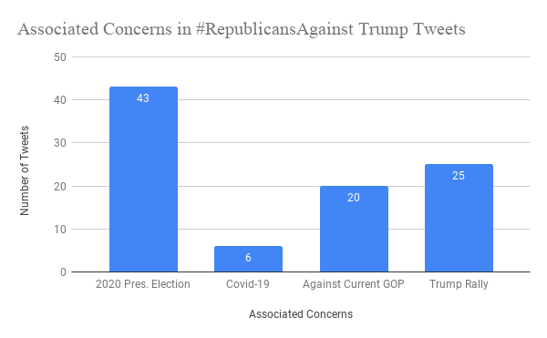
Figure 1. Associated concerns referenced in tweets
in the Presidential race, Democrat Joe Biden, by including the hashtag #VoteBiden or #VoteBlue on top of their declaration of being a Republican against Trump. Jacqueline Alemany, from the Washington Post, highlighted this sentiment in her recent article titled “Power Up: Anti-Trump Republicans are now getting out the vote for Joe Biden.” Alemany highlights how a growing number of Republicans against Trump are realizing that it’s not enough to merely not vote for Trump; rather they are beginning to encourage likeminded conservatives to vote for Joe Biden in the upcoming Presidential election. Part of this new idea is because Trump is beginning to significantly hurt the GOP and their Senate candidates who are currently trying to get reelected for another term (Alemany). Jonathan Martin and Matt Stevens expand on this alarming issue for the GOP in their article from The New York Times. According to a new poll or registered voters, the Republicans are in serious danger of losing their party’s senate majority, based on results that show their candidates are losing in important swing states, largely thanks to their party affiliation with Donald Trump (Martin & Stevens). The findings in this article coincide with the data generated in the twitter spreadsheet since many users also voiced their displeasure with the current GOP. Zooming in on a tweet from ‘murrayb560sl’, he states “The #GOPComplicitCowards #GOPCowards #GOPCorruptionOverCountry #RepublicansForBiden #RepublicansAgainstTrump #VoteBlueToEndThisNightmare #TrumpDeathToll120K”, while many other users in the study also included hashtags that were negative towards the current GOP.
To further analyze the data from the #RepublicansAgainstTrump spreadsheet, categories were cross-referenced to explore possible conclusions. Figure 2 shows this strategy visualized by examining the tweets and their associated concerns based on user age. Looking at user age alone
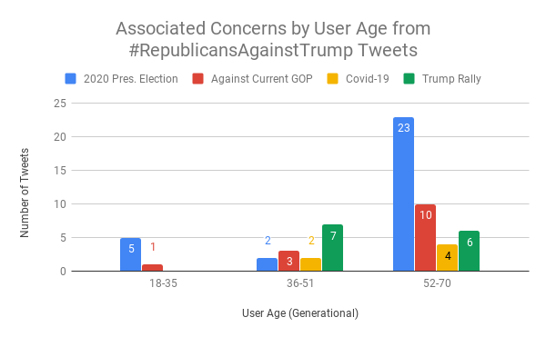
Figure 2. Associated concerns by user age in tweets
reveals that the majority of the tweets generated were from users aged (52-70), roughly the generation of baby boomers. This in itself highlights a possible change in popularity for Donald Trump, who was generally considered more popular than Hillary Clinton with voters in this age group in 2016. Now looking at both categories together in Figure 2, we can see that the 2020 Presidential Election is very much on the minds of twitter users from this age group, and the demographic that Trump had previously had a stranglehold on seems to be going against him this time around. Lastly, I found that the vast majority of the tweets were from users who did identify as being on the right side of the political spectrum. While expected, it was significant to see that this hashtag that was not being used primarily by an outside party trying to get the message out there, rather it was true republicans who were speaking out against their republican President. These findings are demonstrated in Figure 3.
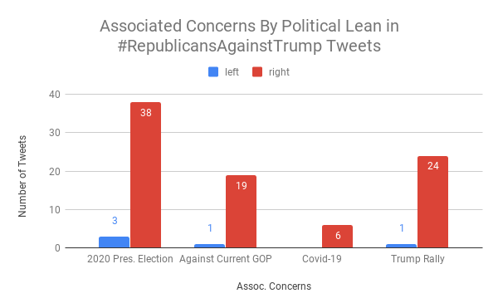
Figure 3. Associated concerns by political lean in tweets
While the research conducted via twitter only highlights a small fraction of public discussion in small window of time, I believe it still offers a glimpse into the attitudes of republicans opposed to Trump. While it cannot be concluded whether or not Trump will have lost enough popularity in recent months to lose the reelection this November, it is clear that there is a growing number of American citizens, specifically Republicans, who are fed up with Donald Trump’s erratic behavior and will do their part to ensure that he is by no means going to run away with the upcoming Presidential election. It is also clear that many (at least among these twitter users) who have been long time supporters of the Republican Party are beginning to seriously consider voting for their rival party and its’ nominee, Joe Biden. Whether this will mean that Trump is removed as President of the United States only time will tell. Overall, researching and analyzing twitter conversations is an effective way to study societal topics and the public’s views on such issues.

Works Cited
Alemany, J. (2020, June 26). Analysis | Power Up: Anti-Trump Republicans are now getting out the vote for Joe Biden. Washington Post. https://www.washingtonpost.com/news/powerpost/paloma/powerup/2020/06/26/powerup-anti-trump-republicans-are-now-getting-out-the-vote-for-joe-biden/5ef4e32688e0fa7b44f67e16/
Could Republican senators turn against Donald Trump?: The chamber of secrets. (2019, Oct 03). The Economist (Online), Retrieved from http://libproxy.lib.unc.edu/login?url=https://search-proquest-com.libproxy.lib.unc.edu/docview/2300297254?accountid=14244
Jacobson, G. C. (2018). The Effects of the Early Trump Presidency on Public Attitudes Toward the Republican Party. Presidential Studies Quarterly, 48(3), 404-435. doi:http://dx.doi.org.libproxy.lib.unc.edu/10.1111/psq.12476
Martin, J., & Stevens, M. (2020, June 25). Trump’s Sagging Popularity Drags Down Republican Senate Candidates. The New York Times. https://www.nytimes.com/2020/06/25/us/politics/trump-senate-republicans-poll.html
Rubin, J. (2017). Corker Shows How Republicans Can Dump Trump. Washington: WP Company LLC d/b/a The Washington Post. Retrieved from http://libproxy.lib.unc.edu/login?url=https://search-proquest-com.libproxy.lib.unc.edu/docview/1954814768?accountid=14244

